



# Year 12 ATAR Methods

## Semester 2 revision

© Department of Education WA 2020

Except where indicated, this content is © Department of Education Western Australia 2020 and released under a Creative Commons CC BY NC licence. Before re-purposing any third-party content in this resource refer to the owner of that content for permission.

Any Western Australian Curriculum content in this resource is used with the permission of the School Curriculum and Standards Authority; this permission does not constitute Authority endorsement of the resource. The Authority accepts no liability for any errors or damages arising from reliance on its content. The Western Australian Curriculum content may be freely copied, or communicated on an intranet, for non-commercial purposes in educational institutions, provided that the Authority is acknowledged as the copyright owner. Copying or communication for any other purpose can be done only within the terms of the Copyright Act 1968 or with prior written permission of the Authority. Any Australian Curriculum content in the Western Australian Curriculum is used by the Authority under the terms of the [Creative Commons Attribution­ Non-commercial 3.0 Australia licence](http://creativecommons.org/licenses/by-nc-sa/3.0/au/).

Requests and enquiries concerning copyright should be addressed to:

Intellectual Property and Copyright

Department of Education

151 Royal Street

EAST PERTH WA 6004

Email: [copyright@education.wa.edu.au](mailto:copyright@education.wa.edu.au)



<https://creativecommons.org/licenses/by-nc/4.0/>

1. Differentiation

Topic 3.1: Further differentiation and applications

**Exponential functions**

* + 1. estimate the limit of $\frac{a^{h}-1}{h}$ as $h→0$, using technology, for various values of $a >0$
    2. identify that $e$ is the unique number $a$ for which the above limit is 1
    3. establish and use the formula $\frac{d}{dx}\left(e^{x}\right)=e^{x}$
    4. use exponential functions of the form $Ae^{kx}$ and their derivatives to solve practical problems

**Trigonometric functions**

* + 1. establish the formulas $\frac{d}{dx}\left(\sin{x}\right)=\cos{x }$ and $\frac{d}{dx}\left(\cos{x}\right)=-\sin{x}$ by graphical treatment, numerical estimations of the limits, and informal proofs based on geometric constructions
    2. use trigonometric functions and their derivatives to solve practical problems

**Differentiation rules**

* + 1. examine and use the product and quotient rules
    2. examine the notion of composition of functions and use the chain rule for determining the derivatives of composite functions
    3. apply the product, quotient and chain rule to differentiate functions such as $xe^{x}$, $\tan{x,} \frac{1}{x^{n}}$, $x\sin{x,} e^{-{x}}\sin{x}$ and $f\left(ax-b\right)$

**The second derivative and applications of differentiation**

* + 1. use the increments formula: $δy≈\frac{dy}{dx}×δx$ to estimate the change in the dependent variable $y$ resulting from changes in the independent variable $x$
    2. apply the concept of the second derivative as the rate of change of the first derivative function
    3. identify acceleration as the second derivative of position with respect to time
    4. examine the concepts of concavity and points of inflection and their relationship with the second derivative
    5. apply the second derivative test for determining local maxima and minima
    6. sketch the graph of a function using first and second derivatives to locate stationary points and points of inflection
    7. solve optimisation problems from a wide variety of fields using first and second derivatives

Exponential functions

**Euler’s number**

$e=2.71828$ (correct to 5 d.p)

|  |  |
| --- | --- |
| Consider the expression $\lim_{n→∞}{{\left(1+\frac{1}{n}\right)}^{n}}$  where $n>0$ | Consider the expression $\lim_{t→0}\left(\frac{a^{t}-1}{t}\right)$ where |
| |  |  | | --- | --- | |  |  | | 1 | 2 | | 2 | 2.25 | | 5 | 2.48832 | | 10 | 2.59374 | | 100 | 2.70481 | | 1000 | 2.71692 | | 10000 | 2.71827 | | 1000000 | 2.71828 | | |  |  | | --- | --- | |  |  | | 2 | 0.69315 | | 2.5 | 0.91629 | | 2.7 | 0.99325 | | 2.71 | 0.99695 | | 2.72 | 1.00063 | | 2.718 | 0.99990 | | 2.7183 | 1.00001 | | 2.71828 | 1.00000 | $∴\lim_{t→0}\left(\frac{a^{t}-1}{t}\right)=1$  when $a=e$ |

**Differentiating exponential functions**

For $y=e^{x}, \frac{dy}{dx}=\lim_{h→0}\left[\frac{f\left(x+h\right)-f(x)}{h}\right]$

$=\lim_{h→0}\left[\frac{e^{\left(x+h\right)}-e^{x}}{h}\right]$

As shown on page 1

$\lim_{t→0}\left(\frac{a^{t}-1}{t}\right)=1$ when $a=e$

$∴\lim_{h→0}\left(\frac{e^{h}-1}{t}\right)=1$

$=\lim_{h→0}\left[\frac{e^{x}\left(e^{h}-1\right)}{h}\right]$

$=e^{x}\lim_{h→0}\left[\frac{e^{h}-1}{h}\right]$

$=e^{x}×1$

$\frac{dy}{dx}=e^{x}$

I.e. $e^{x}$ differentiates to itself.

|  |  |
| --- | --- |
| $f\left(x\right)=e^{x}$ | $f'\left(x\right)=e^{x}$ |

**More on growth and decay**

If $A=A_{0}e^{kt}$ then $\frac{dA}{dt}=k×A_{0}e^{kt}$

$=k×A$

$∴$ if $\frac{dA}{dt}=k×A$

Then $A=A_{0}e^{kt}$

Trigonometric functions

**Establishing the formulas $\frac{d}{dx}\left(\sin{x}\right)=\cos{x}$ and $\frac{d}{dx}\left(\cos{x}\right)=-\sin{x}$**

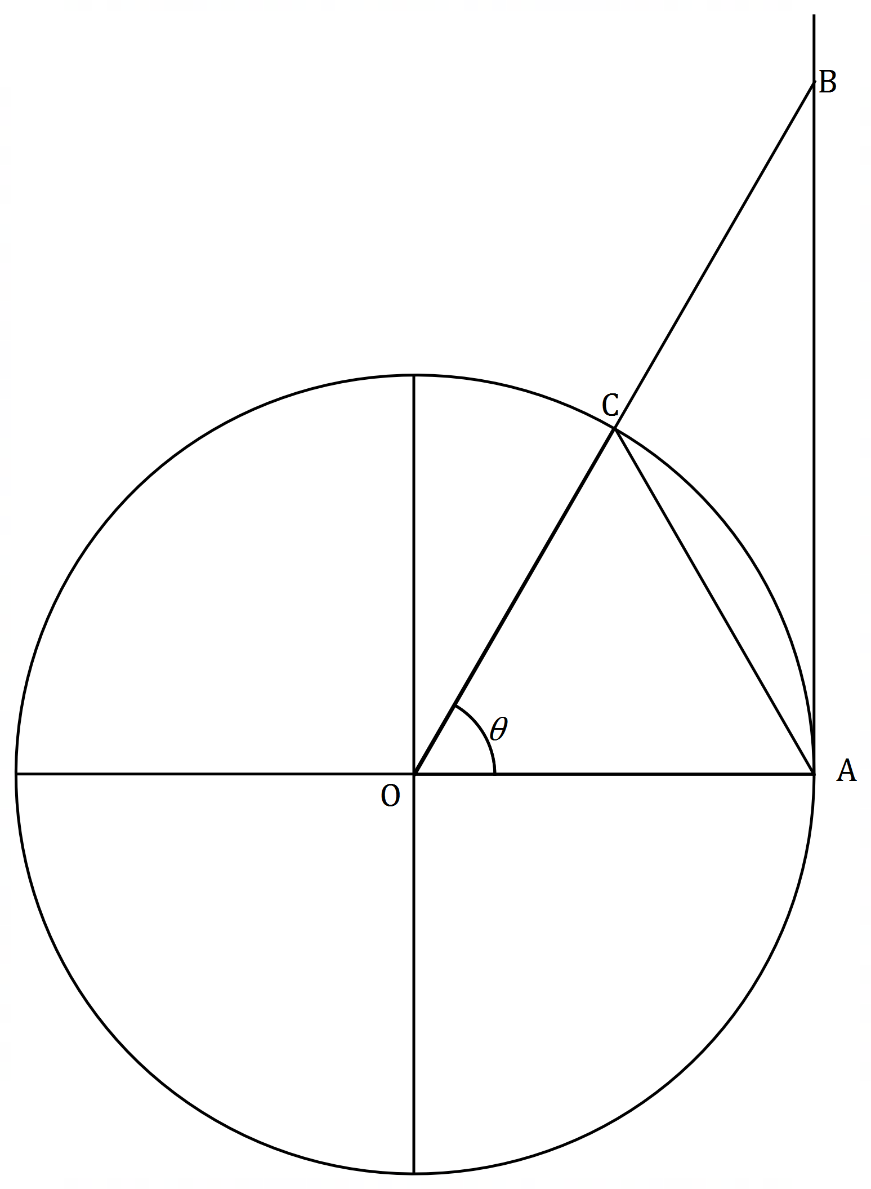**Geometrically**

The diagram on the right shows a unit circle with $AB$ tangent to the circle   
and $θ$ measured in radians with $0<θ<\frac{π}{2}$.

It follows that

$\tan{θ}$ $=\frac{AB}{OA}$

$AB$ $=\tan{θ}×1$

$∴AB$ $=\tan{θ}$

Area $∆OAC$ $=\frac{1}{2}×OA×OC×\sin{θ}$

$=\frac{1}{2}×1×1×\sin{θ}$

$=\frac{\sin{θ}}{2}$

Area sector $OAC$ $=\frac{1}{2}×r^{2}×θ$

$=\frac{1}{2}×1^{2}×θ$

$=\frac{θ}{2}$

Area $∆OAB$ $=\frac{1}{2}×AB×OA$

$=\frac{1}{2}×\tan{θ}×1$

$=\frac{\tan{θ}}{2}$

Comparing these three areas, we can see that

Area $∆OAC$ $<$ Area sector $OAC$ $<$ Area $∆OAB$

$\frac{\sin{θ}}{2}$ $<$ $\frac{θ}{2}$ $<$ $\frac{\tan{θ}}{2}$

For: $\frac{\sin{θ}}{2}$ $<$ $\frac{θ}{2}$

Multiply both sides by 2

Divide both sides by $θ$

$\sin{θ}$ $<$ $θ$

$\frac{\sin{θ}}{θ}$ $<$ $1$

For: $\frac{θ}{2}$ $<$ $\frac{\tan{θ}}{2}$

Multiply both sides by 2 and replace $\tan{θ}$

Multiply both sides by $\cos{θ}$

Divide both sides by $θ$

$θ$ $<$ $\frac{\sin{θ}}{\cos{θ}}$

$θ\cos{θ}$ $<$ $\sin{θ}$

$\cos{θ}$ $<$ $\frac{\sin{θ}}{θ}$

Putting these together: $\cos{θ}$ $<$ $\frac{\sin{θ}}{θ}$ $<$ $1$

We know that as $θ→0$, $\cos{θ}→1$

We can see that $\frac{\sin{θ}}{θ}$ is “sandwiched” between $\cos{θ}$ and 1, then as $θ→0$, $\frac{\sin{θ}}{θ}$ tends towards 1.

### **Using limits**

From first principal’s if $f\left(x\right)=\sin{x}$

$f^{'}\left(x\right)$ $=\lim_{h→0}{\frac{f\left(x+h\right)-f\left(x\right)}{h}}$

$=\lim_{h→0}{\frac{sin\left(x+h\right)-\sin{x}}{h}}$

Use the identity $\sin\left(A±B\right)=\sin{A}\cos{B}±\sin{B}\cos{A}$

Split into two limits

Factorise out $\cos{x}$ and $\sin{x}$

$=\lim_{h→0}{\frac{\sin{x}\cos{h}+\sin{h}\cos{x}-\sin{x}}{h}}$

$=\lim_{h→0}{\frac{\sin{h}\cos{x}}{h}}-\lim_{h→0}{\frac{\sin{x}-\sin{x}\cos{h}}{h}}$

|  |  |  |
| --- | --- | --- |
| $h$ | $\frac{\sin{h}}{h}$ | $\frac{1-\cos{h}}{h}$ |
| -0.02 | 0.9999 | -0.0100 |
| -0.01 | 0.99998 | -0.0050 |
| -0.001 | 0.999998 | -0.0005 |
| -0.0001 | 0.999999998 | -0.00005 |
| 0 | undefined | undefined |
| 0.0001 | 0.999999998 | 0.00005 |
| 0.001 | 0.999998 | 0.0005 |
| 0.01 | 0.99998 | 0.0050 |
| 0.02 | 0.9999 | 0.0100 |

$=\cos{x}\lim_{h→0}{\frac{\sin{h}}{h}}-\sin{x}\lim_{h→0}{\frac{1-\cos{h}}{h}}$

Now we need to find out what $\lim_{h→0}{\frac{\sin{h}}{h}}$ and $\lim_{h→0}{\frac{1-\cos{h}}{h}}$ are.

Using your calculator in radians getting $h$ as close to zero as you can from both the negative and the positive sides.

The table suggests that:

$\lim_{h→0}{\frac{\sin{h}}{h}}=1$ and $\lim_{h→0}{\frac{1-\cos{h}}{h}}=0$

Returning to $f’(x)$ $=\cos{x}\lim_{h→0}{\frac{\sin{h}}{h}}-sinx\lim_{h→0}{\frac{1-\cos{h}}{h}}$

Substitute in $\frac{\sin{h}}{h}=1$ and $\frac{1-\cos{h}}{h}=0$

$=\cos{x}×1-\sin{x} ×0$

$=\cos{x}$

$∴\frac{d}{dx}(\sin{x)}$ $=\cos{x}$

From first principals if $f\left(x\right)=\cos{x}$

Use the identity $\cos\left(A±B\right)=\cos{A}\cos{B}∓\sin{A}\sin{B}$

Split into two limits and factorise out -1

Factorise out $\sin{x}$ and $\cos{x}$

Substitute in $\frac{\sin{h}}{h}=1$ and $\frac{1-\cos{h}}{h}=0$

$f^{'}\left(x\right)$ $=\lim_{h→0}{\frac{f\left(x+h\right)-f\left(x\right)}{h}}$

$=\lim_{h→0}{\frac{cos\left(x+h\right)-\cos{x}}{h}}$

$=\lim_{h→0}{\frac{\cos{x}\cos{h}-\sin{x}\sin{h}-\cos{x}}{h}}$

$=-\lim_{h→0}{\frac{\sin{x}\sin{h}}{h}}-\lim_{h→0}{\frac{\cos{x}-\cos{x}\cos{h}}{h}}$

$=-\sin{x}\lim_{h→0}{\frac{\sin{h}}{h}}-\cos{x}\lim_{h→0}{\frac{1-\cos{h}}{h}}$

$=-\sin{x}×1-\cos{x}×0$

$∴\frac{d}{dx}(\cos{x)=}-\sin{x}$

### **Graphically**

|  |  |  |  |
| --- | --- | --- | --- |
| Angle $θ$ (radians) | $$\sin{θ}$$ | $$\cos{θ}$$ | $$\tan{θ}$$ |
| $$0$$ | $$0$$ | $$1$$ | $$0$$ |
| $$\frac{π}{6}$$ | $$\frac{1}{2}$$ | $$\frac{\sqrt{3}}{2}$$ | $$\frac{1}{\sqrt{3}}=\frac{\sqrt{3}}{3}$$ |
| $$\frac{π}{4}$$ | $$\frac{1}{\sqrt{2}}=\frac{\sqrt{2}}{2}$$ | $$\frac{1}{\sqrt{2}}=\frac{\sqrt{2}}{2}$$ | 1 |
| $$\frac{π}{3}$$ | $$\frac{\sqrt{3}}{2}$$ | $$\frac{1}{2}$$ | $$\sqrt{3}$$ |
| $$π$$ | 1 | 0 | undefined |

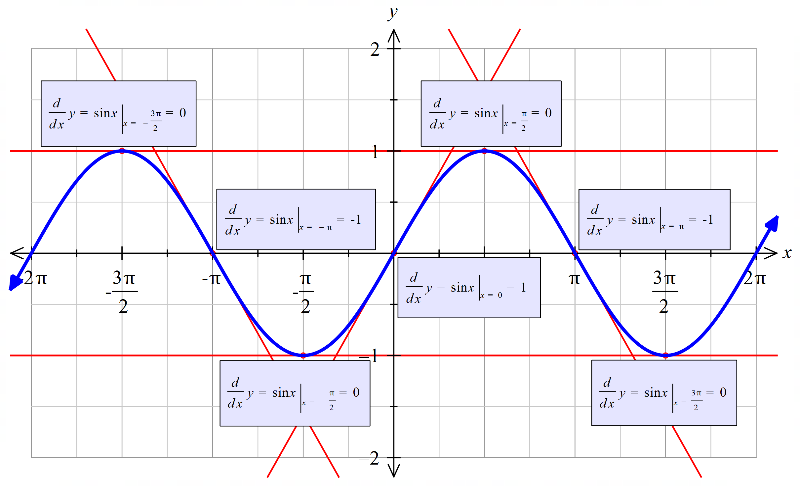Drawing $y=\sin{x}$ and then sketching the tangent at key points helps us determine the function of the gradient.

By sketching the points of the tangents above, as well as others against $y=\sin{x}$ we can see that the

$\frac{dy}{dx}=\cos{x}$.

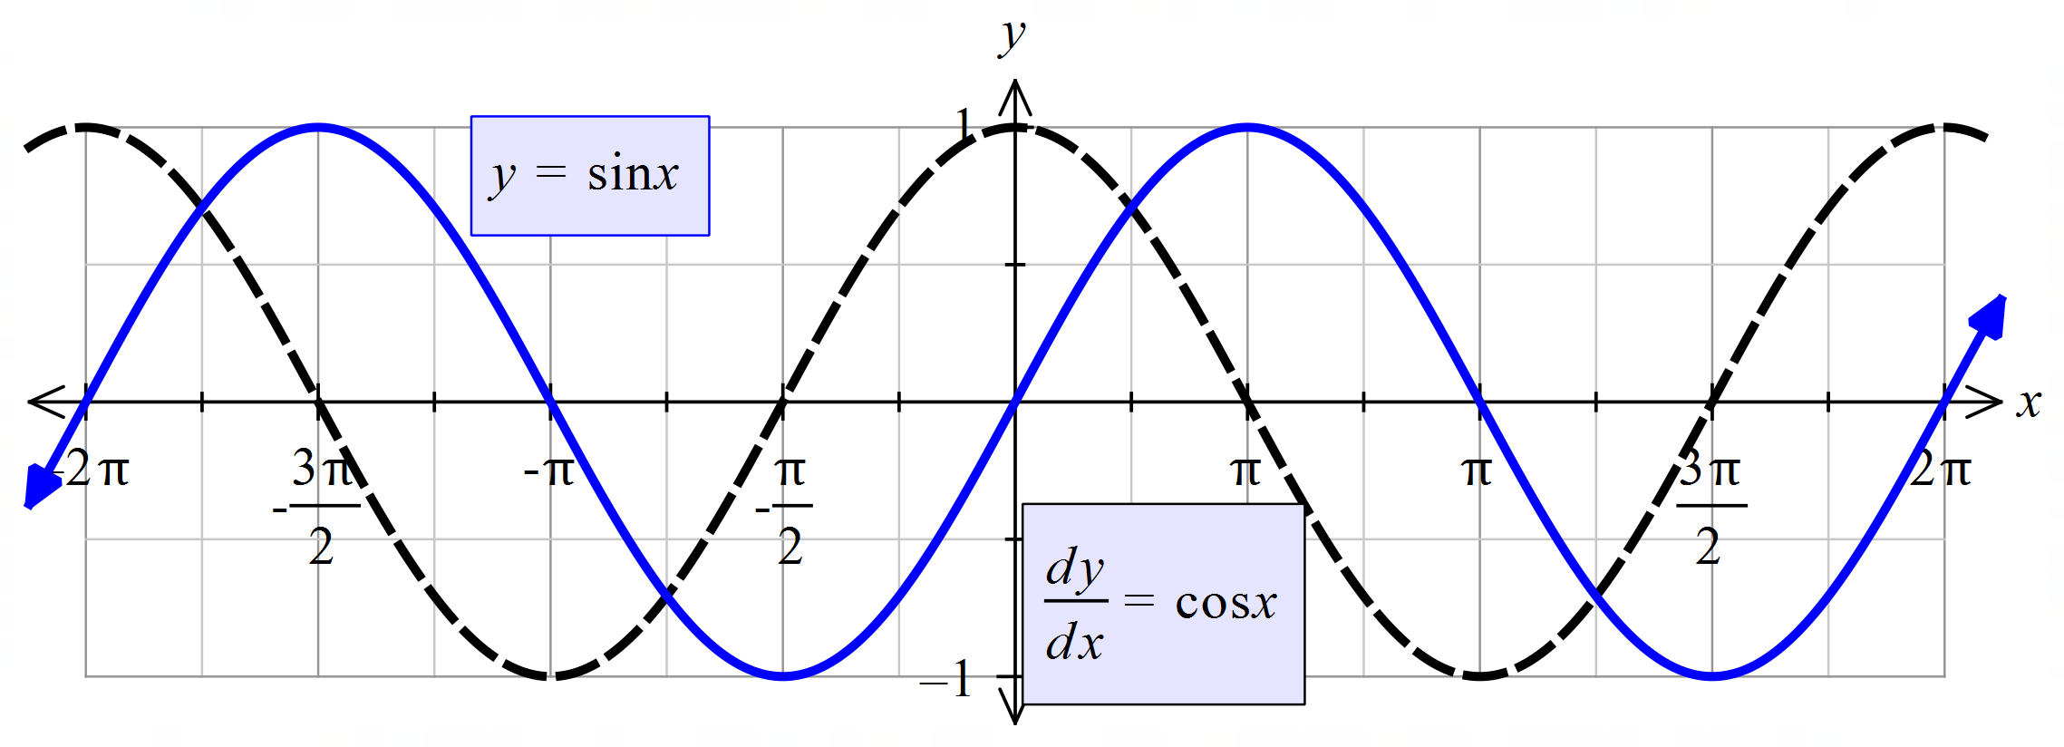

Drawing $y=\cos{x}$ and then sketching the tangent at key points helps us determine the function of the gradient.

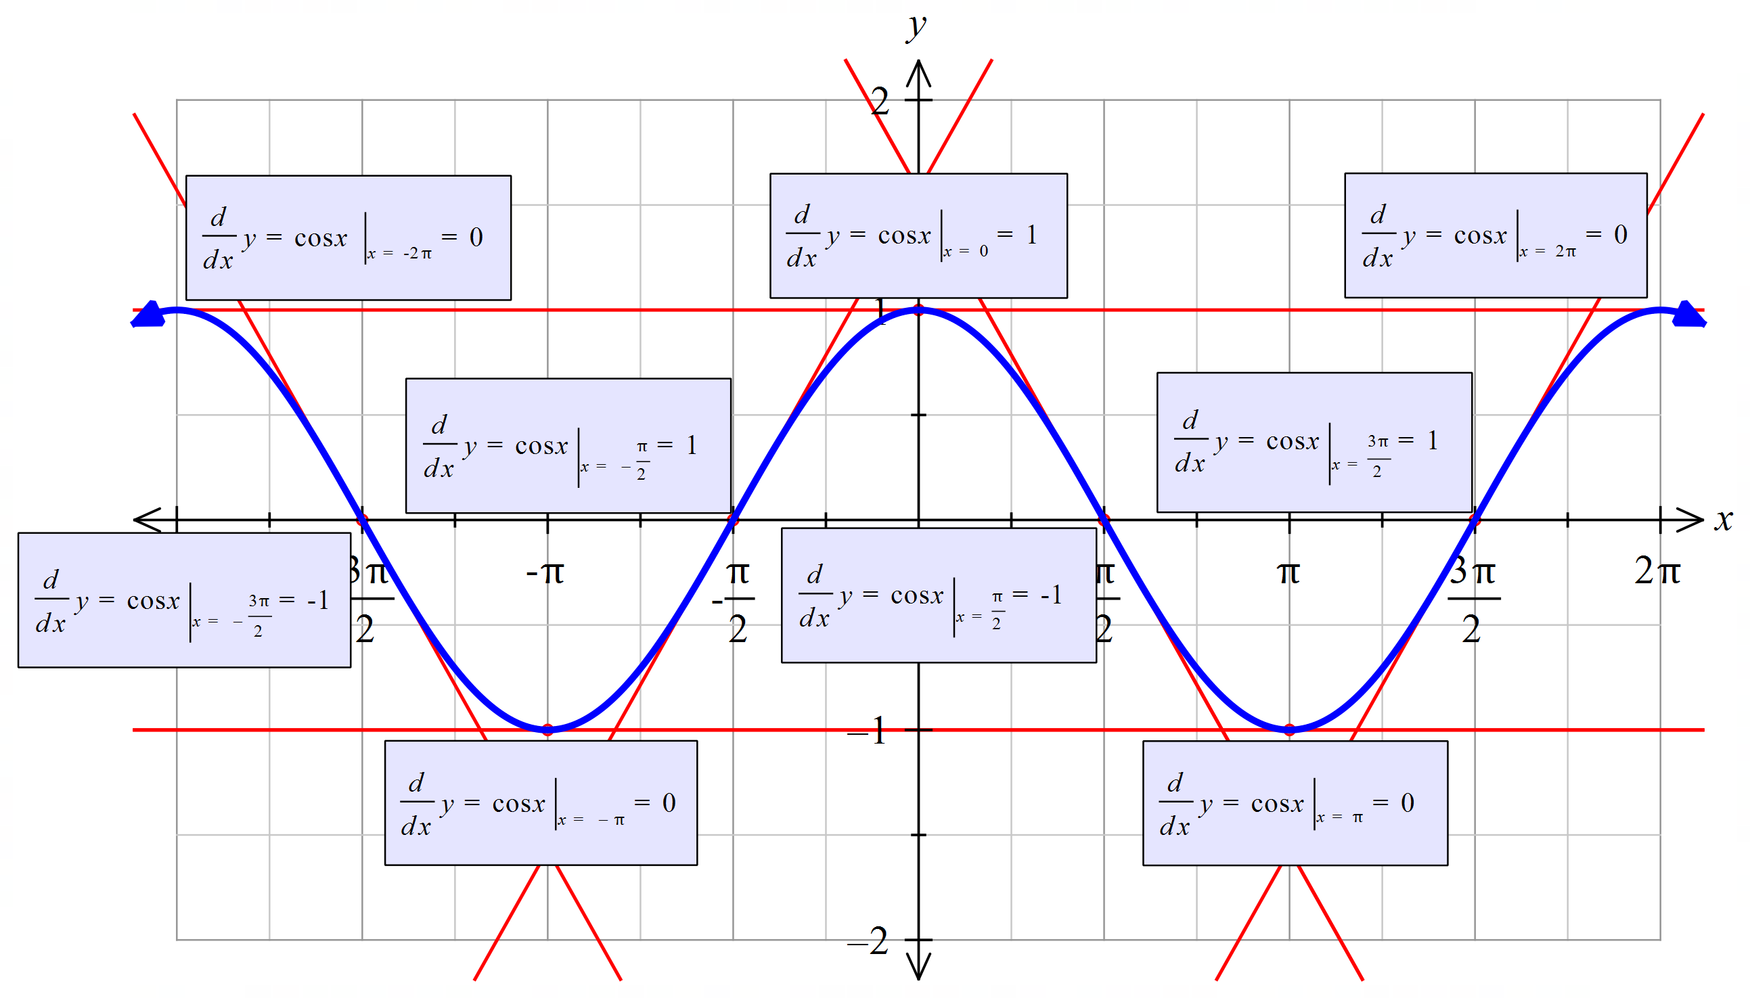

By sketching the points of the tangents above, as well as others against $y=\cos{x}$ we can see that the $\frac{dy}{dx}=-sin{x}$.

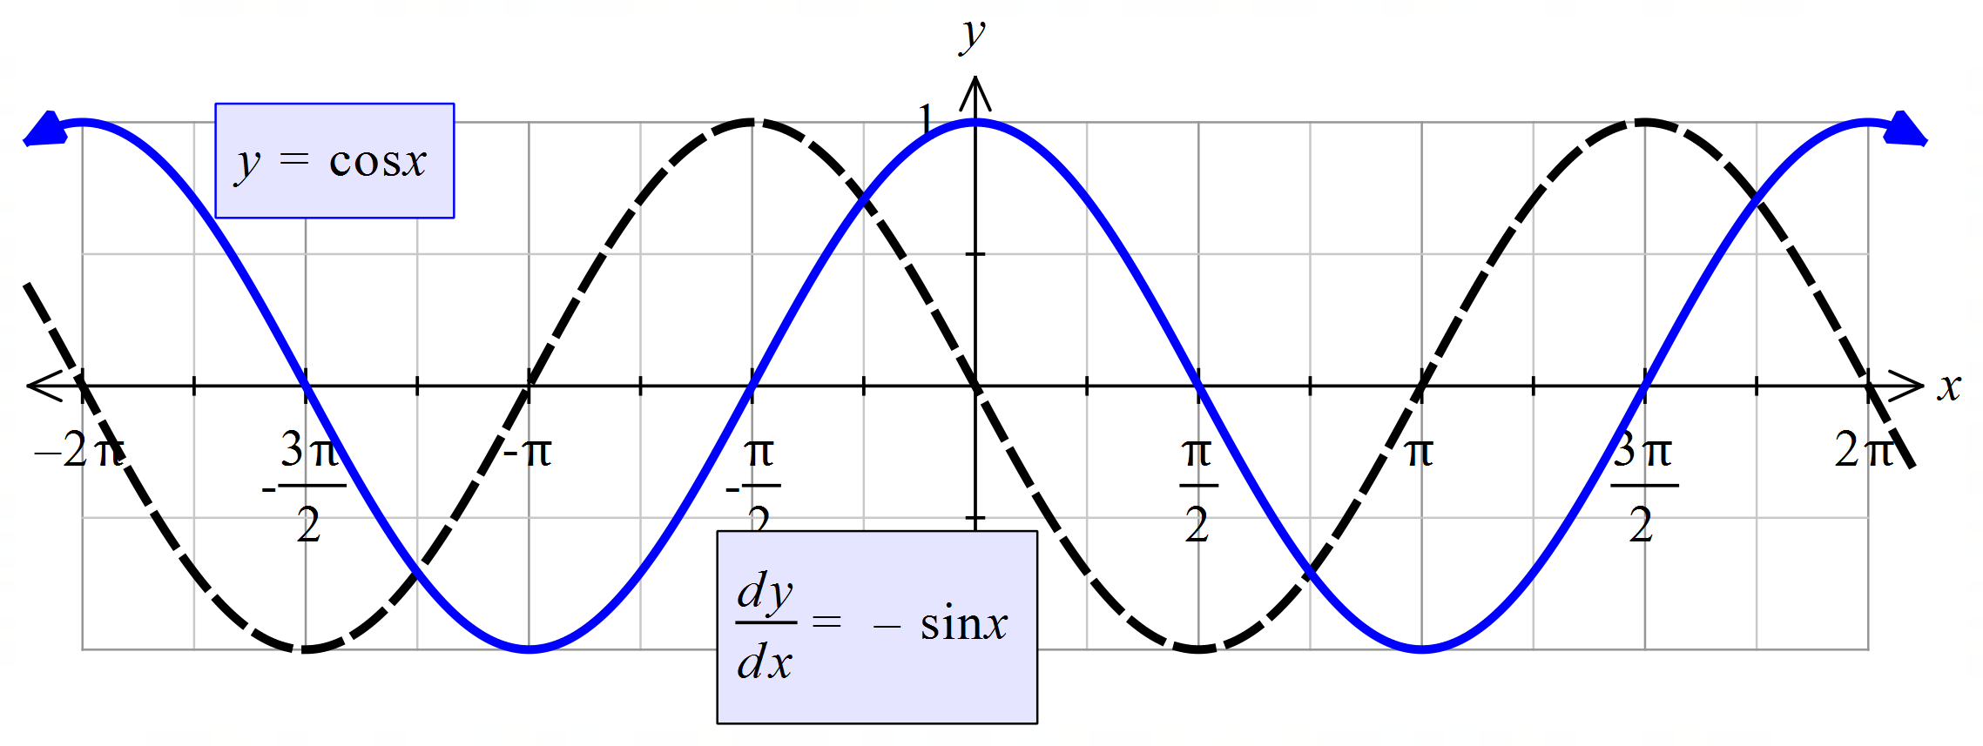

|  |  |
| --- | --- |
| $f\left(x\right)=\sin{x}$ | $f'\left(x\right)=\cos{x}$ |
| $f\left(x\right)=\cos{x}$ | $f^{'}\left(x\right)=-\sin{x}$ |

Differentiation rules

**Product rule**

|  |  |
| --- | --- |
| $$y=f\left(x\right)×g\left(x\right)$$ | $$\frac{dy}{dx}=f'\left(x\right)×g\left(x\right)+f\left(x\right)×g'\left(x\right)$$ |

**Quotient rule**

|  |  |
| --- | --- |
| $$y=\frac{f\left(x\right)}{g\left(x\right)}$$ | $$\frac{dy}{dx}=\frac{f'\left(x\right)×g\left(x\right)-f\left(x\right)×g'\left(x\right)}{{\left[g\left(x\right)\right]}^{2}}$$ |

## Chain rule

|  |  |
| --- | --- |
| $$y={\left[f\left(x\right)\right]}^{n}$$ | $$\frac{dy}{dx}=n{\left[f\left(x\right)\right]}^{n-1}×f'\left(x\right)$$ |
| $$y=f\left(u\right), u=g(x)$$ | $$\frac{dy}{dx}=\frac{dy}{du}×\frac{du}{dx}$$ |
| $$y=e^{ax+b}$$ | $$y'=ae^{ax+b}$$ |
| $$y=sin⁡(ax+b)$$ | $$y'=a\cos{(ax}+b)$$ |
| $$y=\cos\left(ax+b\right)$$ | $$y'=-\operatorname{asin}{(ax+b)}$$ |

The second derivative and applications of differentiation

**Incremental change**

**Using the notation $δx$ as the small change in $x$ and $δy$ as the small change in $y$, then**

$\frac{dy}{dx}=\lim_{δx→0}{\frac{δy}{δx}}$

**If $δx$ is small then $\frac{δy}{δx}≈\frac{dy}{dx}$**

**If finding a percentage change, divide both sides by $y$ and write the percentage change of $x$ as $\frac{δx}{x}$.**

**Marginal rates of change**

**In economic situations there are three main functions**

**Cost, $C(x)$, the cost of producing $x$ items.**

**Revenue, $R\left(x\right),$ the income from selling $x$ units.**

**Profit, $P\left(x\right)=R\left(x\right)-C(x)$**

**The marginal cost, $C'(x)$ gives the approximate cost of producing one more item.**

**Similarly, $R'(x)$ (and $P'(x)$) are the approximate extra revenue (and profit) from the sale of one more item.**

**Application of the second derivative**

**Second derivative**

**Differentiating a function twice give the gradient function of the gradient. Notation includes $\frac{d^{2}y}{dx^{2}}$, $y"$ or $f''(x)$**

**Displacement, Velocity and Acceleration**

Displacement $x(t)$ or $s(t)$ is the distance a particle is from the origin.

Velocity is the rate of change of displacement $∴v=\frac{dx}{dt}$

Acceleration is the rate of change of velocity. $∴a=\frac{dv}{dt}=\frac{d^{2}x}{dt^{2}}$

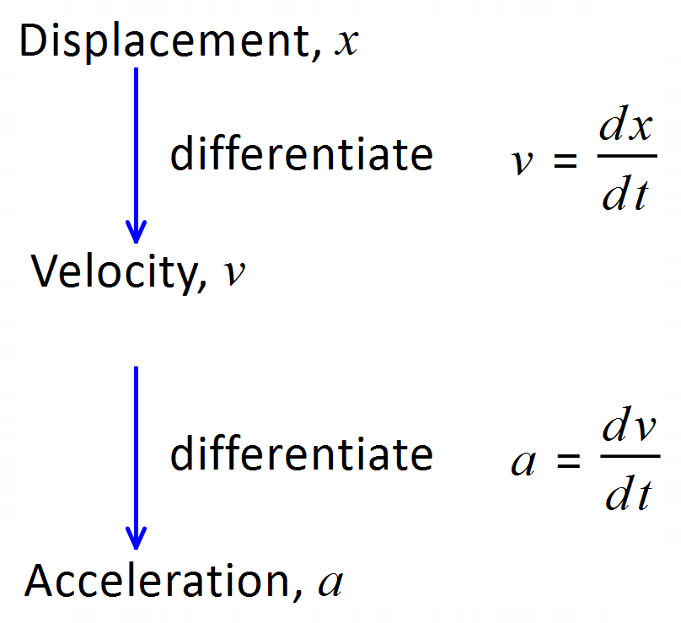

**Curve sketching**

**When given a curve to sketch look for the following features.**

1. What is the basic shape of the graph, (cubic, parabola, hyperbola etc)
2. Find any intercepts
3. Find limits at infinity
4. Check for asymptotes
5. Identify any turning points
6. Find points of inflection

**Stationary and inflection points**

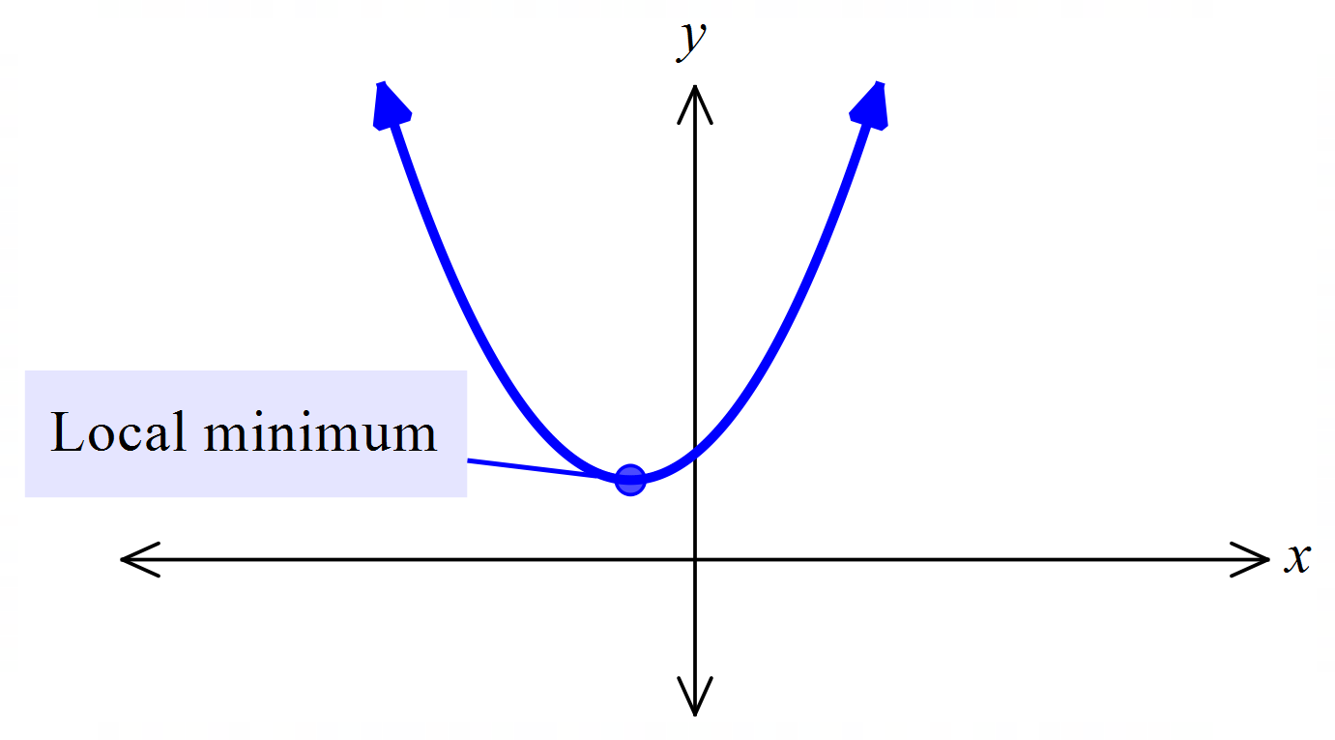For minimum (concave up) at $x=a:y^{'}=0, y^{''}>0$

|  |  |  |  |
| --- | --- | --- | --- |
| $$x$$ | $$a^{-}$$ | $$a$$ | $$a^{+}$$ |
| $$y^{'}$$ | $$-$$\ | $$0$$ $$-$$ | $$+$$/ |

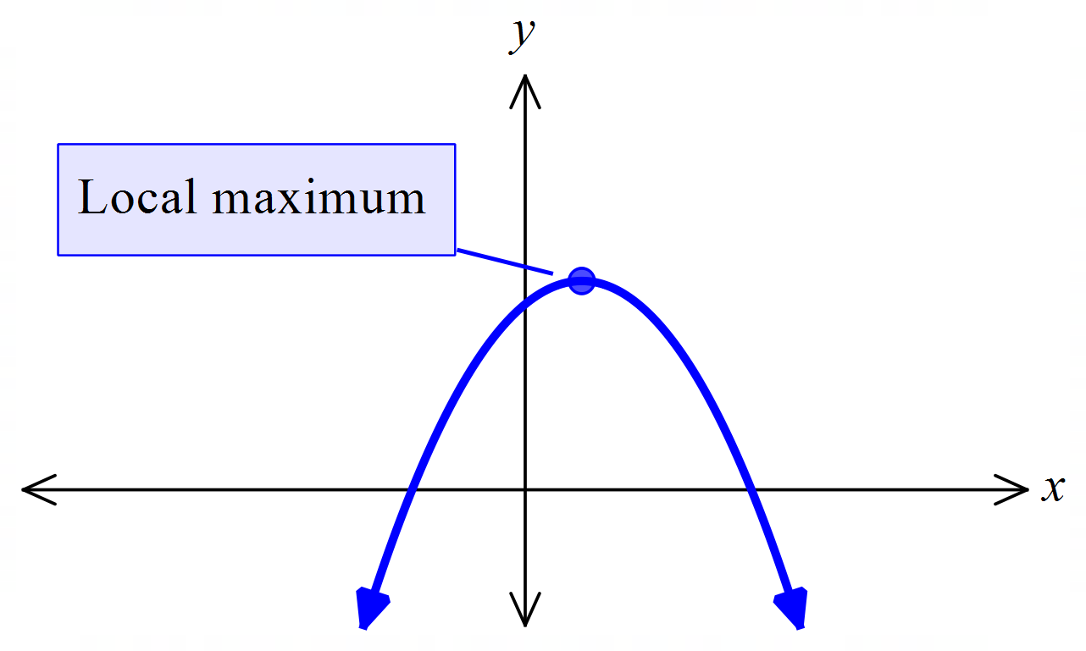For maximum (concave down) at $x=a:y^{'}=0, y^{''}<0$

|  |  |  |  |
| --- | --- | --- | --- |
| $$x$$ | $$a^{-}$$ | $$a$$ | $$a^{+}$$ |
| $$y^{'}$$ | $$+$$/ | $$0$$ $$-$$ | $$-$$\ |

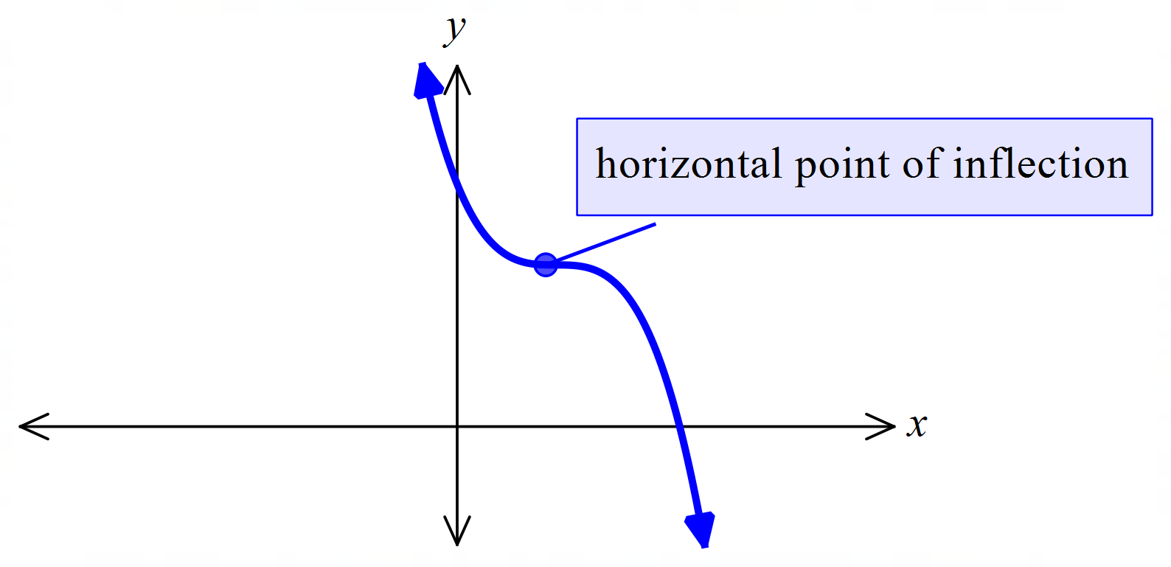For horizontal inflection point at $x=a:y^{'}=y''=0$, $y^{''}\left(a^{+}\right)$ and $y^{''}\left(a^{-}\right)$ have opposite signs.

|  |  |  |  |
| --- | --- | --- | --- |
| $$x$$ | $$a^{-}$$ | $$a$$ | $$a^{+}$$ |
| $$y^{'}$$ | $$±$$ | $$0$$ | $$±$$ |
| $$y"$$ | $$±$$ | 0 | $$∓$$ |

Note: if the first and second derivative are both 0 at the same point, it may not be a horizontal point of inflection. For example, $y=x^{4}$. You will need to do the sign test to check.

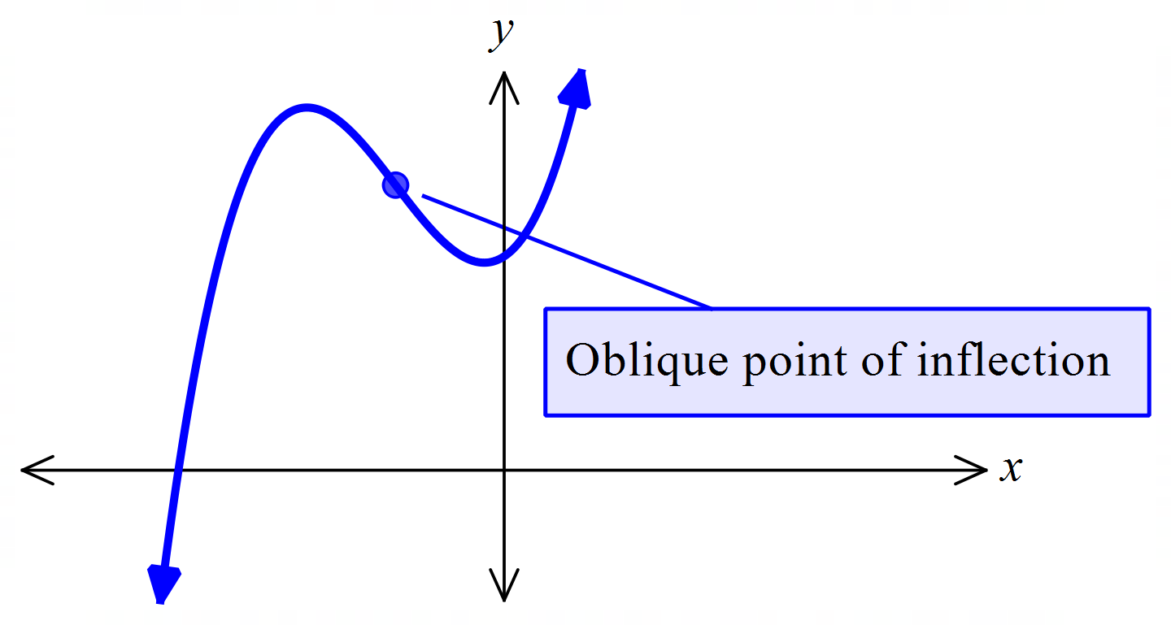For oblique inflection point at $x=a$:

$y'≠0, y^{''}=0. y''(a^{+})$ and $y^{''}\left(a^{-}\right)$ have opposite signs.

**Optimisation**

1. Draw a diagram if possible.
2. Define the variables
3. Define the function to be optimised
4. Use the relationship between the variables to express the function in terms of one variable
5. Determine stationary points
6. Determine nature of turning points
7. Check end points of the domain for global maximum or minimum
8. State conclusion in words.

**Examples**

**1.** A botanist has found that the rate of the loss of leaves from a particular rainforest tree is proportional to the number of leaves on the tree.If the initial number of leaves on the tree is $L_{0}$, then the number of these leaves that remain after time *t* years is $L\left(t\right)=L_{0}e^{-kt}$ where *k* is a positive constant.

**a)** The botanist wishes to study lichens that grow on the leaves of this tree. From past observations, he has found that of 100 leaves tagged, 80 remain after three years. Use this information to determine the value of the constant $k$ correct to 3 decimal places.

|  |
| --- |
| $80=100×e^{-3k}$ $e^{-3k}=\frac{4}{5}$ $k≈0.074$ |

**b)** Using your result from part **a)**, calculate the number of leaves that the botanist should initially tag if he needs to have 200 leaves to study in eight years’ time.

|  |
| --- |
| When $t=8$ the botanist requires 200 leaves so the initial number $L_{0}$ must satisfy $200=L_{0}e^{-8k}$   So $L_{0}=200e^{8×0.074}$ $=362.6$ The botanist should tag approximately 363 leaves |

**c)** Determine the rate of change of the amount of leaves in the year found in part **b)**. and interpret your result.

|  |
| --- |
| Rate of change is $\frac{dL}{dt}=k×L$ $=-0.074×362.6$ $-26.8$ In the 8th year the leaves are decreasing by 27 leaves/year. |

**d)** If initially leaves are tagged, calculate when only half of them will remain on the tree.   
 Give your answer correct to two significant figures.

|  |
| --- |
| $\frac{L_{0}}{2}=L_{0}e^{-kt}$ $\frac{1}{2}=e^{-0.074×t}$ $t=9.32$ 9.3 years will have elapsed |

**2.** Differentiate the following

|  |  |
| --- | --- |
| **a) $y=2e^{x}$** | **b)** |

|  |  |
| --- | --- |
|  |  |

**3.** Differentiate the following

|  |  |
| --- | --- |
| **a) $y=x^{2}-\sin{x}$** | **b) $y=3\cos{x}$** |
| $\frac{dy}{dx}=2x-\cos{x}$ | $\frac{dy}{dx}=-3\sin{x}$ |

**4.** The length of a spring $l$ cm at time $t$ seconds is given by $l=2\cos{t}+12$

**a)** Find when the string is first at the longest and shortest lengths given $t>0$ and state these lengths

|  |
| --- |
| Max and min occur when    ,            Minimum of 10 cm at $π$ seconds and a maximum of 14 cm at $2π$ seconds |

**b)** Determine the rate of change when .

|  |
| --- |
|  |

**5.** Consider the function $y=-\frac{1}{2}\sin{x}-1$ for the domain $-2π≤x≤2π$.

**a)** Using calculus techniques, determine the coordinates of all stationary points.

|  |
| --- |
| $\frac{dy}{dx}$ $=-\frac{1}{2}\cos{x}$ $0$ $=\frac{1}{2}\cos{x}$ for |

**b)** Sketch the function on the axis below, clearly showing all intercepts and stationary points.

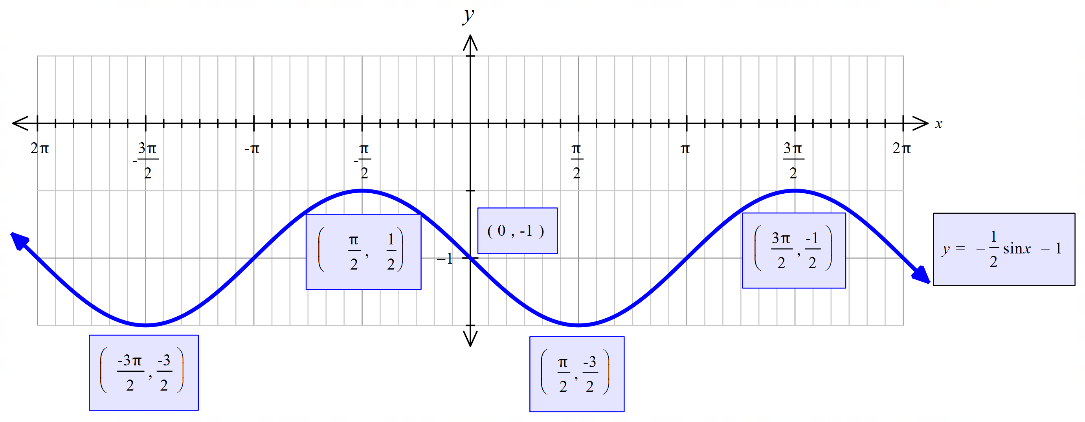

**c)** Determine the equation of the tangent when .

|  |
| --- |
|  |

**6.** Differentiate the following, simplifying your answers where possible

|  |  |
| --- | --- |
| **a) $y=4x^{2}(\sqrt{x}-2)$** | **b) $y={5e}^{x}\sin{x}$** |
| Use the product rule  If $y=f\left(x\right)×g\left(x\right)$ $\frac{dy}{dx}=f'\left(x\right)×g\left(x\right)+f\left(x\right)×g'\left(x\right)$ $f\left(x\right)=4x^{2}, f^{'}\left(x\right)$ $=8x$ $g\left(x\right)=x^{\frac{1}{2}}-2$ , ${ g}^{'}\left(x\right)$ $=\frac{1}{2\sqrt{x}}$ $\frac{dy}{dx}$ $=8x×\left(\sqrt{x}-2\right)+4x^{2}×\frac{1}{2\sqrt{x}}$ $=8x\left(\sqrt{x}-2\right)+2\sqrt{x^{3}}$ $=8x\sqrt{x}-16x+2\sqrt{x^{3}}$ | Use the product rule  If      , |

|  |  |
| --- | --- |
| **c) $y=\frac{2x^{3}-2x}{2x+1}$** | **d) $y=\tan{x}$** |
| Use the quotient rule  If $y=\frac{f\left(x\right)}{g\left(x\right)}$ $\frac{dy}{dx}=\frac{f'\left(x\right)×g\left(x\right)-f\left(x\right)×g'\left(x\right)}{{\left[g\left(x\right)\right]}^{2}}$ $f\left(x\right)$ $=2x^{3}-2x, f^{'}\left(x\right)$ $=6x^{2}-2$ $g\left(x\right)$ $=2x+1$, ${ g}^{'}\left(x\right)$ $=2$ $\frac{dy}{dx}$ $=\frac{(6x^{2}-2)×\left(2x+1\right)-(2x^{3}-2x)×2}{{\left(2x+1\right)}^{2}}$ $=\frac{12x^{3}+6x^{2}-4x-2-4x^{3}+4x}{{\left(2x+1\right)}^{2}}$ $=\frac{8x^{3}-6x^{2}-2}{{\left(2x+1\right)}^{2}}$ | Rewrite as $y=\frac{\sin{x}}{\cos{x}}$ Use the quotient rule  If      , |

|  |  |
| --- | --- |
| **e) $y=2{\left(x^{4}-2x\right)}^{5}$** | **f) $y=3e^{3x-1}$** |
| Use the chain rule  If $y$ $={\left[f\left(x\right)\right]}^{n}$ $\frac{dy}{dx}$ $=n{\left[f\left(x\right)\right]}^{n-1}×f'\left(x\right)$ $f\left(x\right)$ $=2(x^{4}-2x),$ $f^{'}\left(x\right)=4x^{3}-2$ $\frac{dy}{dx}$ $=n{\left[f\left(x\right)\right]}^{n-1}×f'\left(x\right)$ $=5×2{\left(x^{4}-2x\right)}^{4}×\left(4x^{3}-2\right)$ $=10(4x^{3}-2){\left(x^{4}-2x\right)}^{4}$ | Use the chain rule  If |

|  |
| --- |
| **g) $y=2\sin{(3x-1)}$** |
| Use the chain rule  If |

|  |
| --- |
| **h) $-2e^{2x}\cos{(x^{2}+π)}$** |
| Use the chain and product rule $f\left(x\right)$ $=-2e^{2x}, f^{'}\left(x\right)$ $=-4e^{2x}$ $g\left(x\right)$ $=\cos{(x^{2}+π)}$, $g^{'}\left(x\right)$ $=-2x\sin{(x^{2}+π)}$ $\frac{dy}{dx}$ $=(-4e^{2x})×\cos\left(x^{2}+π\right)+$ ( $-2e^{2x})×(-2x\sin\left(x^{2}+π\right))$ $=-4e^{2x}\cos\left(x^{2}+π\right)+4xe^{2x}\sin{(x^{2}+π)}$ |

**7. Find the approximate percentage change of the volume of a cylinder, of height 10cm, when the radius is increased by 2%.**

|  |
| --- |
| $V=πr^{2}h$ $\frac{δr}{r}=0.02$ $\frac{dV}{dr}=20πr$ $=10πr^{2}$ $\frac{δV}{V}≈\frac{ \frac{dV}{dr}×δr}{V}$ $=\frac{20πr× δr}{10πr^{2}}$ $=\frac{2×δr}{r}$ $=2×0.02$ $=0.04$ or $4\%$ |

**8.** A community orchestra intends to sell tickets to their Christmas concert at a price per ticket of $\$(15-0.1n)$  
 . if $n$ tickets are sold, the cost for running the concert is given by $C\left(n\right)=200+10n$.

**a)** Find an expression for the revenue from the concert.

|  |
| --- |
| Revenue $=$ number of tickets $×$ price per ticket $R\left(n\right)=n\left(15-0.1n\right)$ $R\left(n\right)=15n-0.1n^{2}$ |

**b)** Determine an expression for the total profit if $n$ tickets are sold.

|  |
| --- |
| Profit $=$ Revenue $-$ cost $P\left(n\right)=R\left(n\right)-C(n)$ $=15n-0.1n^{2}-(200+10n)$ $=5n-0.1n^{2}-200$ |

**c)** Find the average profit/loss per ticket if 80 tickets are sold.

|  |
| --- |
| Average $=\frac{P\left(80\right)}{80}$ $=\frac{5\left(80\right)-0.1{\left(80\right)}^{2}-200}{80}$ $=\frac{840}{80}$ $=-3$    Loss of $10.50 per ticket |

**d)** By how much will the total profit increase due to the sale of the 81st ticket?

|  |
| --- |
| $P'\left(n\right)=5-0.02n$ $P^{'}\left(80\right)=5-0.02(80)$ $=3.4$ Profit will increase by $\$3.40$ on the sale of the 81st ticket. |

**9. Given $g^{'}\left(x\right)=e^{2x}sin⁡(3x)$, determine a simplified value for the rate of change for $g'(x)$ when $x=\frac{π}{2}$**

|  |
| --- |
| $g"(x)={2e}^{2x}sin⁡(3x)$ $+ 3e^{2x}cos\left(3x\right)$ $g"\left(\frac{π}{2}\right)=2e^{π}sin\left(\frac{3π}{2}\right)+3e^{π}cos\left(\frac{3π}{2}\right)$ $=2e^{π}\left(-1\right)+3e^{π}(0)$ $=-2e^{π}$ |

**10.** Consider the function $f\left(x\right)=\frac{{\left(x-1\right)}^{2}}{e^{x}}$

**a)** Show that the first derivative is $f^{'}\left(x\right)=\frac{-x^{2}+4x-3}{e^{x}}$

|  |
| --- |
| $f^{'}\left(x\right)=\frac{e^{x}2\left(x-1\right)-{e^{x}(x-1)}^{2}}{e^{2x}}$ $=\frac{e^{x}\left(x-1\right)(2-x+1)}{e^{2x}}$ $=\frac{-x^{2}+4x-3}{e^{x}}$ |

**b)** Use your result from part **a)** to explain why there are stationary points at $x=1$ and $x=3$.

|  |
| --- |
| $f^{'}\left(x\right)=\frac{-\left(x-1\right)\left(x-3\right)}{e^{x}}$ $f^{'}\left(1\right)=f'(3)=0$ |

It can be shown that the second derivative is $f^{''}\left(x\right)=\frac{x^{2}-6x+7}{e^{x}}$.

**c)** Use the second derivative to describe the type of stationary points at $x=1$ and $x=3$. (3 marks)

|  |
| --- |
| $f^{''}\left(x\right)=\frac{x^{2}-6x+7}{e^{x}}$ $f"(1)=\frac{2}{e}$ $f"(3)=\frac{-2}{e^{3}}$ When $x=1, f"(x)>0$ hence local minimum  When $x=3, f"(x)<0$ hence local maximum |

**11.** Let A, B, C, D, E, F and G be points on the graph of a continuous function $f(x)$. The table below contains information about the sign of $f\left(x\right), f^{'}\left(x\right)$ and $f"(x)$ at these points.

|  |  |  |  |  |  |  |  |
| --- | --- | --- | --- | --- | --- | --- | --- |
| **Point** | **A** | **B** | **C** | **D** | **E** | **F** | **G** |
| $$x$$ | $$-4$$ | $$-3$$ | $$-1$$ | $$0$$ | $$1$$ | $$2$$ | $$4$$ |
| $$f(x)$$ | $$+$$ | $$0$$ | $$-$$ | $$0$$ | $$+$$ | $$+$$ | $$+$$ |
| $$f'(x)$$ | $$-$$ | $$-$$ | $$0$$ | $$+$$ | $$+$$ | $$0$$ | $$+$$ |
| $$f"(x)$$ | $$+$$ | $$+$$ | $$+$$ | $$0$$ | $$-$$ | $$0$$ | $$+$$ |

There are no other points at which $f\left(x\right), f^{'}\left(x\right)$ or $f"(x)$ are equal to zero.

**a)** which point is a local minimum?

|  |
| --- |
| C as the derivative is zero, gradient is decreasing on the left and increasing on the right and the second derivative is positive meaning it is concave up at that point. |

**b)** Describe the nature of the graph at point F.

|  |
| --- |
| **Horizontal point of inflection. Gradient is zero so it is a stationary point. The gradient to the left is increasing as is the gradient to the right. The second derivative is zero at the point but negative (concave down) on the left and positive (concave up) on the right.** |

**b) Sketch the function on the axes below**

|  |
| --- |
| **Local minimum at C and horizontal point of inflection at F. $x-$**  **intercepts at -3 and 0.**  **Point of inflection at $x=0$ $$f(x)$$** |

**12. A closed box is constructed with a square base, exactly 10 square metres of material is to be used in the construction of the box, without wastage.**

**Let $h=$ height of the box, $w=$ width of box $=$ length of box.**

**a) Show that $5=w^{2}+2wh$**

|  |
| --- |
| **Surface area = $2w^{2}+4wh=10$ $∴w^{2}+2wh=5$** |

**b) by using calculus, determine the maximum volume of the box and state the dimensions required to achieve this maximum.**

|  |
| --- |
| $V=hw^{2}$ $h=\frac{5-w^{2}}{2w}$**so**          **negative therefore maximum**      **×**      **Volume is a maximum 2.152 m3 when the height and width are 1.291 m.** |

**Exam practice questions**

**Question 1 Calculator assumed (11 marks)**

Atmospheric pressure decreases exponentially by 12% for every 1000 m risen above sea level. The pressure $P$ kPa at a height metres above sea level is given by for some constants and .

**a)** Given that the pressure at sea level is 101.325 kPa, determine:

* + 1. , and (1 mark)
    2. $k$ correct to 3 significant figures. (3 marks)

**b)** To the nearest metre, at what height is the pressure half that at sea level? (2 marks)

**c)** Determine the rate of change of pressure at the height found in part **b)** to 3 significant figures.  
 (2 marks)

**d)** Elite athletes typically train at high altitudes to improve performance. One training regime is to live at a height of 1800 m and train at a lower altitude of 1000m. To two decimal places, what is the ratio of the pressure at the higher altitude to that at the lower? (3 marks)

**Question 2** **Calculator assumed** **(7 marks)**

Einsteininium-252 is a radioactive substance that decays continuously such that $\frac{dA}{dt}=kA$, where $A$ is the mass in grams, is the time in days, is the initial amount and is a constant. The time taken for an amount to decay to half its original size is known as the half-life. The half-life of Einsteinium is 471.7 days.

**a)** Determine the value of $k$ to 3 significant figures**.** (3 marks)

**b)** How many days will it take for 2 grams of the substance to decay to 1.5 grams? (2 marks)

**c)** Determine the rate of change of the amount of Einsteinium on the day found in part **b)** (2 marks)

**Question 3 Calculator free** **(2 marks)**

Differentiate the following with respect to $x$ simplifying your answers as far as possible.

**a) $6x^{2}-{5e}^{x}$**  (1 mark)

**b) ${3e}^{x}+e$**  (1 mark)

**Question 4 Calculator free (6 marks)**

Differentiate the following

* 1. (2 marks)
  2. $2\sin{x}+4\cos{x}$ (2 marks)
  3. $3\sin{x}-π^{2}$ (2 mark)

**Question 5 Calculator free (6 marks)**

A particle moves in such a way that its displacement $x$ cm from an origin $O$ in $t$ seconds is

* 1. Determine the velocity of the particle after $\frac{π}{4}$ seconds (2 marks)
  2. When during the first $2π$ seconds is the particle stationary. (2 marks)
  3. The distance the particle travels in the first 5 seconds. (2 marks)

#### **Question 6 Calculator free (6 marks)**

Differentiate the following, simplifying your answers.

* 1. (3 marks)
  2. $y=e^{\sqrt{x}}$ (2 marks)
  3. $y=\cos{e^{1-x^{2}}}$ (3 marks)
  4. $y=\sin{(3\cos{2x)}}$ (3 marks)

### 

**Question 7 Calculator assumed (8 marks)**

**A balloon has a volume $V=\frac{4πr^{3}}{3}$, where its radius is $r$.**

**a) Determine an expression for $\frac{dV}{dr}$. (1 mark)**

**b) The balloon is being inflated at a rate of 100 cm3 per second. At what rate is the balloon’s radius increasing at the time when the radius is 5 cm? (3 marks)**

**c) Find the approximate percentage increase in the balloon’s volume when its radius increases by 1%. (Use $δV≈\frac{dV}{dr}×δr$) (4 marks)**

**Question 8 Calculator assumed (4 marks)**

A company produces $n$ items of a certain product. The cost function is given by

$C\left(n\right)=1100+2\sqrt[3]{n}$.

Each item sells for $42.

Find:

**a)** An expression for the marginal profit $P'(n)$. (2 marks)

**b)** a value for $P'(60)$ and explain what this means. (2 marks)

**Question 9 Calculator free (10 marks)**

**Let $f\left(x\right)=(x-1)(x^{2}-16)$.**

**a) Show that $f^{'}\left(x\right)=(3x-8)(x+2)$ (3 marks)**

**b) Determine the equation of the tangent to the graph of $f(x)$ at the point where $x=3$. (3 marks)**

**c) What is the maximum value of the function over the domain $-4≤x≤4$? (4 marks)**

**Question 10 Calculator free (6 marks)**

**A cubic function $f\left(x\right)=ax^{3}+bx^{2}+cx+d$ has these features:**

* $f^{'}\left(x\right)≥0$**only for $-2≤x≤6$**
* $f"(x)≥0$**only for $x≤2$**
* **There are exactly two points at which the graph of $f(x)$ meets the $x-$ axis**

$d<0$

**a) (i) State the $x-$ coordinate of the point of inflection. (1 mark)**

**(ii) Is the graph of $f(x)$ horizontal at the point of inflection. Explain your answer. (1 mark)**

**b) Is $a$ positive or negative? Explain your answer. (2 marks)**

**c) Determine the coordinates of the local maximum. (2 marks)**

**Question 11 Calculator free (7 marks)**

**A farmer has $1500 available to build an E-shaped fence along a straight river so as to create two identical rectangular pastures.**

**The material for the side parallel to the river costs $6 per metre and the materials for the three sides perpendicular to the river cost $5 per metre.**

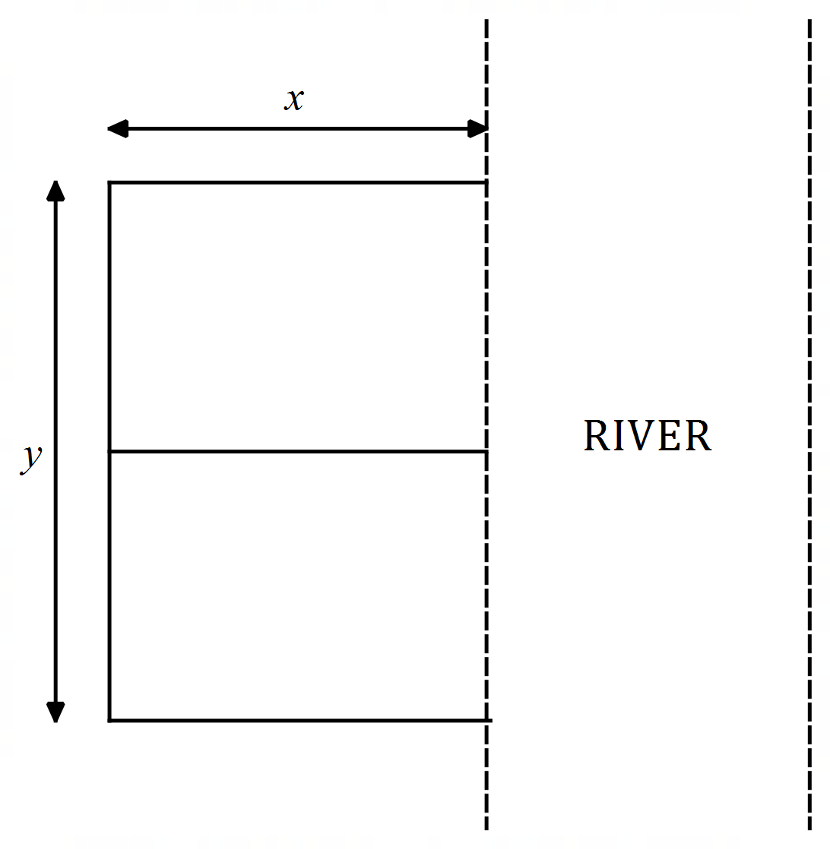

**Each of the sides perpendicular to the river is $x$ metres long, and the side parallel to is $y$ metres long.**

**a) Assuming that the farmer spends the entire $1500, show that the total area $A(x)$ of the two pastures, in square metres, is $A\left(x\right)=\frac{5}{2}(100x-x^{2})$ (3 marks)**

**b) Use calculus methods to determine the dimensions of the fence which maximises the total area and state this area. (4 marks)**

Solutions

**Question 1 (11 marks)**

Atmospheric pressure decreases exponentially by 12% for every 1000 m risen above sea level. The pressure $P$ kPa at a height metres above sea level is given by $P\left(h\right)=P_{0}e^{kh}$ for some constants $k$ and $P_{0}$.

**a)** Given that the pressure at sea level is 101.325 kPa, determine:

**(i) $P_{0}$** , and (1 mark)

|  |  |  |
| --- | --- | --- |
| **Solution** | **Specific behaviours** | **Point** |
| $P_{0}=101.325$ | * states *P*0 correctly | 3.1.4 |

**(ii) $k$**  correct to 3 significant figures. (3 marks)

|  |  |  |
| --- | --- | --- |
| **Solution** | **Specific behaviours** | **Point** |
| When $h=1000$  and $P_{1}=0.88P_{0}$  so $0.88=e^{1000k}$ $k=-0.00012783$  or $k=-0.000128$ (3 s.f.) | * substitutes correctly into formula to derive an equation for $k$* calculates $k$ correctly * gives answer correct to three significant figures | 3.1.4 |

**b)** To the nearest metre, at what height is the pressure half that at sea level? (2 marks)

|  |  |  |
| --- | --- | --- |
| **Solution** | **Specific behaviours** | **Point** |
| If at height $h$ the pressure is half that of sea level, then $0.5P_{0}=P_{0}e^{kh} .$ $h=5422.227$    5422 metres | * sets up an appropriate equation for the required height * solves and rounds correctly | 3.1.4 |

**c)** Determine the rate of change of pressure at the height found in part **b)** to 3 significant figures.  
 (2 marks)

|  |  |  |
| --- | --- | --- |
| **Solution** | **Specific behaviours** | **Point** |
| $\frac{dP}{dh}=k×P$ $=-0.000128×0.5×101.325$ $=-0.00648$ kPa/m | * sets up an equation with the correct ratio * solves equation correctly with correct unit | 3.1.4 |

**d)** Elite athletes typically train at high altitudes to improve performance. One training regime is to live at a height of 1800 m and train at a lower altitude of 1000m. To two decimal places, what is the ratio of the pressure at the higher altitude to that at the lower? (3 marks)

|  |  |  |
| --- | --- | --- |
| **Solution** | **Specific behaviours** | **Point** |
| $\frac{P\left(1800\right)}{P\left(1000\right)}=\frac{P_{0}×e^{1800k}}{P_{0}×e^{1000k}}$ $=e^{-0.000128×800}$ $=0.9027$ 0.90 (2 d.p.) | * sets up an equation with the correct ratio * solves equation correctly * rounds appropriately | 3.1.4 |

**Question 2 (7 marks)**

Einsteininium-252 is a radioactive substance that decays continuously such that $\frac{dA}{dt}=kA$, where $A$ is the mass in grams, is the time in days, is the initial amount and is a constant. The time taken for an amount to decay to half its original size is known as the half-life. The half-life of Einsteinium is 471.7 days.

|  |  |  |
| --- | --- | --- |
| **Solution** | **Specific behaviours** | **Point** |
| $A=A_{0}e^{kt}$ $\frac{1}{2}=e^{471.7k}$ $k=-0.00147$ | * Sets up equation * Solves equation correctly * Rounds appropriately | 3.1.4 |

**a)** Determine the value of $k$ to 3 significant figures. (3 marks)

**b)** How many days will it take for 2 grams of the substance to decay to 1.5 grams? (2 marks)

|  |  |  |
| --- | --- | --- |
| **Solution** | **Specific behaviours** | **Point** |
| $1.5=2e^{-0.00147t}$ $k=195.77$ 196 days | * Sets up equation * Solves equation correctly and rounds to days | 3.1.4 |

**c)** Determine the rate of change of the amount of Einsteinium on the day found in part b) (2 marks)

|  |  |  |
| --- | --- | --- |
| **Solution** | **Specific behaviours** | **Point** |
| $\frac{dA}{dt}=kA$ $=-0.00147×1.5$ $=-0.0022$ g/day | * Sets up equation * Solves equation correctly with correct units | 3.1.4 |

**Question 3**  **(2 marks)**

Differentiate the following with respect to $x$ simplifying your answers as far as possible.

**a) $6x^{2}-{5e}^{x}$**  (1 mark)

|  |  |  |
| --- | --- | --- |
| **Solution** | **Specific behaviours** | **Point** |
| $\frac{d}{dx}=12x-5e^{x}$ | * Determines the correct epression for the derivative | 3.1.3 |

**b) ${3e}^{x}+e$**  (1 mark)

|  |  |  |
| --- | --- | --- |
| **Solution** | **Specific behaviours** | **Point** |
| $\frac{d}{dx}=3e^{x}$ | * Determines the correct expression for the derivative | 3.1.3 |

**Question 4 (6 marks)**

Differentiate the following

**a) $x^{3}-3cos{x}$**  (2 marks)

|  |  |  |
| --- | --- | --- |
| **Solution** | **Specific behaviours** | **Point** |
| $\frac{d}{dx}=3x^{2}+3\sin{x}$ | * Differentiates first term correctly * Differentiates seconds term correctly | 3.1.5 |

**b) $2\sin{x}+4\cos{x}$**  (2 marks)

|  |  |  |
| --- | --- | --- |
| **Solution** | **Specific behaviours** | **Point** |
| $\frac{d}{dx}=2\cos{x}-4\sin{x}$ | * Differentiates first term correctly * Differentiates seconds term correctly | 3.1.5 |

**c) $3\sin{x}-π^{2}$**  (2 mark)

|  |  |  |
| --- | --- | --- |
| **Solution** | **Specific behaviours** | **Point** |
| $\frac{d}{dx}=3\cos{x}$ | * Differentiates first term correctly * Differentiates seconds term correctly | 3.1.5 |

#### **Question 5 (6 marks)**

A particle moves in such a way that its displacement $x$ cm from an origin $O$ in $t$ seconds is

* 1. Determine the velocity of the particle after $\frac{π}{4}$ seconds (2 marks)

|  |  |  |
| --- | --- | --- |
| **Solution** | **Specific behaviours** | **Point** |
| cm/s | * Differentiates to find velocity function * Solves for correct | 3.1.6 |

|  |  |  |
| --- | --- | --- |
| **Solution** | **Specific behaviours** | **Point** |
| Stationary when $v=0$ $0$ $=5\sin{xt}$ $t$ $=0, π, 2π$ | * Identifies particle stationary when $v=0$* Finds all solutions for | 3.1.6 |

* 1. When during the first $2π$ seconds is the particle stationary. (2 marks)
  2. The distance the particle travels in the first 5 seconds. (2 marks)

|  |  |  |
| --- | --- | --- |
| **Solution** | **Specific behaviours** | **Point** |
| Total distance covered is 20 cm | * Calculates diplacement at $t=0, π$ and $2π$* Calculates distance correctly | 3.1.6 |

#### **Question 6 (6 marks)**

Differentiate the following simplifying your answers.

* 1. (3 marks)

|  |  |  |
| --- | --- | --- |
| **Solution** | **Specific behaviours** | **Point** |
|  | ✓✓Applies quotient rule correctly   * Simplifies the final form | 3.1.7 |

* 1. (2 marks)

|  |  |  |
| --- | --- | --- |
| **Solution** | **Specific behaviours** | **Point** |
|  | * Applies chain rule correctly | 3.1.7 |

* 1. (3 marks)

|  |  |  |
| --- | --- | --- |
| **Solution** | **Specific behaviours** | **Point** |
| $\frac{dy}{dx}=-\sin\left(e^{1-x^{2}}\right)×\left(-2x\right)\left(e^{1-x^{2}}\right)$ $=2x\left(e^{1-x^{2}}\right)\sin\left(e^{1-x^{2}}\right)$ | * Applies chain rule correctly * Simplifies the final form | 3.1.7 |

* 1. (3 marks)

|  |  |  |
| --- | --- | --- |
| **Solution** | **Specific behaviours** | **Point** |
| $\frac{dy}{dx}=\cos\left(3\cos{2x}\right)×(-3×2)(\sin{2x)}$ $=-6\sin\left(2x\right)cos⁡[3\cos\left(2x\right)]$ | * Differentiates $\cos\left(3\cos{2x}\right)$ correctly * Differentiates $-3×2(\sin{2x)}$ correctly * simplifies | 3.1.7 |

**Question 7 (8 marks)**

**A balloon has a volume $V=\frac{4πr^{3}}{3}$, where its radius is $r$.**

**a) Determine and expression for $\frac{dV}{dr}$. (1 mark)**

|  |  |  |
| --- | --- | --- |
| **Solution** | **Specific behaviours** | **Point** |
| $\frac{dV}{dr}=4πr^{2}$ | * differentiates correctly | 3.1.10 |

**b) The balloon is being inflated at a rate of 100 cm3 per second. At what rate is the balloon’s radius increasing at the time when the radius is 5 cm? (3 marks)**

|  |  |  |
| --- | --- | --- |
| **Solution** | **Specific behaviours** | **Point** |
| $\frac{dV}{dr}=\frac{dV}{dt}×\frac{dt}{dr}$ $100=4π{(5)}^{2}×\frac{dr}{dt}$ $\frac{dr}{dt}=\frac{1}{π}=0.32$ cm/s | * uses chain rule * substitues in correct value * solves to find correct rate with appropriate units | 3.1.10 |

**c) Find the approximate percentage increase in the balloon’s volume when its radius increases by 1%. (Use $δV≈\frac{dV}{dr}×δr$). (3 marks)**

|  |  |  |
| --- | --- | --- |
| **Solution** | **Specific behaviours** | **Point** |
| $\frac{δV}{V}≈\frac{\frac{dV}{dr}×δr}{V}$ $=\frac{4πr^{2}×δr}{\frac{4πr^{3}}{3}}$ $=\frac{3δr}{r}$ $=3×0.01$ Volume increases by 3% | * Represnts proportional change in volume as $\frac{δV}{V}$* **Substitues $\frac{4πr^{3}}{3}$ for $V$** * Represents $\frac{δr}{r}$ as 0.01 * Manipulates formula to find 3% increase | 3.1.10 |

**Question 8 (4 marks)**

A company produces $n$ items of a certain product. The cost function is given by

$C\left(n\right)=1100+2\sqrt[3]{n}$.

Each item sells for $42.

Find:

**a)** An expression for the marginal profit $P'(n)$. (2 marks)

|  |  |  |
| --- | --- | --- |
| **Solution** | **Specific behaviours** | **Point** |
| $R\left(n\right)=42n$ $P\left(n\right)=R\left(n\right)-C(n)$ $=42n-\left(1100+2\sqrt[3]{n}\right)$ $=42n-1100-2\sqrt[3]{n}$ $P^{'}\left(n\right)=42-\frac{2}{3\sqrt[3]{n^{2}}}$ | * Finds profit function * Differentiates correctly | 3.1.10 |

**b)** a value for $P^{'}\left(60\right)$ and explain what this means. (2 marks)

|  |  |  |
| --- | --- | --- |
| **Solution** | **Specific behaviours** | **Point** |
| $P^{'}\left(60\right)=42-\frac{2}{3\sqrt[3]{{60}^{2}}}$ $=41.9565$ Profit of the 61st unit is $41.96 | * Finds $P^{'}\left(60\right)$* States meaning including profit and ite number | 3.1.10 |

**Question 9 Solution (10 marks)**

**Let $f\left(x\right)=(x-1)(x^{2}-16)$.**

**a) Show that $f^{'}\left(x\right)=(3x-8)(x+2)$ (3 marks)**

|  |  |  |
| --- | --- | --- |
| **Solution** | **Specific behaviours** | **Point** |
| $f^{'}\left(x\right)=1\left(x^{2}-16\right)+(x-1)(2x)$ $=x^{2}-16+2x^{2}-2x$ $=3x^{2}-2x-16$ $=3x^{2}-8x+6x-16$ $=x\left(3x-8\right)+2(3x-8)$ $=(3x-8)(x+2)$ | * Differentiates $f\left(x\right)$ correctly * Simplifies correctly * Factorises | 3.1.7 |

**b) Determine the equation of the tangent to the graph of $f(x)$ at the point where $x=3$. (3 marks)**

|  |  |  |
| --- | --- | --- |
| **Solution** | **Specific behaviours** | **Point** |
| $f^{'}\left(3\right)=[3(3)-8](3+2)$ $=5$ Tangent has equation $y=5x+c$ $f\left(3\right)=\left(3-1\right)(3^{2}-16)$ $=-14$ $-14=5(3)+c$ $c=-29$ $∴y=5x-29$ | * Correctly evaluates $f(3)$* Correclty evaluates $f'(3)$* Correctly determines the equation of the tangent | 3.1.7 |

**c) What is the maximum value of the function over the domain $-4≤x≤4$? (4 marks)**

|  |  |  |
| --- | --- | --- |
| **Solution** | **Specific behaviours** | **Point** |
| Stationary points where $\left(3x-8\right)\left(x+2\right)=0$ $x=\frac{8}{3}$ or $-2$ $f"(x)=6x-2$ $f"\left(\frac{8}{3}\right)=14$ $f"(-2)=-14$ $∴$ local max at -2 $f\left(-2\right)=36$   Check end points of domain for global max $f\left(-4\right)=0$ and $f\left(4\right)=0$ $∴$ max value over the domain is 36 | * Finds $x-$ values of stationary points * Finds second derivate to determine maximum * Correctly evaluates $f\left(-2\right)$ and $f\left(-4\right)$* Correctly states maximum value | 3.1.14 |

**Question 10 Solution (6 marks)**

**A cubic function $f\left(x\right)=ax^{3}+bx^{2}+cx+d$ has these features:**

* $f^{'}\left(x\right)≥0$**only for $-2≤x≤6$**
* $f"(x)≥0$**only for $x≤2$**
* **There are exactly two points at which the graph of $f(x)$ meets the $x-$ axis**

$d<0$

**a) (i) State the $x-$ coordinate of the point of inflection. (1 mark)**

|  |  |  |
| --- | --- | --- |
| **Solution** | **Specific behaviours** | **Point** |
| $x=2$ | * States correct answer | 3.1. |

**(ii) Is the graph of $f(x)$ horizontal at the point of inflection. Explain your answer. (1 mark)**

|  |  |  |
| --- | --- | --- |
| **Solution** | **Specific behaviours** | **Point** |
| No as stationary points of the cubic must be at $x=-2$ and $x=6$ so $f(2)≠0$ | * States that the point of inflection is not horzintal with the correct explanation | 3.1. |

**b) Is $a$ positive or negative? Explain your answer. (2 marks)**

|  |  |  |
| --- | --- | --- |
| **Solution** | **Specific behaviours** | **Point** |
| As $x→±∞, f(x)$ is negative. This is a characteristic of a cubic with $a<0$ | * State that $a$ is negative * Explains correctly from given information. | 3.1. |

**c) Determine the coordinates of the local maximum. (2 marks)**

|  |  |  |
| --- | --- | --- |
| **Solution** | **Specific behaviours** | **Point** |
| Local maximum at $(6, 0)$ | * States $x-$ coordinate * States $y-$ coordinate | 3.1. |

**Question 11 Solution (7 marks)**

**A farmer has $1500 available to build an E-shaped fence along a straight river so as to create two identical rectangular pastures.**

**The material for the side parallel to the river costs $6 per metre and the materials for the three sides perpendicular to the river cost $5 per metre.**



**Each of the sides perpendicular to the river is $x$ metres long, and the side parallel to is $y$ metres long.**

**a) Assuming that he farmer spends the entire $1500, show that the total area $A(x)$ of the two pastures, in square metres, is $A\left(x\right)=\frac{5}{2}(100x-x^{2})$ (3 marks)**

|  |  |  |
| --- | --- | --- |
| **Solution** | **Specific behaviours** | **Point** |
| Total cost = Cost of the side parallel  + Cost of sides perpendicular $1500=6×y+5×3x$ $1500=6y+15x$ $y=\frac{1500-15x}{6}$ $=\frac{5}{2}(100-x)$      Area $=x×y$ $=x×\frac{5}{2}(100-x)$ $=\frac{5}{2}(100x-x^{2})$ | * Determines equation representing cost * Rearranges to make $y$ the subject * Substitues into the equaton for area. | 3.1.16 |

**b) Use calculus methods to determine the dimensions of the fence which maximises the total area and state this area. (4 marks)**

|  |  |  |
| --- | --- | --- |
| **Solution** | **Specific behaviours** | **Point** |
| $\frac{dA}{dx}=\frac{5}{2}\left(100-2x\right)=0$ $x=50$ $y=\frac{5}{2}(100-50)$ $=125$ $A=50×125$ $=6250$ ∴ the fence will be 50 m wide and 125 m long with an area of 6250 m2 | * Differentiates correctly * Solves for $x$* Substitues to find $y$* Determines the maximum area and states dimension and area | 3.1.16 |

2. Integration

Topic 3.2: Integrals

**Anti-differentiation**

3.2.1 identify anti-differentiation as the reverse of differentiation

3.2.2 use the notation $\int{f\left(x\right)dx}$ for anti-derivatives or indefinite integrals

3.2.3 establish and use the formula $\int{x^{n}dx=\frac{1}{n+1}x^{n+1}+c}$ for $n≠-1$

3.2.4 establish and use the formula $\int{e^{x}dx=e^{x}+c}$

3.2.5 establish and use the formulas $\int{\sin{x}}dx=-cos{x}+c$ and $\int{\cos{x}}dx=\sin{x}+c$

3.2.6 identify and use linearity of anti-differentiation

3.2.7 determine indefinite integrals of the form $\int{f\left(ax-b\right)dx}$

3.2.8 identify families of curves with the same derivative function

3.2.9 determine $f\left(x\right),$ given $f'\left(x\right)$ and an initial condition $f\left(a\right)=b$

**Definite integrals**

3.2.10 examine the area problem and use sums of the form $\sum_{i}{f\left(x_{i}\right) δx_{i}}$ to estimate the area under the curve $y=f(x)$

3.2.11 identify the definite integral $\int_{a}^{b}{f\left(x\right)dx }$ as a limit of sums of the form $\sum_{i}{f\left(x_{i}\right) δx_{i}}$

3.2.12 interpret the definite integral $\int_{a}^{b}{f\left(x\right)dx }$ as area under the curve $y=f\left(x\right)$ if $f\left(x\right)>0$

3.2.13 interpret $\int_{a}^{b}{f\left(x\right)dx }$ as a sum of signed areas

3.2.14 apply the additivity and linearity of definite integrals

**Fundamental theorem**

3.2.15 examine the concept of the signed area function $F\left(x\right)=\int_{a}^{x}{f\left(t\right)dt}$

3.2.16 apply the theorem: $F^{'}\left(x\right)=\frac{d}{dx}\left(\int_{a}^{x}{f\left(t\right)dt}\right)=f\left(x\right)$, and illustrate its proof geometrically

3.2.17 develop the formula $\int_{a}^{b}{f'\left(x\right)dx=f\left(b\right)-f(a)}$ and use it to calculate definite integrals

**Applications of integration**

* + 1. calculate total change by integrating instantaneous or marginal rate of change
    2. calculate the area under a curve

3.2.20 calculate the area between curves

3.2.21 determine displacement given velocity in linear motion problems

3.2.22 determine positions given linear acceleration and initial values of position and velocity.

Anti-differentiation, indefinite integrals

Anti-differentiation is the opposite of differentiation. It is commonly called integration.

Integrating is the process of finding the primitive or antiderivative of a function.

$\frac{d}{dx}\left(x^{4}\right)=4x^{3}$

$\frac{d}{dx}\left(x^{4}-2\right)=4x^{3}$

$\frac{d}{dx}\left(x^{4}+7\right)=4x^{3}$ ∴ the antiderivative of $4x^{3}$ is $x^{4}+c$.

Integration uses the symbol

∴ $\int{4x^{3}dx=x^{4}+c}$

## Techniques

|  |  |
| --- | --- |
| $\int{x^{n}dx}$ | $\frac{x^{n+1}}{n+1}+c$ where $n≠-1$ |
| $\int{{\left(ax+b\right)}^{n}dx}$ | $\frac{{\left(ax+b\right)}^{n+1}}{n+1}+c$ where $n≠-1$ |
| $\int{f^{'}\left(x\right)×{\left[f\left(x\right)\right]}^{n}dx}$ | $\frac{\left[f{\left(x\right)}^{n+1}\right]}{n+1}+c$ where $n≠-1$ |
| $\int{e^{mx}dx}$ | $\frac{e^{mx}}{m}+c$ |
| $\int{f^{'}\left(x\right)e^{f\left(x\right)}dx }$ | $e^{f\left(x\right)}+c$ |
| $\int{cos⁡(ax+b)}dx$ | $\frac{sin⁡(ax+b)}{a}+c$ |
| $\int{sin⁡(ax+b)}dx$ | $-\frac{\cos\left(ax+b\right)}{a}+c$ |

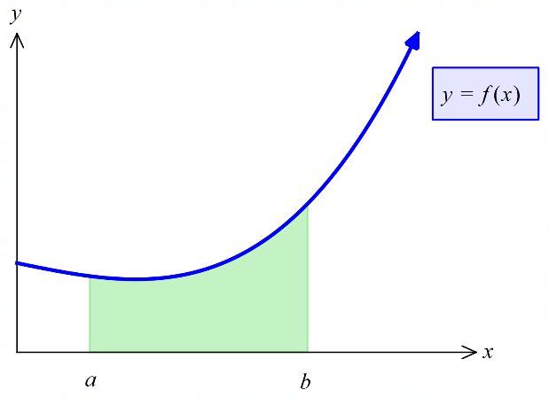Definite Integrals

$\int_{a}^{b}{f(x)}dx$ denotes the area under the curve $f(x)$ from $x=a$ to $x=b$ where $f(x)$ is a non-negative function, where $a≤x≤b$

$\int_{a}^{b}{f(x)}dx$ is where $f(x)$ is integrated with upper limit $b$ and lower limit $a$ with respect to $x$

$\int_{a}^{b}{f'(x)}dx=f\left(b\right)-f(a)$ or $\int_{a}^{b}{f(x)}dx=F(b)-F(a)$

Definite integrals require no units, but the area should include units.

Linearity property of anti-differentiation

|  |  |
| --- | --- |
| $\int_{a}^{b}{f\left(x\right)dx}$ | $-\int_{b}^{a}{f\left(x\right)dx}$ |
| $\int_{a}^{b}{kf\left(x\right)dt}$ | $k\int_{a}^{b}{f\left(x\right)dt}$ |
| $\int_{a}^{b}{\left[f\left(x\right)+g\left(x\right)\right]dx}$ | $\int_{a}^{b}{f(x)dx}+\int_{a}^{b}{g(x)dx}$ |
| $\int_{a}^{b}{f(x)dx}+\int_{b}^{c}{f(x)dx}$ | $\int_{a}^{c}{f(x)dx}$ |

Fundamental theorem of calculus

|  |  |
| --- | --- |
| $\int_{a}^{b}{f'\left(x\right)dx}$ | $f\left(b\right)-f(a)$ |
| $\frac{d}{dx}\int_{a}^{x}{f\left(t\right)dt}$ | $f(x)$ |

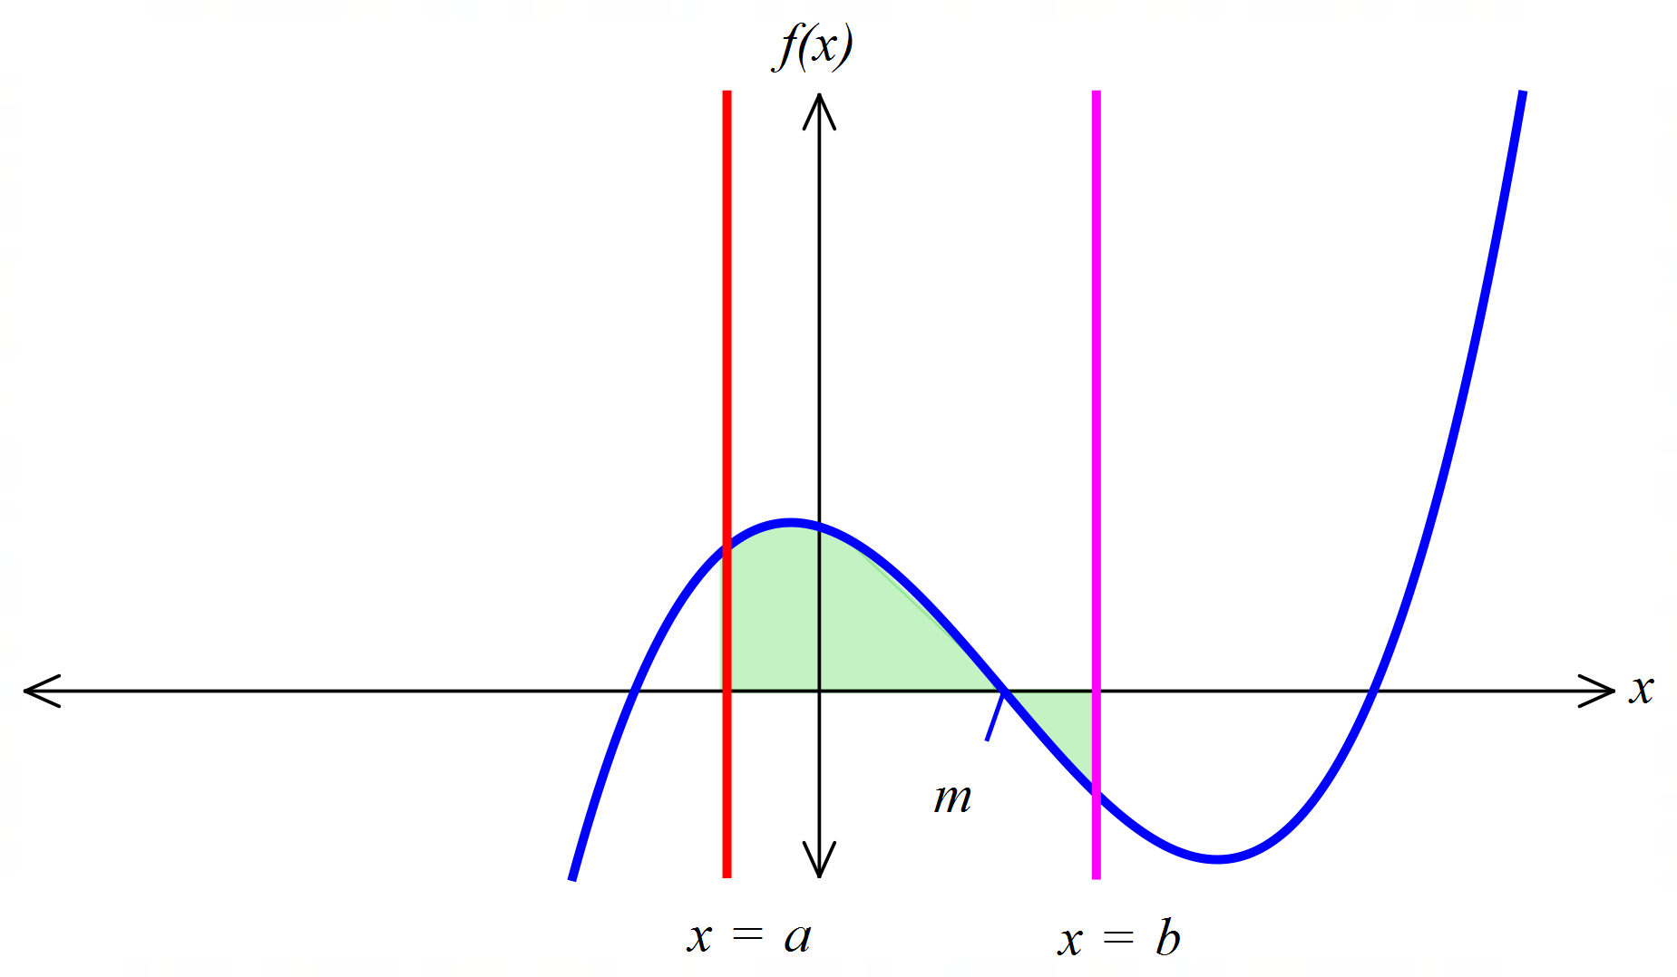

Area under the curve

Area of the region trapped between $y=f(x)$, the $x$-axis and the lines $x=a$ and $x=b$ is:

$A=\int_{a}^{b}{\left|f(x)\right|dx}=\left|\int_{a}^{m}{f\left(x\right)dx}\right|+\left|\int_{m}^{b}{f\left(x\right)dx}\right|$

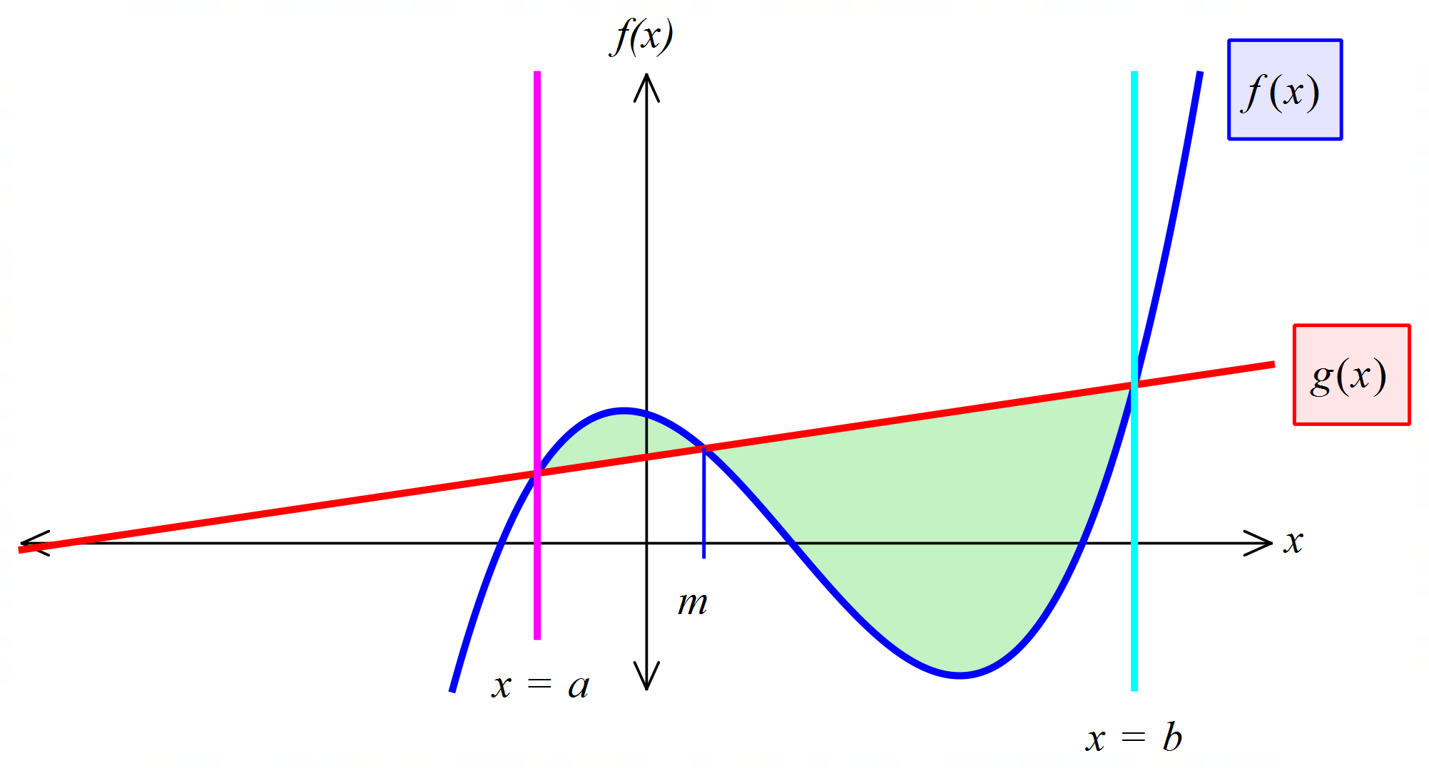Area of the region trapped between $y=f(x)$ and $y=g(x)$ is:

$A=\int_{a}^{b}{\left|f\left(x\right)-g\left(x\right)\right|dx }$

$=\left|\int_{a}^{m}{f\left(x\right)-g(x)dx}\right|+\left|\int_{m}^{b}{g\left(x\right)-f\left(x\right)dx}\right|$

Total change from the rate of change

Net change in $Q$ for $a≤t≤b$ is $\int_{a}^{b}{\frac{dQ}{dt}}dt$

Rectilinear motion

Displacement at time $t, x=\int{v}dt$

Velocity $v=\frac{dx}{dt}=\int{a}dt$

Acceleration $a=\frac{dv}{dt}=\frac{d^{2}x}{dt^{2}}$

Body returns to the origin when $x=0$

Body changes direction when $v=0$

Change in displacement for $a≤t≤b=∆x=\int_{a}^{b}{v}dt$

Distance travelled for $a≤t≤b=\int_{a}^{b}{|v|}da$

**Examples**

**13.** Evaluate the following indefinite integrals, giving answer with positive indices.

|  |  |
| --- | --- |
| **a) $\int{\left(x^{2}-7x+5\right) dx}$** | **b) $\int{\frac{3}{x^{5}} dx}$** |
| $=\frac{x^{3}}{3}-\frac{7x^{2}}{2}+5x+c$ | $=\int{3x^{-5} dx}$ $=\frac{3x^{-4}}{-4}+c$ $=-\frac{3}{4x^{4}}+c$ |
| **c) $\int{-2\sqrt{x} dx}$** | **d) $\int{\frac{x^{2}-x}{x^{4}} dx}$** |
| $=\int{-2x^{\frac{1}{2}} dx }$ $=-\frac{2x^{\frac{3}{2}}}{\frac{3}{2}}+c$ $=-\frac{4\sqrt{x^{3}}}{3}+c$ | $=\int{\left(\frac{x^{2}}{x^{4}}-\frac{x}{x^{4}}\right)} dx$ $=\int{\left(\frac{1}{x^{2}}-\frac{1}{x^{3}}\right)}dx$ $=\int{(x^{-2}-x^{-3})} dx$ $=\frac{x^{-1}}{-1}-\frac{x^{-2}}{-2}+c$ $=\frac{1}{2x^{2}}-\frac{1}{x}+c$ |
| **e) $\int{2{x\left(x^{2}-5\right)}^{3} dx}$** | **f)** |
|  |  |

|  |  |
| --- | --- |
| **g) $\int{5\cos\left(\frac{2x}{π}\right)dx }$** | **h) $\int{\sin{(3x+5)}dx}$** |
| $=5\sin{\frac{\left(\frac{2x}{π}\right)}{\frac{2}{π}}}+c$ $=\frac{5π\sin\left(\frac{2x}{π}\right)}{2}+c$ | $=-\frac{\cos\left(3x+5\right)}{3}+c$ |

**14.** Part of the graph of $y=f\left(x\right)$ is shown below. The areas of the bounded regions $A$ and $B$ are 7 and 4 square units respectively.



**a)** Evaluate $\int_{0}^{1}{f(-x)}dx$

|  |
| --- |
| The solution of $y=f(-x)$ is a reflection of the graph about the $y-$ axis.  The required integral is the signed area $–A$ i.e. -7 |

**b)** Evaluate $\int_{-1}^{1}{[2-f\left(x\right)]}dx$

|  |
| --- |
| $\int_{-1}^{1}{[2-f\left(x\right)]}dx=\int_{-1}^{1}{2}dx-\int_{-1}^{1}{f\left(x\right)}dx$ $={[2x]}_{-1}^{1}-(-7+4)$ $=2\left(1\right)-2\left(-1\right)+3$ $=7$ |

**15.**

**a)** Determine $\frac{d}{dx}\left(2xe^{2x}\right)$.

|  |
| --- |
| $\frac{d}{dx}\left(2xe^{2x}\right)=2x\left(2e^{2x}\right)+e^{2x}(2)$ $$=4xe^{2x}+2e^{2x}$$ $=2e^{2x}\left(2x+1\right)$ |

**b)** Use your answer in part (a) to determine $\int{4xe^{2x}+2e^{2x}}dx$.

|  |
| --- |
| $\frac{d}{dx}\left(2xe^{2x}\right)=2x\left(2e^{2x}\right)+e^{2x}(2)$ $=4xe^{2x}+2e^{2x}$ $\int{\frac{d}{dx}\left(2xe^{2x}\right)dx=}\int{4xe^{2x} dx}+\int{2 e^{2x}}dx$ $2xe^{2x}=\int{4xe^{2x} dx}+e^{2x}$ $\int{4xe^{2x} dx}=2xe^{2x}-e^{2x}dx$ $=\left(2x-1\right)e^{2x}+c$ |

**16.** The graph of $y=e^{x-1}$ is shown below.

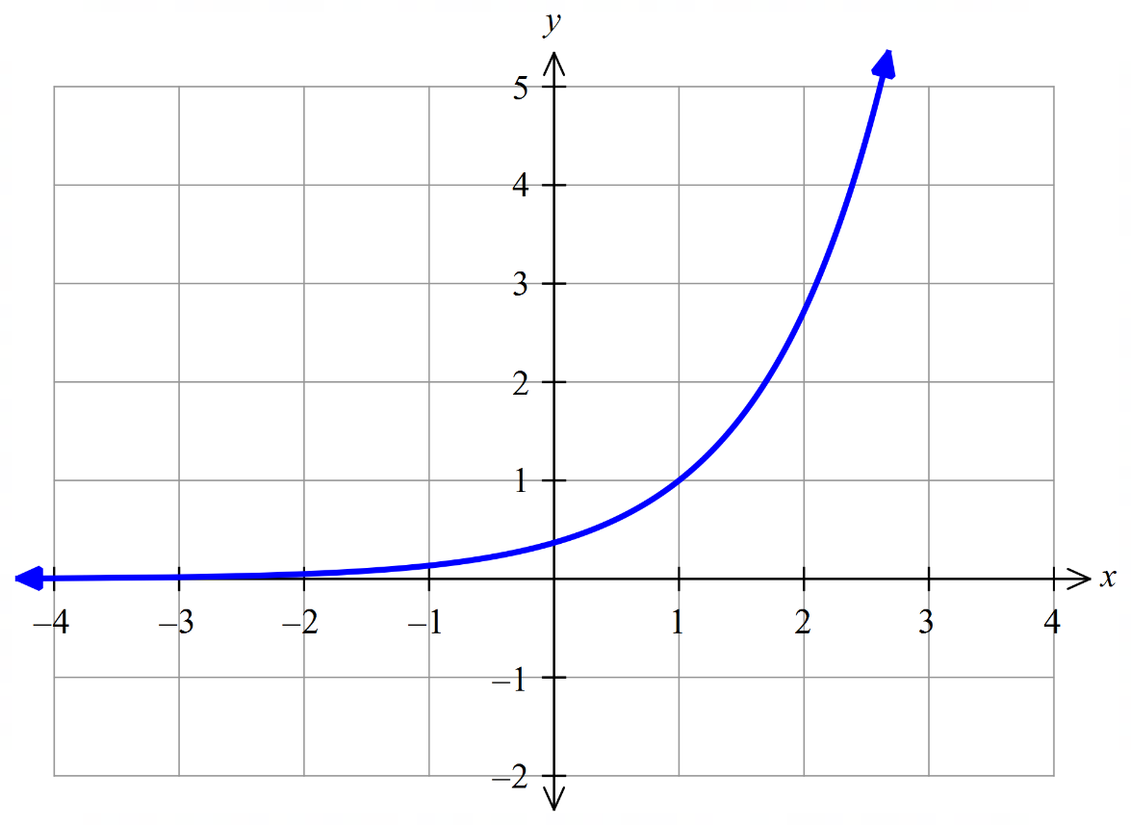

Calculate the exact area between the graphs of $y=e^{x-1}, y=2-x$ and the two axes.

|  |
| --- |
| $A=\int_{0}^{1}{e^{x-1}} dx+\int_{1}^{2}{(2-x)} dx$ $={\left[e^{x-1}\right]}_{0}^{1}+{\left[2x-\frac{x^{2}}{2}\right]}_{1}^{2}$ $=1-e^{-1}+\left(4-2\right)-\left(2-\frac{1}{2}\right)$ $=\frac{3}{2}-\frac{1}{e}$ |

**17.** The displacement in centimetres of a particle from the point O in a straight line is given by

$x\left(t\right)=\frac{1}{3}{\left(\frac{t}{2}-4\right)}^{2}-2$ for $0≤t≤10$, where $t$ is measured in seconds.

Calculate the:

**a)** Time(s) that the particle is at rest.

|  |
| --- |
| ∴ particle at rest at 8 seconds |

**b)** Displacement of the particle during the fifth second.

|  |
| --- |
| ∴ Displacement -0.5833 cm during the fifth second |

**c)** Maximum speed of the particle and the time when this occurs.

|  |
| --- |
| $v=\frac{dx}{dt}=\frac{t-8}{6}, 0≤t≤10$ check end points of the domain    Speed=|velocity|  ∴max speed 1.33 cm/s when $t=0$ |

**d)** Total distance travelled in the first 10 seconds.

|  |
| --- |
| or  ∴ particle travels 5.667 cm in the first 10 seconds |

Exam practice questions

**Question 12 Calculator free (8 marks)**

Evaluate the following indefinite integrals, giving answer with positive indices.

**a) $\int{(2x^{4}-3x+2)} dx$**  (1 mark)

**b) $\int{x^{2}({x^{3}+2)}^{4}} dx$**  (2 marks)

**c)** Determine $\int{\frac{1}{\sqrt[3]{x}}} dx$ (2 marks)

**d)** Determine $\int{\frac{2}{e^{4x}}} dx$ (2 marks)

**e)** Determine $\int{\sin{(4x+π)}}dx$ (1 marks)

**Question 13 Calculator free (6 marks)**

Consider the derivative function $f^{'}\left(x\right)=xe^{x^{2}}$

**a)** Determine $f”(1)$ (2 marks)

**b)** Explain the meaning of your answer to part **a)** (1 mark)

**c)** Determine the expression for $y=f(x)$, given that it intersects the $y-$ axis at the point $(0, 2)$. (3 marks)

**Question 14 Calculator free (11 marks)**

The graph of the function $f(x)$ is shown for $-3≤x≤3$.

The areas enclosed between the graph, the $x-$ axis and the lines $x=-3$ and $x=3$ are marked in the appropriate regions.



Determine:

**a)** The value of $\int_{-2}^{3}{f(x)}dx$ (2 marks)

**b)** The area encloses between the graph of $f(x)$ and the $x-$ axis, from $x=-2$ to $x=3$.  
 (2 marks)

**c)** The value of $\int_{0}^{3}{f(-x)}dx$. (2 marks)

**d)** The value of $\int_{0}^{2}{x-f(x)}dx$. (3 marks)

**e)** The value of $\int_{-1}^{1}{f'(x)}dx$. (2 marks)

**Question 15 Calculator free (8 marks)**

Let $f(x)$ be a function such that $f\left(-2\right)=4, f\left(-1\right)=0, f\left(1\right)=0$ and $f\left(3\right)=2$.   
Further, $f^{'}\left(x\right)<0$ for $-2≤x<0, f^{'}\left(0\right)=0$ and $f^{'}\left(x\right)>0$ for $0<x≤3$.

**a)** Evaluate the following definite integrals:

**(i) $\int_{0}^{3}{f'(x)}dx$** . (2 marks)

**(ii) $\int_{-2}^{3}{f'(x)}dx$**  (2 marks)

**c)** What is the area bounded by the graph of $f'(x)$ and the $x$ axis between $x=-2$ and $x=3$?   
 Justify your answer. (4 marks)

**Question 16 Calculator free (4 marks)**

The graphs of $y=6-2e^{x-4}$ and $y=-\frac{1}{4}x+5$ intersect at $x=4$ for $x≥0$.



Determine the exact area between $y=6-2e^{x-4}$ and $y=-\frac{1}{4}x+5$ and the $y$ axis for $x≥0$.

**Question 17 Calculator assumed (14 marks)**

A wall in a new Western Australian hotel is to feature a rolling, wave-shapes window. Engineers have modelled the top edge of the wave shape by joining together two functions,

and

are constants.

The functions give the height, , above ground level of the top edge of the measured in metres. The origin is defined as the leftmost point of the window which is at ground level and is the horizontal distance to the right of the origin measured in metres. The graph of the two functions is shown below.



**a)** Determine the value of the constant $a$ in the function $h_{2}\left(x\right)=a[\cos\left(x-1\right)+1]$ (3 marks)

**b)** Determine length of the bottom edge of the window. (2 marks)

**c)** Determine the volume of glass required for the window if it has a uniform thickness of 3 cm.   
 (5 marks)

**Question 18 Calculator assumed (8 marks)**

It takes an elevator 16 seconds to ascend from the ground floor of a building to the sixth floor. The velocity of the elevator during its ascent is given by

m/s

The velocity is measured in metres per second, while time, , is measured in seconds.

**a)** Determine the acceleration of the elevator during its ascent and provide a sketch of the acceleration function for $0≤t≤16$. (2 marks)

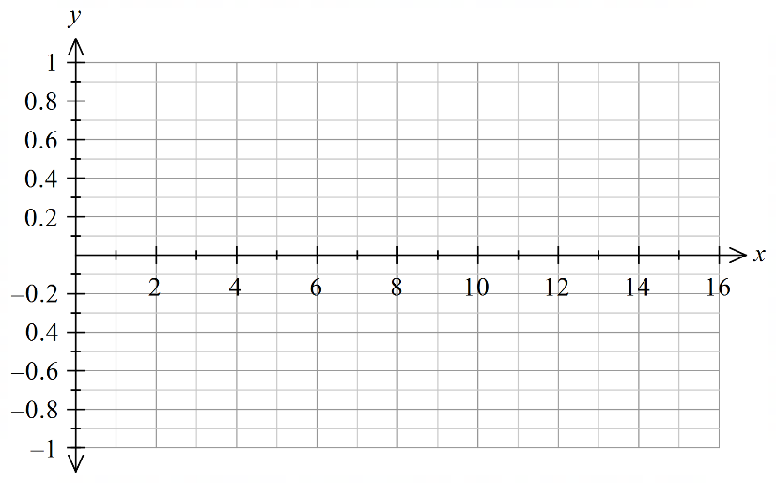

**b)** With reference to your answer from part **a)**, explain what is happening to the velocity of the elevator in the interval $0<t<8$ and in the interval $8<t<16$. (3 marks)

**c)** Suppose that the ground floor has displacement $x=0$ m. Determine the displacement function of the elevator and hence determine the height above the ground floor of the sixth floor. (3 marks)

**Question 19 Calculator assumed (10 marks)**

The velocity of a robotic engine moving on a monorail is given by

$v=3t^{2}-12t+9$ metres per second, where $t=$ time in seconds.

Determine:

**a)** the acceleration after 4 seconds (2 marks)

**b)** how far the engine is from its starting point after 10 seconds. (3 marks)

**c)** the total distance travelled by the engine in the first 10 seconds. (3 marks)

**d)** the average velocity of the engine during the first 10 seconds (2 marks)

Solutions

**Question 12 Calculator free (8 marks)**

Evaluate the following indefinite integrals, giving answer with positive indices.

**a) $\int{(2x^{4}-3x+2)} dx$**  (1 mark)

|  |  |  |
| --- | --- | --- |
| **Solution** | **Specific behaviours** | **Point** |
| $\int{(2x^{4}-3x+2)} dx=\frac{2x^{5}}{5}-\frac{3x^{2}}{2}+2x+c$ | * Integrates correctly | 3.2.3 |

**b) $\int{x^{2}({x^{3}+2)}^{4}} dx$**  (2 marks)

|  |  |  |
| --- | --- | --- |
| **Solution** | **Specific behaviours** | **Point** |
| $\int{x^{2}({x^{3}+2)}^{4}} dx=\frac{x^{2}{\left(x^{3}+2\right)}^{5}}{5\left(3x^{2}\right)}+c$ $=\frac{{\left(x^{3}+2\right)}^{5}}{15}+c$ | * Integrates correctly * Simplifies answer | 3.2.3 |

**c)** Determine $\int{\frac{1}{\sqrt[3]{x}}} dx$ (2 marks)

|  |  |  |
| --- | --- | --- |
| **Solution** | **Specific behaviours** | **Point** |
| $\int{\frac{1}{\sqrt[3]{x}}} dx=\int{x^{-\frac{1}{3}}} dx$ $=\frac{x^{\frac{2}{3}}}{\frac{2}{3}}+c$ $=\frac{3\sqrt[3]{x^{2}}}{2}+c$ | * rewrites integral with negative and fractional indices * integrates correctly | 3.2.3 |

**d)** Determine $\int{\frac{2}{e^{4x}}} dx$ (2 marks)

|  |  |  |
| --- | --- | --- |
| **Solution** | **Specific behaviours** | **Point** |
| $\int{\frac{2}{e^{4x}}} dx=\int{2e^{-4x}}dx$ $=\frac{2e^{-4x}}{-4}+c$ $=-\frac{1}{2e^{4x}}+c$ | * Integrates correctly * Simplifies and uses positive indices | 3.2.4 |

**e)** Determine $\int{\sin{(4x+π)}}dx$ (1 marks)

|  |  |  |
| --- | --- | --- |
| **Solution** | **Specific behaviours** | **Point** |
| $\int{\sin{(4x+π)}}dx =-\frac{\cos\left(4x+π\right)}{4}+c$ | * Integrates correctly | 3.2.5 |

**Question 13 Calculator free (6 marks)**

Consider the derivative function $f^{'}\left(x\right)=xe^{x^{2}}$

**a)** Determine $f”(1)$ (2 marks)

|  |  |  |
| --- | --- | --- |
| **Solution** | **Specific behaviours** | **Point** |
| $f"(x)=x(2xe^{x^{2}})+e^{x^{2}}$ $f"(1)=3e$ | * Uses the chain rule to correctly differentiate $f’(x)$ | 3.1.11 |

**b)** Explain the meaning of your answer to part **a)** (1 mark)

|  |  |  |
| --- | --- | --- |
| **Solution** | **Specific behaviours** | **Point** |
| $f"(1)$ is the rate of change of the derivative function when $x=1$ | * States the value is the rate of change of the derivative and includes when $x=1$ | 3.1.11 |

**c)** Determine the expression for $y=f(x)$, given that it intersects the $y-$ axis at the point $(0, 2)$. (3 marks)

|  |  |  |
| --- | --- | --- |
| **Solution** | **Specific behaviours** | **Point** |
| $\int{{xe}^{x^{2}}}dx=\frac{e^{x^{2}}}{2}+c$ $2=\frac{e^{0}}{2}+c$ $c=\frac{3}{2}$ ∴ $f\left(x\right)=\frac{e^{x^{2}}}{2}+\frac{3}{2}$ | * Correctly integrates $f^{'}\left(x\right)$* Substitutes $\left(0, 2\right)$ into the expression to find $c$* States final expression for $y=f(x)$ | 3.2.9 |

**Question 14 Calculator free (14 marks)**

The graph of the function $f(x)$ is shown for $-3≤x≤3$.

The areas enclosed between the graph, the $x-$ axis and the lines $x=-3$ and $x=3$ are marked in the appropriate regions.



Determine:

**a)** The value of $\int_{-2}^{3}{f(x)}dx$ (2 marks)

|  |  |  |
| --- | --- | --- |
| **Solution** | **Specific behaviours** | **Point** |
| $\int_{-2}^{3}{f(x)}dx=-4+4-2=-2$ | * Uses additive property of integrals * Correctly uses signed areas | 3.2.13 |

**b)** The area encloses between the graph of $f(x)$ and the $x-$ axis, from $x=-2$ to $x=3$.  
 (2 marks)

|  |  |  |
| --- | --- | --- |
| **Solution** | **Specific behaviours** | **Point** |
| Area $= 4+4+2=10$ | * Uses additive property of area * Correctly selects unsigned areas | 3.2.14 |

**c)** The value of $\int_{0}^{3}{f(-x)}dx$. (2 marks)

|  |  |  |
| --- | --- | --- |
| **Solution** | **Specific behaviours** | **Point** |
| $\int_{0}^{3}{f\left(-x\right)}dx=\int_{-3}^{0}{f\left(x\right)}dx$ $=3-4$ $=-1$ | * Correctly determines the effect of the transformation on the integral * Correctly evaluates the integral. | 3.2.14 |

**d)** The value of $\int_{0}^{2}{x-f(x)}dx$. (3 marks)

|  |  |  |
| --- | --- | --- |
| **Solution** | **Specific behaviours** | **Point** |
| $\int_{0}^{2}{x-f\left(x\right)}dx=\int_{0}^{2}{x}dx-\int_{0}^{2}{f\left(x\right)}dx$ $={\left[\frac{x^{2}}{2}\right]}_{0}^{2}-4$ $=2-4$ $=-2$ | * Separates integral into correct components * Integrates first component correctly * Integrates second component correctly | 3.2.14 |

**e)** The value of $\int_{-1}^{1}{f'(x)}dx$. (2 marks)

|  |  |  |
| --- | --- | --- |
| **Solution** | **Specific behaviours** | **Point** |
| $\int_{-1}^{1}{f^{'}\left(x\right)}dx={\left[f\left(x\right)\right]}_{-1}^{1}$ $=3-(-3)$ $=6$ | * Applies Fundamental Theorem of Calculus * Evaluates integral correctly | 3.2.17 |

**Question 15 Calculator free (8 marks)**

Let $f(x)$ be a function such that $f\left(-2\right)=4, f\left(-1\right)=0, f\left(1\right)=0$ and $f\left(3\right)=2$.   
Further, $f^{'}\left(x\right)<0$ for $-2≤x<0, f^{'}\left(0\right)=0$ and $f^{'}\left(x\right)>0$ for $0<x≤3$.

**a)** Evaluate the following definite integrals:

**(i) $\int_{0}^{3}{f'(x)}dx$** . (2 marks)

|  |  |  |
| --- | --- | --- |
| **Solution** | **Specific behaviours** | **Point** |
| $\int_{0}^{3}{f^{'}\left(x\right)}dx={\left[f\left(x\right)\right]}_{0}^{3}$ $=f\left(3\right)-f(0)$ $=2-(-1)$ $=3$ | * Applies Fundamental Theorem of Calculus * Evaluates integral correctly | 3.2.17 |

**(ii) $\int_{-2}^{3}{f'(x)}dx$**  (2 marks)

|  |  |  |
| --- | --- | --- |
| **Solution** | **Specific behaviours** | **Point** |
| $\int_{0}^{3}{f^{'}\left(x\right)}dx={\left[f\left(x\right)\right]}_{-2}^{3}$ $=f\left(3\right)-f(-2)$ $=2-4$ $=-2$ | * Applies Fundamental Theorem of Calculus * Evaluates integral correctly | 3.2.17 |

**c)** What is the area bounded by the graph of $f'(x)$ and the $x$ axis between $x=-2$ and $x=3$? Justify your answer. (4 marks)

|  |  |  |
| --- | --- | --- |
| **Solution** | **Specific behaviours** | **Point** |
| Since $f'(x)$ is positive for $x>0$ and negative for $x<0$, the area is | * Writes the expression for area in terms of absolute value * Uses the intervals where $f^{'}\left(x\right)$ is positive and negative * Breaks the integral over the correct intervals * Calculates the correct value of the area | 3.2.13 |

**Question 16 Calculator free (4 marks)**

The graphs of $y=6-2e^{x-4}$ and $y=-\frac{1}{4}x+5$ intersect at $x=4$ for $x≥0$.



Determine the exact area between $y=6-2e^{x-4}$ and $y=-\frac{1}{4}x+5$ and the $y$ axis for $x≥0$.

|  |  |  |
| --- | --- | --- |
| **Solution** | **Specific behaviours** | **Point** |
| $A=\int_{0}^{4}{\left(6-2e^{x-4}-\left[-\frac{1}{4}x+5\right]\right)}dx$ $=\int_{0}^{4}{\left(-2e^{x-4}+\frac{1}{4}x+1\right)}dx$ $={\left[-2e^{x-4}+\frac{x^{2}}{8}+x\right]}_{0}^{4}$ $=\left(-2+2+4\right)-\left(-2e^{-4}\right)$ $=2\left(2+\frac{1}{e^{4}}\right)$ | * Sets up an appropriate area for area * Uses correct limits * Anti-differentiates correctly * Calculates area | 3.2.20 |

**Question 17 Calculator assumed (14 marks)**

A wall in a new Western Australian hotel is to feature a rolling, wave-shapes window. Engineers have modelled the top edge of the wave shape by joining together two functions,

and

are constants.

The functions give the height, , above ground level of the top edge of the measured in metres. The origin is defined as the leftmost point of the window which is at ground level and is the horizontal distance to the right of the origin measured in metres. The graph of the two functions is shown below.



**a)** Determine the value of the constant $a$ in the function $h_{2}\left(x\right)=a[\cos\left(x-1\right)+1]$ (3 marks)

|  |  |  |
| --- | --- | --- |
| **Solution** | **Specific behaviours** | **Point** |
| Function meet at $x=1$.  Highest point is $h_{1}\left(1\right)=4-4{\left(1-1\right)}^{2}$ $=4$  Function meet at $(1, 4)$ $h_{1}\left(1\right)=4$ $4=a[\cos\left(1-1\right)+1]$ $4=2a$ $a=2$ | * States highest point is $h_{1}(1)$* Recognises need to solve $h_{2}\left(1\right)=h_{1}(1)$* Determines value of $a$ | 3.2.19 |

**b)** Determine length of the bottom edge of the window. (2 marks)

|  |  |  |
| --- | --- | --- |
| **Solution** | **Specific behaviours** | **Point** |
| $h_{1}\left(d\right)=0$ $0=2[\cos\left(d-1\right)+1]$ $d=π+1$ $d=4.14$ Length of the window is 4.14 metres long. | * Recognises need to solve $h_{2}\left(d\right)=0$* Solves for $d$ | 3.2.19 |

**c)** Determine the volume of glass required for the window if it has a uniform thickness of 3 cm. (5 marks)

|  |  |  |
| --- | --- | --- |
| **Solution** | **Specific behaviours** | **Point** |
| $A=\int_{0}^{1}{h_{1}\left(x\right)}dx+\int_{1}^{π+1}{h_{2}\left(x\right)}dx$ $\int_{0}^{1}{h_{1}\left(x\right)}dx=\frac{8}{3}$ $\int_{1}^{π+1}{h_{2}\left(x\right)}dx=2π$ $A=\frac{8}{3}+2π$ $=8.95$ $V=$ ( $\frac{8}{3}+2π)×0.03$ $=0.27$  The window has a volume of 0.27 m3 | * Recognises the required area is the sum of the areas under $h_{1}\left(x\right)$ and $h_{2}\left(x\right)$* Determines area under $h_{1}\left(x\right)$* Determines area under $h_{2}\left(x\right)$* Determines total area * Determines volume including units | 3.2.19 |

**Question 18 Calculator assumed (8 marks)**

It takes an elevator 16 seconds to ascend from the ground floor of a building to the sixth floor. The velocity of the elevator during its ascent is given by

m/s

The velocity is measured in metres per second, while time, , is measured in seconds.

**a)** Determine the acceleration of the elevator during its ascent and provide a sketch of the acceleration function for $0≤t≤16$. (2 marks)

|  |  |  |
| --- | --- | --- |
| **Solution** | **Specific behaviours** | **Point** |
| $a\left(t\right)=\frac{9π^{2}}{256}\cos\left(\frac{πt}{16}\right)$ | * Differentiates the velocity function to obtain the acceleration * Provides a sketch clearly showing the peak acceleration values and correctly locating the zero acceleration point. | 3.1.9 |

**b)** With reference to your answer from part **a)**, explain what is happening to the velocity of the elevator in the interval $0<t<8$ and in the interval $8<t<16$. (3 marks)

|  |  |  |
| --- | --- | --- |
| **Solution** | **Specific behaviours** | **Point** |
| Since the acceleration is positive on the interval $0<t<8$, the velocity is increasing on the interval $0<t<8$.  Since the acceleration is negative on the interval $8<t<16$, the velocity is decreasing on the interval $8<t<16$. | * References acceleration graph or function * Recognises that the upward velocity is increasing on the interval $0<t<8$* Recognises that the upward velocity is decreasing on the interval $8<t<16$ | 3.2.22 |

**c)** Suppose that the ground floor has displacement $x=0$ m. Determine the displacement function of the elevator and hence determine the height above the ground floor of the sixth floor. (3 marks)

|  |  |  |
| --- | --- | --- |
| **Solution** | **Specific behaviours** | **Point** |
| The displacement is the integral of the velocity $x\left(t\right)=-9\cos\left(\frac{πt}{16}\right)+c$ m  Since $x\left(0\right)=0$ it follows that $0=-9\cos\left(0\right)+c$ $c=9$    Hence $x\left(t\right)=9-9\cos\left(\frac{πt}{16}\right)$ m $x\left(16\right)=9-9\cos\left(\frac{16π}{16}\right)$ $=18$  m | * Integrates velocity function to obtain the displacement function including unknown integration constant * Determines integration constant * Evaluates $x\left(16\right)$ | 3.2.21 |

**Question 19 Calculator assumed (10 marks)**

The velocity of a robotic engine moving on a monorail is given by

$v=3t^{2}-12t+9$ metres per second, where $t=$ time in seconds.

Determine:

**a)** the acceleration after 4 seconds (2 marks)

|  |  |  |
| --- | --- | --- |
| **Solution** | **Specific behaviours** | **Point** |
| $a=6t-12$ When ms-2 | * Differentiates to find $a$* Correctly evaluates $a$ at $t=4$ | 3.1.9 |

**b)** how far the engine is from its starting point after 10 seconds. (3 marks)

|  |  |  |
| --- | --- | --- |
| **Solution** | **Specific behaviours** | **Point** |
| $x=t^{3}-6t^{2}+9t+c$, with $c=0$ When $t=10, x=490$ m | * Integrates to find $x$* Correctly reasons that $c=0$* Correctly evaluates $x$ at $t=10$ | 3.2.21 |

**c)** the total distance travelled by the engine in the first 10 seconds. (3 marks)

|  |  |  |
| --- | --- | --- |
| **Solution** | **Specific behaviours** | **Point** |
| Engine is stationary when $3t^{2}-12t+9=0$ $t=1$ or $3$ $x\left(1\right)=4$, $x\left(3\right)=0$ Total distance $=4+4+490=498$ m  or  Total distance  m | * Finds times when engine is stationary * Determines displacement at these times * Calculates total distance | 3.2.22 |

**d)** the average velocity of the engine during the first 10 seconds (2 marks)

|  |  |  |
| --- | --- | --- |
| **Solution** | **Specific behaviours** | **Point** |
| Average velocity ms-1 | * Interprets average velocity as displacement divided by time * Uses displacement rather than distance |  |

3. Discrete random variables

Topic 3.3: Discrete random variables

**General discrete random variables**

3.3.1 develop the concepts of a discrete random variable and its associated probability function, and their use in modelling data

3.3.2 use relative frequencies obtained from data to obtain point estimates of probabilities associated with a discrete random variable

3.3.3 identify uniform discrete random variables and use them to model random phenomena with equally likely outcomes

3.3.4 examine simple examples of non-uniform discrete random variables

3.3.5 identify the mean or expected value of a discrete random variable as a measurement of centre, and evaluate it in simple cases

3.3.6 identify the variance and standard deviation of a discrete random variable as measures of spread, and evaluate them using technology

3.3.7 examine the effects of linear changes of scale and origin on the mean and the standard deviation

3.3.8 use discrete random variables and associated probabilities to solve practical problems

**Bernoulli distributions**

3.3.9 use a Bernoulli random variable as a model for two-outcome situations

3.3.10 identify contexts suitable for modelling by Bernoulli random variables

3.3.11 determine the mean $p$ and variance $p\left(1-p\right)$ of the Bernoulli distribution with parameter $p$

3.3.12 use Bernoulli random variables and associated probabilities to model data and solve practical problems

**Binomial distributions**

3.3.13 examine the concept of Bernoulli trials and the concept of a binomial random variable as the number of ‘successes’ in $n$ independent Bernoulli trials, with the same probability of success $p$ in each trial

3.3.14 identify contexts suitable for modelling by binomial random variables

3.3.15 determine and use the probabilities $P\left(X=x\right)=\left(\begin{matrix}n \\ x\end{matrix}\right)p^{x}{\left(1-p\right)}^{n-x}$ associated with the binomial distribution with parameters $n$ and $p$; note the mean $np$ and variance $np\left(1-p\right)$ of a binomial distribution

3.3.16 use binomial distributions and associated probabilities to solve practical problems

General discrete random variables

A discrete random variable $X$ can only take on countable values. Generally, these are whole numbers.

If $X$ is a discrete random variable, then for its probability distribution function $p\left(x\right)$ the following conditions must hold true:

* Each value of $p(x)$ must be between 0 and 1, $0≤p\left(x\right)≤1$
* and the sum of all the values of $p(x)$ must equal 1, $\sum{p(x)}=1$

The expected value or mean is found by summing the products of each value of $X$ and the probability that $X$ takes on that value for $X,$

$μ=E\left(X\right)=\sum{x}×p(x)$

The variance of a random variable $X$, is a measure of the spread of the probability about its mean $Var\left(X\right)=σ^{2}=\sum{{\left(x-μ\right)}^{2}×p\left(x\right)}$

$=E{\left(X\right)}^{2}-{\left[E\left(X\right)\right]}^{2}$

$=\sum{x^{2}×p\left(x\right)-μ^{2}}$

The standard deviation of a random variable $X$ is the square root of the variance $SD\left(X\right)=σ=\sqrt{Var\left(X\right)}$

Linear function of a discrete random variable $E\left(aX+b\right)$ $=aE\left(X\right)+b$

$Var\left(aX+b\right)$ $=a^{2}Var\left(X\right)$

$SD\left(aX+b\right)$ $=|a|SD(X)$

**Bernoulli distributions**

A Bernoulli variable assigns “success” the numerical value of 1 and “failure” the numerical value of 0.

The probability of success on a single trial, $p$, is constant for all trials, so the probability of failure on a single trial is $(1-p)$

If $X$ is a Bernoulli variable with parameter $p$

The probability distribution function of $X$ is:

$p\left(x\right)=\left\{\begin{aligned}p if x=1 \\ 1-p if x=0\end{aligned}\right.$

Mean for $X$, $μ=E\left(X\right)=p$

Variance for $X, σ^{2}=E\left(X^{2}\right)-μ^{2}=p(1-p)$

**Binomial distributions**

The generic definition of a binomial variable $X$ number of successes $n$ independent Bernoulli trials.

The probability of achieving a successful outcome for each trial must be the same for each trial (constant). That is, the trials must be independent.

$X=0, 1, 2, 3,…n$ The maximum value of $X$ is $n$.

The probability distribution function for a binomial variable $X$ defined over $n$ trials with $p$ as the constant probability of producing a successful outcome for each trial is $p\left(x\right)=\left({n \atop x}\right)p^{x}{\left(1-p\right)}^{n-x}$ where $x=0, 1, 2, 3…n$.

If $X\sim B(n,p)$, ( $X$ is binomially distributed with number of items, $n$ and a probability of $p$)

then the mean of $X=np$ and the variance of $X=np(1-p)$

**Examples**

**18.** A tetrahedral die has the numbers 1 to 4 on each face. When thrown, each side is equally likely to land facedown. Let $X$ be defined as the sum of the numbers on the facedown side when the die is thrown.

**a)** Complete the following table.

|  |  |  |  |  |  |
| --- | --- | --- | --- | --- | --- |
|  | Roll two | | | | |
| Roll one | Sum of two rolls | 1 | 2 | 3 | 4 |
| 1 | $$1+1=2$$ | $$3$$ |  |  |
| 2 | $$3$$ |  |  |  |
| 3 |  | $$5$$ |  |  |
| 4 |  |  |  |  |

|  |  |  |  |  |  |  |  |  |  |  |  |  |  |  |  |  |  |  |  |  |  |  |  |  |  |  |  |  |  |  |  |  |
| --- | --- | --- | --- | --- | --- | --- | --- | --- | --- | --- | --- | --- | --- | --- | --- | --- | --- | --- | --- | --- | --- | --- | --- | --- | --- | --- | --- | --- | --- | --- | --- | --- |
| |  |  |  |  |  |  | | --- | --- | --- | --- | --- | --- | |  | Roll two | | | | | | Roll one | Sum of two rolls | 1 | 2 | 3 | 4 | | 1 |  |  |  |  | | 2 |  |  |  |  | | 3 |  |  |  |  | | 4 | $$5$$ | $$6$$ | $$7$$ | $$8$$ | |

**b) (i)** Hence, or otherwise, complete the probability distribution of $X$, which is given by the following table.

|  |  |  |  |  |  |  |  |
| --- | --- | --- | --- | --- | --- | --- | --- |
| $$x$$ | 2 | 3 | 4 | 5 | 6 | 7 | 8 |
|  |  |  |  |  |  |  |  |

|  |  |  |  |  |  |  |  |  |  |  |  |  |  |  |  |  |
| --- | --- | --- | --- | --- | --- | --- | --- | --- | --- | --- | --- | --- | --- | --- | --- | --- |
| |  |  |  |  |  |  |  |  | | --- | --- | --- | --- | --- | --- | --- | --- | |  | 2 | 3 | 4 | 5 | 6 | 7 | 8 | |  |  |  |  |  |  |  |  | |

**(ii)** Calculate the probability of obtaining a sum of five or less.

|  |
| --- |
| $P\left(S≤5\right)=\frac{4+3+2+1}{16}=\frac{10}{16}$ |

**(iii)** Determine the mean and standard deviation for $X$.

|  |
| --- |
| Mean $=5$ Standard deviation $=1.58$ |

**19.** A bag contains 1 red marble and 4 green marbles. A single marble is drawn from the bag. The random variable $Y$ is defined as the number of green marbles drawn from the bag.

**a)** Complete the probability distribution for $Y$ shown below.

|  |  |  |
| --- | --- | --- |
| $$y$$ | 0 | 1 |
|  |  |  |

|  |  |  |  |  |  |  |
| --- | --- | --- | --- | --- | --- | --- |
| |  |  |  | | --- | --- | --- | |  | 0 | 1 | |  |  |  | |

**b)** State the distribution of $Y$.

|  |
| --- |
| Bernoulli distribution |

**c)** Determine the mean and standard deviation of the distribution.

|  |
| --- |
| $μ=\frac{4}{5}$ $σ=\sqrt{\frac{1}{5}×\frac{4}{5}}=\frac{2}{5}$ |

The above process is repeated five times, with the marble being replaced every time. The random variable $X$ is defined as the number of green marbles drawn from the bag in five attempts.

**d)** State the distribution of $X$, including its parameters.

|  |
| --- |
| $X\sim Bin\left(5,\frac{4}{5}\right)$ |

**e)** Evaluate the probability of selecting exactly two green marbles.

|  |
| --- |
| $P\left(X=2\right)=\left({5 \atop 2}\right){\left(\frac{4}{5}\right)}^{2}{\left(\frac{1}{5}\right)}^{3}$ $=\frac{32}{625}$ |

Exam practice questions

**Question 20 Calculator assumed (4 marks)**

Ten shop owners in a coastal resort were asked how many extra staff they intended to hire for the next holiday season. Their responses are shown below:

$3, 0, 2, 1, 2, 1, 1, 0, 2, 1$

If $N=$ number of additional staff,

**a)** Complete the probability distribution of $N$ below. (2 marks)

|  |  |  |  |  |
| --- | --- | --- | --- | --- |
| $$n$$ | 0 | 1 | 2 | 3 |
| $$P(N=n)$$ |  |  |  |  |

**b)** What is the mean number of staff the shop owners intend to hire? (2 marks)

**Question 21 Calculator assumed (7 marks)**

A group of researchers conducted a study into the number of siblings of adult Australian citizens. They surveyed a total of 200 participants and recorded the number of siblings, , for each participant.

A few days later the lead researcher discovered that the survey data had been misplaced. Fortunately, one of the research assistances had been doing some rough calculations on a whiteboard and the lead researcher was able to recover the following information about the probability distribution for and the mean .

|  |  |  |  |  |
| --- | --- | --- | --- | --- |
|  | 0 | 1 | 2 | 3 |
|  |  |  |  |  |

The letters $a$ and $b$ have been used to denote unknown probabilities.

**a) (i)** write two independent equations to for $a$ and $b$. (2 marks)

**(ii)** Hence solve for the unknown probabilities. (2 marks)

Later that day the research assistant found the complete probability distribution in their records and discovered that they had made an error in their original calculation of the mean. The correct probability distribution is given in the table below.

|  |  |  |  |  |
| --- | --- | --- | --- | --- |
|  | 0 | 1 | 2 | 3 |
|  |  |  |  |  |

**b) (i)** Given that there were 200 participants in the study, complete the table below to show the number of participants $N$ with $0, 1, 2, 3$ siblings. (1 mark)

**(ii)** Determine the correct mean and standard deviation of the number of siblings $X$. (2 marks)

**Question 22 Calculator assumed (9 marks)**

A building has five alarms configured in such a way that the system functions if at least two of the alarms work. The probability that an alarm fails overnight is 0.05. Let the random variable $X$ denot the number of alarms that fail overnight.

**a)** State the distribution of $X$. (2 marks)

**b)** What assumptions are required for the distribution of part **a).** (2 mark)

**c)** What is the probability the alarm system fails overnight? (2 marks)

One of the alarms is removed in the evening for maintenance and is not replaced.

**d)** What is the probability that the system still works in the morning? (3 marks)

Solution

**Question 20 Calculator assumed (4 marks)**

Ten shop owners in a coastal resort were asked how many extra staff they intended to hire for the next holiday season. Their responses are shown below:

$3, 0, 2, 1, 2, 1, 1, 0, 2, 1$

If $N=$ number of additional staff,

**a)** Complete the probability distribution of $N$ below. (2 marks)

|  |  |  |  |  |
| --- | --- | --- | --- | --- |
| $$n$$ | 0 | 1 | 2 | 3 |
|  |  |  |  |  |

|  |  |  |
| --- | --- | --- |
| **Solution** | **Specific behaviours** | **Point** |
| |  |  |  |  |  | | --- | --- | --- | --- | --- | |  | 0 | 1 | 2 | 3 | |  |  |  |  |  | | * Gives one correct entry * Completes table correctly | 3.3.1 |

**b)** What is the mean number of staff the shop owners intend to hire? (2 marks)

|  |  |  |
| --- | --- | --- |
| **Solution** | **Specific behaviours** | **Point** |
| $E\left(X\right)=\left(0×\frac{2}{10}\right)+ \left(1×\frac{4}{10}\right)+ \left(2×\frac{3}{10}\right)$ $+ \left(3×\frac{1}{10}\right)$ $=1.3$ | * Gives correct expression for $E(X)$* Simplifies answer | 3.3.5 |

**Question 21 Calculator assumed (7 marks)**

A group of researchers conducted a study into the number of siblings of adult Australian citizens. They surveyed a total of 200 participants and recorded the number of siblings, , for each participant.

A few days later the lead researcher discovered that the survey data had been misplaced. Fortunately, one of the research assistances had been doing some rough calculations on a whiteboard and the lead researcher was able to recover the following information about the probability distribution for and the mean .

|  |  |  |  |  |
| --- | --- | --- | --- | --- |
|  | 0 | 1 | 2 | 3 |
|  |  |  |  |  |

The letters $a$ and $b$ have been used to denote unknown probabilities.

**a) (i)** write two independent equations to for $a$ and $b$. (2 marks)

|  |  |  |
| --- | --- | --- |
| **Solution** | **Specific behaviours** | **Point** |
| Probabilities add to 1. $0.2+a+b+0.1=1$ $a+b=0.7$    Calculation for the mean $0.2×0+a×1+b×2+0.1×3=1.3$ $a+2b=1$ | * Recognises that probabilities must add to 1 * Implements the formula for the mean | 3.3.1  3.3.5 |

**(ii)** Hence solve for the unknown probabilities. (2 marks)

|  |  |  |
| --- | --- | --- |
| **Solution** | **Specific behaviours** | **Point** |
| From the first equation $a=0.7-b$   Substituting into second equation $\left(0.7-b\right)+2b=1$ $b=0.3$ $a=0.4$ | * Solves for $b$* Solves for $a$ | 3.3.1  3.3.5 |

Later that day the research assistant found the complete probability distribution in their records and discovered that they had made an error in their original calculation of the mean. The correct probability distribution is given in the table below.

|  |  |  |  |  |
| --- | --- | --- | --- | --- |
|  | 0 | 1 | 2 | 3 |
|  |  |  |  |  |

**b) (i)** Given that there were 200 participants in the study, complete the table below to show the number of participants $N$ with $0, 1, 2, 3$ siblings. (1 mark)

|  |  |  |
| --- | --- | --- |
| **Solution** | **Specific behaviours** | **Point** |
| |  |  |  |  |  | | --- | --- | --- | --- | --- | |  | 0 | 1 | 2 | 3 | |  |  |  |  |  | |  |  |  |  |  | | * Determines correct number of participants in each response group. | 3.3.8 |

**(ii)** Determine the correct mean and standard deviation of the number of siblings $X$.   
 (2 marks)

|  |  |  |
| --- | --- | --- |
| **Solution** | **Specific behaviours** | **Point** |
| $μ=1.4$ $σ=0.9165$ | * Determines mean * Determines standard deviation | 3.3.5  3.3.6 |

**Question 22 Calculator assumed (9 marks)**

A building has five alarms configured in such a way that the system functions if at least two of the alarms work. The probability that an alarm fails overnight is 0.05. Let the random variable $X$ denot the number of alarms that fail overnight.

**a)** State the distribution of $X$. (2 marks)

|  |  |  |
| --- | --- | --- |
| **Solution** | **Specific behaviours** | **Point** |
| $X\sim Bin(5, 0.05)$ | * States the binomial distribution * Gives the correct parameters | 3.3.14 |

**b)** What assumptions are required for the distribution of part **a).** (2 mark)

|  |  |  |
| --- | --- | --- |
| **Solution** | **Specific behaviours** | **Point** |
| The alarms fail independent of each other  The probability that an alarm fails is constant/unchanging/same for all alarms | * States one correct assumption * States the second correct assumption | 3.3.16 |

**c)** What is the probability the alarm system fails overnight? (2 marks)

|  |  |  |
| --- | --- | --- |
| **Solution** | **Specific behaviours** | **Point** |
| We need $P\left(X≥4\right)=1=P(X≤3)$ $=1-0.99997$ $=0.00003$ | * Writes the first probability statement correctly * Obtains the correct final answer to at least 5 decimal places | 3.3.16 |

One of the alarms is removed in the evening for maintenance and is not replaced.

**d)** What is the probability that the system still works in the morning? (3 marks)

|  |  |  |
| --- | --- | --- |
| **Solution** | **Specific behaviours** | **Point** |
| Let the random variable $Y$ denote the number of alarms that fail out of the 4.  Then $Y\sim Bin(4, 0.05)$ $P\left(Y≥3\right)=0.00048$ $1-0.000048=0.99952$ | * States the distribution of the random variable with correct parameters * Writes the first probability statement correctly * Obtains the correct final answer | 3.3.16 |

4. Logarithms

Topic 4.1: The logarithmic function

**Logarithmic functions**

4.1.1define logarithms as indices: $a^{x}=b$ is equivalent to $x=\log_{a}{b}$ i.e. $a^{\log_{a}{b}}=b$

4.1.2establish and use the algebraic properties of logarithms

4.1.3examine the inverse relationship between logarithms and exponentials: $y=a^{x}$ is equivalent to $x=\log_{a}{y}$

4.1.4interpret and use logarithmic scales

4.1.5solve equations involving indices using logarithms

4.1.6identify the qualitative features of the graph of $y=\log_{a}{x}$ ($a>1)$, including asymptotes, and of its translations $y=\log_{a}{x}+b$ and ${y=log}_{a}{(x-c)}$

4.1.7solve simple equations involving logarithmic functions algebraically and graphically

4.1.8identify contexts suitable for modelling by logarithmic functions and use them to solve practical problems

**Calculus of the natural logarithmic function**

* + 1. define the natural logarithm $\ln{x}=\log_{e}{x}$

4.1.10 examine and use the inverse relationship of the functions $y=e^{x}$ and $y=\ln{x}$

4.1.11establish and use the formula $\frac{d}{dx}\left(\ln{x}\right)=\frac{1}{x}$

4.1.12establish and use the formula $\int{\frac{1}{x}dx=\ln{ x }+c}$, for $x>0$

4.1.13determine derivatives of the form $\frac{d}{dx}\left(\ln{f(x})\right)$ and integrals of the form $\int{\frac{f^{'}\left(x\right)}{f\left(x\right)}}dx$, for $f (x)>0$

4.1.14use logarithmic functions and their derivatives to solve practical problems

Logarithms

For $a^{x}=b$ $a$ is the base, $x$ is the exponent and $b$ is the solution

Then $\log_{a}{b}=x$“the log of $b$ base $a$ is $x$.”

Logarithm laws

$\log_{a}{P}+\log_{a}{Q}=\log_{a}{(P×Q)}$

$\log_{a}{P}-\log_{a}{Q}=\log_{a}\left(\frac{P}{Q}\right)$

${\log_{a}{P}}^{n}=n×\log_{a}{P}$

$\log_{a}{a}=1$

$\log_{a}{1}=0$

Change of base

$\log_{a}{x}=\frac{\log_{b}{x}}{\log_{b}{a}}$ and $a^{x}=b^{(\log_{b}{a})x}$

Inverse relationship

$f\left(x\right)=a^{x}$ and $g\left(x\right)=\log_{a}{x}$ are inverses of each other

$\log_{a}\left(a^{x}\right)=x$ and $a^{\log_{a}{x}}=x$

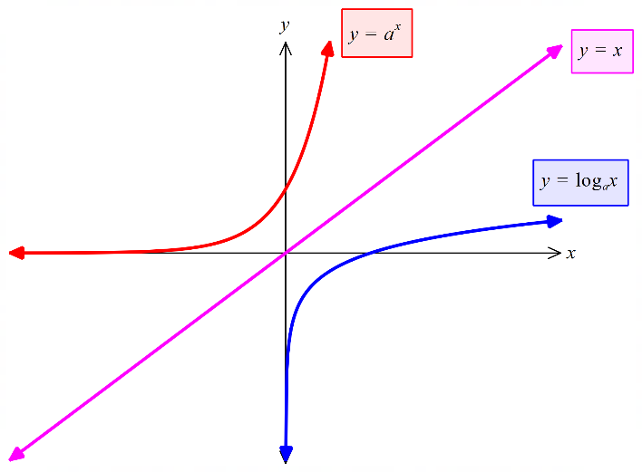

Graph of logarithm functions in the form $y=\log_{a}{(x)}$

$x-$ intercept is $(1, 0)$ and has another point $\left(a, 1\right)$

$y-$ axis is a vertical asymptote

$y=\log_{a}{(x)}+b$ is a vertical translation of $y=\log_{a}{(x)}$  
 (translates $b$ units up)

$y=\log_{a}{(x-c)}$ is a horizontal translation of $y=\log_{a}{(x)}$  
 (translates $c$ units right)

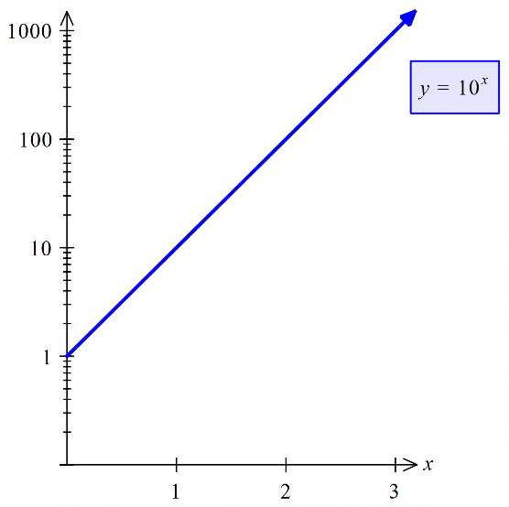Graphs with logarithmic scales

Some graph paper has a logarithmic scale on one axis. Exponential equations will appear as straight lines.

Differentiation of logarithmic functions

If $y$ $=\ln{x}$

Then $x$ $=e^{y}$

$\frac{dx}{dy}$ $=e^{y}$

$\frac{dy}{dx}$ $={\frac{1}{e^{y}}}^{ }$

$=\frac{1}{x}$

|  |  |
| --- | --- |
| $f\left(x\right)=\ln{x}$ | $f'\left(x\right)=\frac{1}{x}$ |
| $y=\ln{f(x)}$ | $\frac{dy}{dx}=\frac{f^{'}\left(x\right)}{f(x)}$ |

Use the change of base formula if given a logarithm that is not base $e$

Integration to give logarithmic functions

If $y$ $=\ln{x}$

Then $\frac{dy}{dx}$ $=\frac{1}{x}$

If we had $y$ $=\frac{1}{x}$ 
Then $\int{\frac{1}{x}}dx$ $=\ln{x}+c$

|  |  |
| --- | --- |
| $\int{\frac{1}{x}dx}$ | $\ln{x}+c$ |
| $\int{\frac{f^{'}\left(x\right)}{f(x)}}dx$ | $\ln{f(x)}+c$ for $x>0$ |

Examples

**20.**

**a)** Given that $\log_{8}{x}=2$ and $\log_{2}{y}=5$, evaluate $x-y$.

|  |
| --- |
| $8^{2}-2^{5}=32$ |

**b)** Express $y$ in terms of $x$ given that $\log_{2}{(x+y)}+2=\log_{2}{(x-2y)}.$

|  |
| --- |
| $\log_{2}{(x+y)}+2$ $=\log_{2}{(x-2y)}$ $\log_{2}{(x+y)}+\log_{2}{4}$ $=\log_{2}{(x-2y)}$ $\log_{2}{[4(x+y)}]$ $=\log_{2}{(x-2y)}$ $4\left(x+y\right)$ $=x-2y$ $4x+4y$ $=x-2y$ $y$ $=-\frac{x}{2}$ |

**21.** The Richter magnitude, $M$, of an earthquake is determined from the logarithm of the amplitude, $A$, of waves recorded by seismographs.

$M=\log_{10}{\frac{A}{A_{0}}}$, where $A_{0}$ is a reference value.

An earthquake in a town in New Zealand in November 2015 was estimated at 5.5 on the Richter scale, while the earthquake just north of Hayman Island measured 3.4 on the same scale. How many times larger was the amplitude of the waves in New Zealand compared to those at Haman Island?

|  |
| --- |
| $M$ $=\log{\frac{A}{A_{0}}}$ $A$ $=A_{0}{10}^{M}$ $\frac{A_{NZ}}{A_{H}}$ $=\frac{{10}^{5.5}}{{10}^{3.4}}$ $={10}^{2.1}$ |

**22.**

**a)** Determine $\frac{d}{dx}(x^{2}\ln{x)}$.

|  |
| --- |
| $\frac{d}{dx}(x^{2}\ln{x})$ $=x^{2}×\frac{1}{x}+\ln{x}×2x$ $=x(1+2\ln{x})$ |

**b)** Using your answer from part **a)**, show that the graph of $y=x^{2}\ln{x}$ has only one stationary point.

|  |
| --- |
| $\frac{d}{dx}(x^{2}\ln{x})$ $=x(1+2\ln{x})$ $0$ $=x(1+2\ln{x})$ $\ln{x}$ $=-\frac{1}{2}$, or $x$ $=0$ $x$ $=e^{-\frac{1}{2}}$ Only one point where derivative is zero hence only one stationary point. |

**c)** Sketch the graph of $y=x^{2}\ln{x}$, showing all features.

|  |
| --- |
| Graph only exist for $x>0$ therefore open circle at origin  Turning point at (0.61, -0.18) to 2d.p. |

**d)** The area bounded by the graph of $y=x^{2}\ln{x}$, the $x$ axis, $x=1$ and .

|  |
| --- |
| units2 |

Exam practice questions

**Question 23 Calculator free (4 marks)**

Solve exactly $4e^{2x}=81-5e^{2x}$ exactly for $x$.

**Question 24 Calculator free (6 marks)**

Given that $\log_{10}{2}=x$ and $\log_{10}{7}=y$

**a)** Express $\log_{10}{14}$ in terms of $x$ and $y$. (2 marks)

**b)** Show that $\log_{10}{17.5}=y-2x+1$. (2 marks)

**c)** Evaluate ${10}^{y-x}.$ (2 marks)

**Question 25 Calculator free (7 marks)**

**a)** Evaluate $\int_{0}^{1}{\frac{-12x}{1+3x^{2}}}dx$. (3 marks)

**b)** Given $f\left(x\right)=\ln{(2-x^{3})}$

**(i)** determine $f'(1)$. (3 marks)

**(ii)** In relation to the graph of $f(x)$, explain the meaning of your answer to **b)(i)**. (1 mark)

**Question 26 Calculator assumed (9 marks)**

Let $f\left(x\right)=x\ln{(x+3)}.$

**a)** Use calculus to locate and classify all the stationary points of $f(x)$ and find any points of inflection. (5 marks)

**b)** On the axes provided sketch the graph of $f(x)$, labelling all key features. (4 marks)

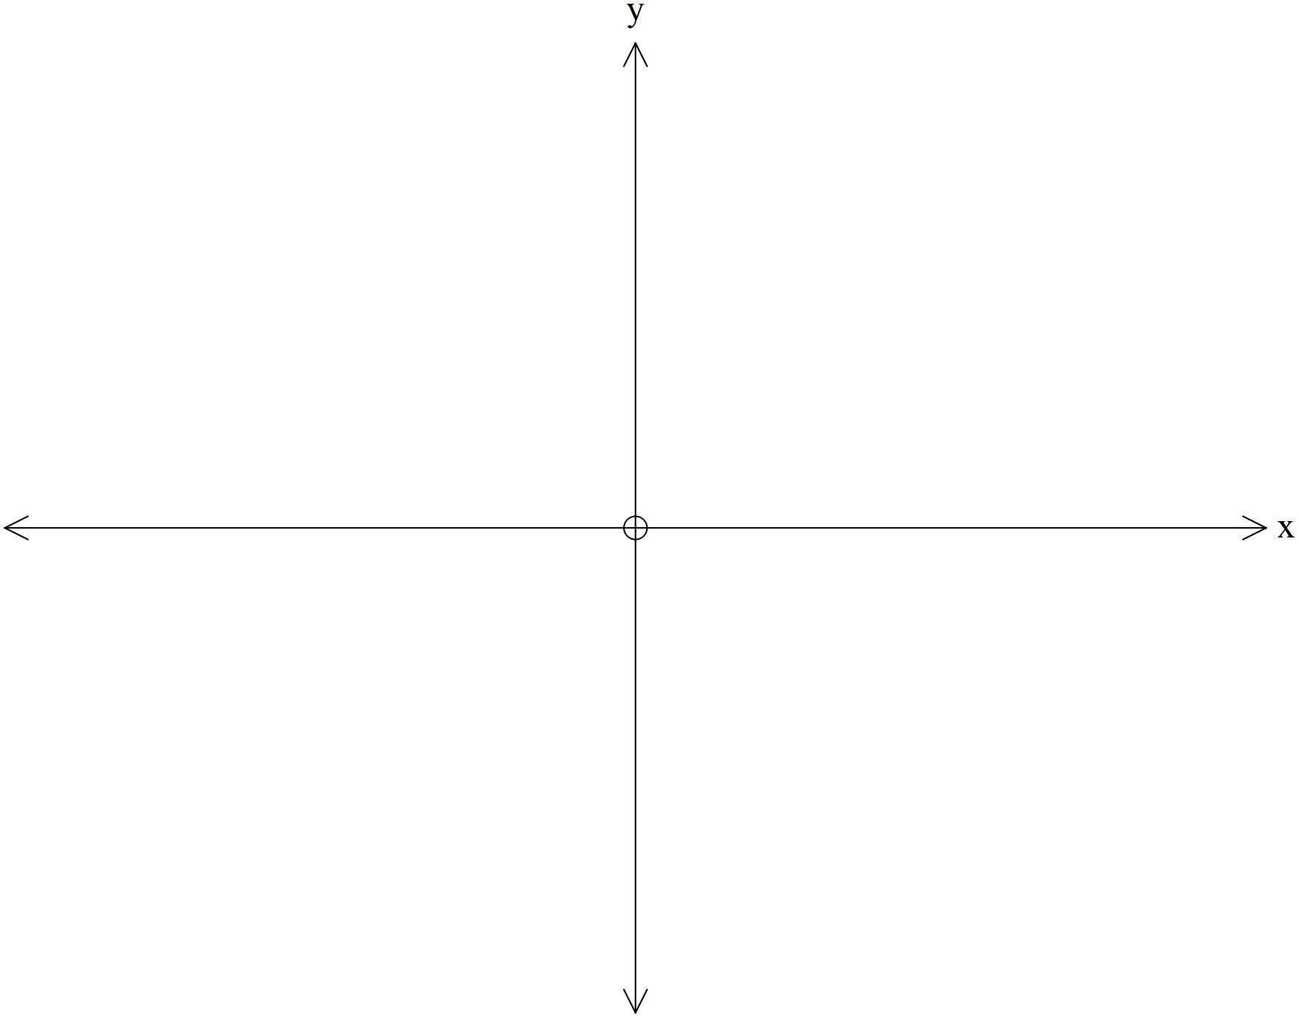

**Question 27 Calculator assumed (8 marks)**

Consider the function $f\left(x\right)=\log_{a}{(x-1)}$ where $a>1$.

**a)** On the axes below, sketch the graph of $f(x)$, labelling important features. (3 marks)



**b)** Determine the value of $m$ if $f\left(m\right)=1$. (2 marks)

**c)** Determine the coordinates of the $x$ intercept of $f\left(x+b\right)+c$, where $b$ and $c$ are positive real constants. (3 marks)

**Question 28 Calculator assumed (7 marks)**

The ear has the remarkable ability to handle an enormous range of sound levels. In order to express levels of sound meaningfully in numbers that are more manageable, a logarithmic scale is used, rather than a linear scale. This scale is the decibel (dB) scale.

The sound intensity level , is given by the formula below.

dB, where is the sound intensity and is the reference sound intensity.

and are measured watt/m2.

**a)** Listening to a sound intensity of 5 billion times that of the reference intensity $(I=5×{10}^{9}I_{0})$ for more than 30 minutes is considered unsafe. To what sound intensity level does this correspond?   
 (2 marks)

**b)** The reference sound intensity, $I_{0}$, has a sound intensity level of $0$ dB. If a household vacuum cleaner has a sound intensity watt/m2 and this corresponds to a sound intensity level $L=70$ dB, determine $I_{0}$. (2 marks)

The average sound intensity level for rainfall is $50$ dB and for heavy traffic $85$ dB.

**c)** How many times more intense is the sound of traffic than that of rainfall? (3 marks)

**Question 29 Calculator free (3 marks)**

Determine the following.

$\int_{0}^{1}{\frac{3x+1}{3x^{2}+2x+1}dx}$

**Question 30 Calculator free (8 marks)**

A company manufactures and sells items for $\$x$. The profit, $\$P$, made by the company per item sold is dependent on the selling price and can be modelled by the function:

$P\left(x\right)=\frac{50\ln\left(\frac{x}{2}\right)}{x^{2}}$ where $1.5≤x≤10$.

The graph of $P(x)$ is shown below:



**a)** Describehow the profit per item sold varies as the selling price changes. (3 marks)

**b)** Determine the exact price that should be charged for the item if the company wishes to maximise the profit per item sold. (5 marks)

**Question 31 Calculator free (10 marks)**

**a)** Determine a simplified expression for $\frac{d}{dx}(x\ln\left(x\right))$. (2 marks)

**b)** Use your answer from part **a)** to show that $\int{\ln{(x)}dx}=x\ln\left(x\right)-x+c$, where $c$ is a constant. (4 marks)

The graphs of the functions $f\left(x\right)=5$ and $g\left(x\right)=\ln{(x)}$ are shown below.



**c)** Determine the exact area enclosed between the $x-$ axis, the $y-$ axis and the functions $f\left(x\right)$  
 and $g(x)$. (4 marks)

**Question 32 Calculator free (6 marks)**

Consider the graph of $y=\ln\left(x\right)$ shown below.

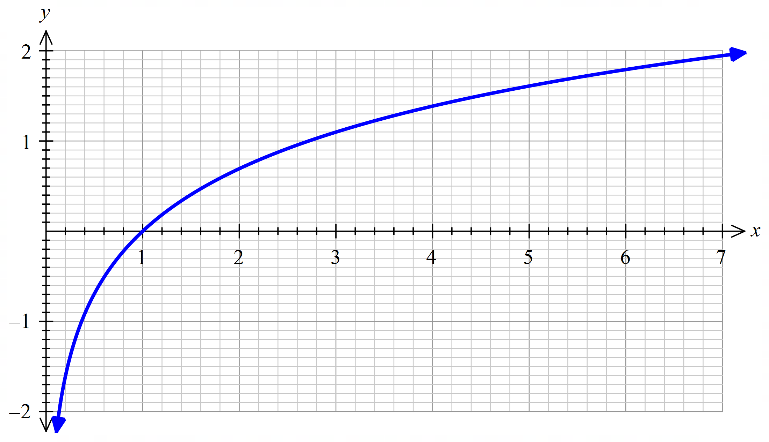

**a)** Use the graph to estimate the value of $p$ in each of the following:

**(i) $1.4=\ln\left(p\right)$**  (1 mark)

**(ii) $e^{p+1}-3=0$** (2 marks)

**b)** On the axes below sketch the graph of $y=\ln\left(x-2\right)+1$ (3 marks)

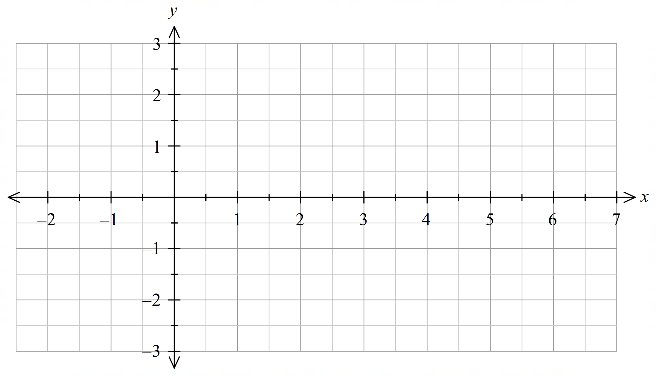

**Question 33 Calculator assumed (15 marks)**

A microbiologist is studying the effect of temperature on the growth of a certain type of bacteria under controlled laborotory conditions. A population of bacteria is incubated at a temperature of 30oC and the size of the population measured at hourly intervals for six hours. The logarithm of the population size appears to lie on a straight line when plotted against time (measured in hours) and the line of best fit shown on the axes below.

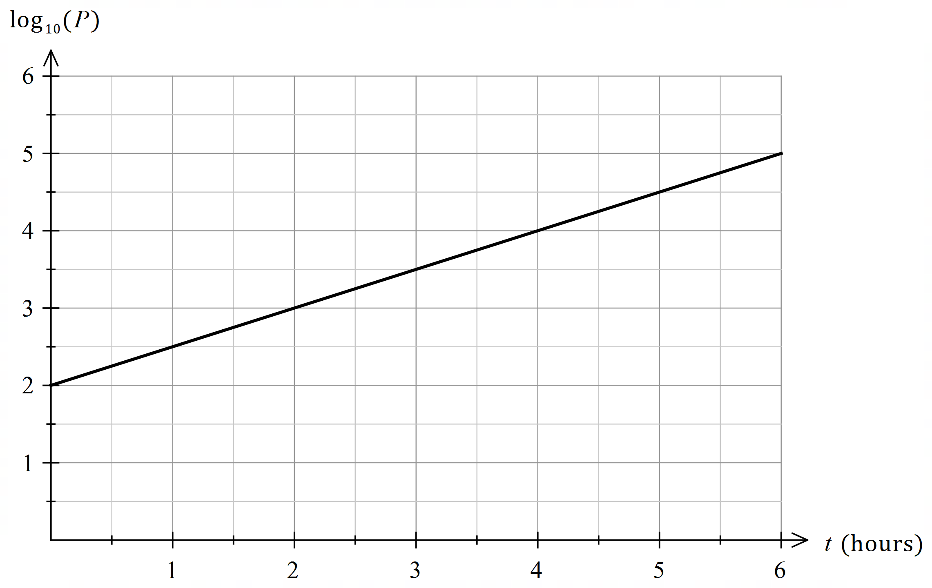

**a)** **(i)** On the basis of thegraph above, what is the size of the bacteria population after two hours?  
 (2 marks)

**(ii)** The equation of the line can be written in the form $\log_{10}\left(P\right)=At+B$. Use the graph to determine the values of $A$ and $B$. (2 marks)

Another populationof the same bacteria is cultured at 40oC. The size of the population, $P$, after $t$ hours satisfies the equation

$$\log_{10}\left(P\right)=\frac{1}{3}t+2$$

**b)** **(i)** Express the above equation in the form $P=A{\left(10\right)}^{Bt}$ (3 marks)

**(ii)** Determine the size of the population after exactly four hours to the nearest whole number.   
 (1 mark)

**(iii)** Express the above equation in the form $t=C\log_{10}\left(\frac{P}{D}\right)$ (3 marks)

**(iv)** How many minutes does it take for the population to reach a size of 5000? Give your answer to the nearest minute. (2 marks)

**c)** With reference to parts **a)** and **b)**, describe the effect of temperature on the population growth of this type of bacteria. (2 marks)

**Question 34 Calculator free (6 marks)**

Part of Josie’s workout at her gym involves a 10 minute run on a treadmill. The treadmill’s program makes her run at a constant 12.3 km/h for the first 2 minutes and then her speed, , is determined by the equation below, where is the time in minutes after she began running.

$s\left(t\right)=10-\frac{\ln\left(t-1.99\right)}{t}$ km/h

**a)** Sketch the graph of her speed during this run versus time on the axes below.  (3 marks)

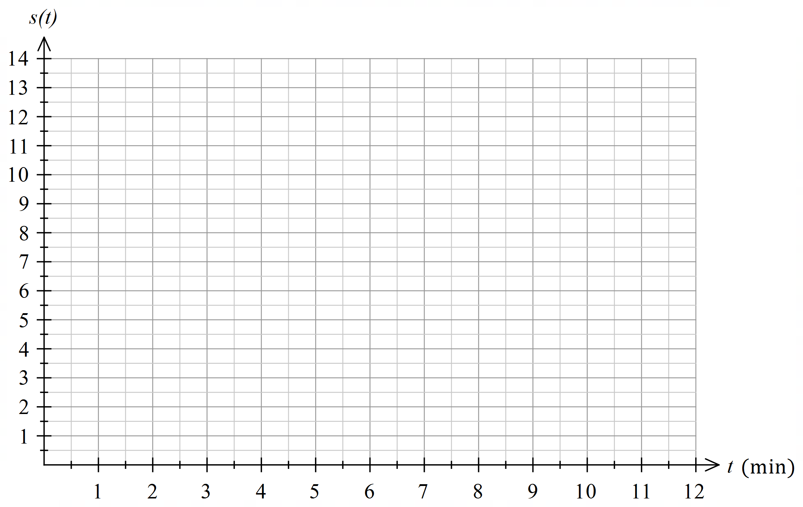

**b)** At what time(s) is Josie’s speed 10 km/h? (1 mark)

**c)** At what time(s) during her run is Josie’s acceleration zero? (2 marks)

**Question 35 Calculator free (8 marks)**

**a)** Determine the area bound by the graph of $f\left(x\right)=e^{x}$ and the $x-$ axis between $x=0$ and $x=\ln\left(2\right)$ (3 marks)

**b)** Hence, determine the area bound by the graph $f\left(x\right)=e^{x}$, the line $y=2$ and the $y-$ axis. (2 marks)

**c)** Determine the area bounded by the graph $f\left(x\right)=e^{x}$, the line $y=a$ and the $y-$ axis where $a$ is a positive constant. (3 marks)

Solutions

**Question 23 Calculator free (4 marks)**

Solve exactly $4e^{2x}=81-5e^{2x}$ exactly for $x$.

(4 marks)

|  |  |  |
| --- | --- | --- |
| **Solution** | **Specific behaviours** | **Point** |
| $4e^{2x}$ $=81-5e^{2x}$ $9e^{2x}$ $=81$ $e^{2x}$ $=9$ $\ln\left(e^{2x}\right)$ $=\ln{(9)}$ $2x$ $=\ln{(9)}$ $x$ $=\frac{\ln\left(9\right)}{2}$ | * collects exponential terms * uses natural logs to simplify the equation * uses log laws to simplify LHS of equation * solves exactly for $x$ | 4.1.5 |

**Question 24 Calculator free (6 marks)**

Given that $\log_{10}{2}=x$ and $\log_{10}{7}=y$

**a)** Express $\log_{10}{14}$ in terms of $x$ and $y$. (2 marks)

|  |  |  |
| --- | --- | --- |
| **Solution** | **Specific behaviours** | **Point** |
| $\log_{10}{14}$ $=\log_{10}\left(2×7\right)$ $=\log_{10}{2}+\log_{10}{7}$ $=x+y$ | * express $14$ as $2×7$* uses log laws to obtain the expression | 4.1.2 |

**b)** Show that $\log_{10}{17.5}=y-2x+1$. (2 marks)

|  |  |  |
| --- | --- | --- |
| **Solution** | **Specific behaviours** | **Point** |
| $\log_{10}{17.5}$ $=\log_{10}{\frac{7×10}{4}}$ $=\log_{10}{7}+\log_{10}{10}-\log_{10}{2^{2}}$ $=y-2x+1$ | * uses log laws to correctly expand * uses log law for a power to obtain the correct expression | 4.1.2 |

**c)** Evaluate ${10}^{y-x}.$ (2 marks)

|  |  |  |
| --- | --- | --- |
| **Solution** | **Specific behaviours** | **Point** |
| ${10}^{x}$ $=2$ ${10}^{y}$ $=7$ ${10}^{y-x}$ $=\frac{{10}^{y}}{{10}^{x}}$ $=\frac{7}{2}$ | * requires logarithmic equations in exponential form * uses index laws to evaluate | 4.1.1 |

**Question 25 Calculator free (7 marks)**

**a)** Evaluate $\int_{0}^{1}{\frac{-12x}{1+3x^{2}}}dx$. (3 marks)

|  |  |  |
| --- | --- | --- |
| **Solution** | **Specific behaviours** | **Point** |
| $\int_{0}^{1}{\frac{-12x}{1+3x^{2}}}dx$ $=-2\ln{{\left[1+3x^{2}\right]}_{0}^{1}}$ $=-2[\ln\left(4\right)-\ln\left(1\right)]$ $=\ln\left(\frac{1}{16}\right)$ (or $-\ln{16}$ or $-2\ln{4}$ | * identifies the solution involving $\ln{}$* determines correct expression * evaluates limits and correctly determines and simplifies solution | 4.1.13 |

**b)** Given $f\left(x\right)=\ln{(2-x^{3})}$

**(i)** determine $f'(1)$. (3 marks)

|  |  |  |
| --- | --- | --- |
| **Solution** | **Specific behaviours** | **Point** |
|  | * identifies the need for the quotient rule to find the derivative * correctly determines derivative * determines the derivative at $x=1$ | 4.1.13 |

**(ii)** In relation to the graph of $f(x)$, explain the meaning of your answer to **b)(i)**. (1 mark)

|  |  |  |
| --- | --- | --- |
| **Solution** | **Specific behaviours** | **Point** |
| $f'(1)$ is the gradient of the curve (or the tangent to the curve) at the point where $x=1$ | * explains meaning | 4.1.14 |

**Question 26 Calculator assumed (9 marks)**

Let $f\left(x\right)=x\ln{(x+3)}.$

**a)** Use calculus to locate and classify all the stationary points of $f(x)$ and find any points of inflection. (5 marks)

|  |  |  |
| --- | --- | --- |
| **Solution** | **Specific behaviours** | **Point** |
| $\frac{df}{dx}$ $=\frac{x}{x+3}+ln⁡(x+3)$ For stationary points            positive, ∴minimum  For point of inflections $\frac{d^{2}f}{dx^{2}}$ $=0$ $x$ $=-6$  No point of inflection as function is undefined for $x≤-3$ | * differentiates correctly * finds the critical point * finds $y$ co-ordinate and justifies minimum * finds second derivative * rejects point of inflection | 4.1.14 |

**b)** On the axes provided sketch the graph of $f(x)$, labelling all key features. (4 marks)

|  |  |  |
| --- | --- | --- |
| **Solution** | **Specific behaviours** | **Point** |
|  | * shows vertical asymptote * shows minimum * shows intercepts * has correct shape of graph | 4.1.6 |

**Question 27 Calculator assumed (8 marks)**

Consider the function $f\left(x\right)=\log_{a}{(x-1)}$ where $a>1$.

**a)** On the axes below, sketch the graph of $f(x)$, labelling important features. (3 marks)

|  |  |  |
| --- | --- | --- |
| **Solution** | **Specific behaviours** | **Point** |
|  | * asymptote at $x=1$* gives correct shape $x-$* intercept at $x=2$ | 4.1.6 |

**b)** Determine the value of $m$ if $f\left(m\right)=1$. (2 marks)

|  |  |  |
| --- | --- | --- |
| **Solution** | **Specific behaviours** | **Point** |
| $1$ $=\log_{a}\left(m-1\right)$ $m-1$ $=a$ $m$ $=a+1$ | * Equates $f(m)$ to 1 * Solves for $m$ | 4.1.6 |

**c)** Determine the coordinates of the $x$ intercept of $f\left(x+b\right)+c$, where $b$ and $c$ are positive real constants. (3 marks)

|  |  |  |
| --- | --- | --- |
| **Solution** | **Specific behaviours** | **Point** |
| $0$ $=\log_{a}\left(x-1+b\right)+c$ $-c$ $=\log_{a}\left(x-1+b\right)$ $a^{-c}$ $=x-1+b$ $x$ $=a^{-c}+ 1-b$ Coordinate is $(a^{-c}+ 1-b, 0)$ | * Equates new function to zero * Solves for $x$* States coordinate | 4.1.6 |

**Question 28 Calculator assumed (7 marks)**

The ear has the remarkable ability to handle an enormous range of sound levels. In order to express levels of sound meaningfully in numbers that are more manageable, a logarithmic scale is used, rather than a linear scale. This scale is the decibel (dB) scale.

The sound intensity level , is given by the formula below.

dB, where is the sound intensity and is the reference sound intensity.

and are measured watt/m2.

**a)** Listening to a sound intensity of 5 billion times that of the reference intensity $(I=5×{10}^{9}I_{0})$ for more than 30 minutes is considered unsafe. To what sound intensity level does this correspond?   
 (2 marks)

|  |  |  |
| --- | --- | --- |
| **Solution** | **Specific behaviours** | **Point** |
| $L$ $=10\log\left(\frac{5×{10}^{9}I_{0}}{I_{0}}\right)$ $≈97$ dB | * Substitutes for $L$* Calculates level | 4.1.8 |

**b)** The reference sound intensity, $I_{0}$, has a sound intensity level of $0$ dB. If a household vacuum cleaner has a sound intensity watt/m2 and this corresponds to a sound intensity level $L=70$ dB, determine $I_{0}$. (2 marks)

|  |  |  |
| --- | --- | --- |
| **Solution** | **Specific behaviours** | **Point** |
| watt/m2 | * Substitutes for $L$ and $I$* Determines $I_{0}$ including units | 4.1.8 |

The average sound intensity level for rainfall is $50$ dB and for heavy traffic $85$ dB.

**c)** How many times more intense is the sound of traffic than that of rainfall? (3 marks)

|  |  |  |
| --- | --- | --- |
| **Solution** | **Specific behaviours** | **Point** |
| $50$ $=10\log\left(\frac{I_{rain}}{I_{0}}\right)$ $\frac{I_{rain}}{I_{0}}$ $={10}^{5}$ $I_{rain}$ $={10}^{5}I_{0}$ $85$ $=10\log\left(\frac{I_{traffic}}{I_{0}}\right)$ $\frac{I_{traffic}}{I_{0}}$ $={10}^{8.5}$ $I_{traffic}$ $={10}^{8.5}I_{0}$ $\frac{I_{traffic}}{I_{rain}}$ $=\frac{{10}^{8.5}}{{10}^{5}}$ $={10}^{3.5}$ $≈3200$ | * Rearranges logarithmic equation      * Writes ratio and cancels $I_{0}$* Determines how many more times intense | 4.1.8 |

**Question 29 Calculator free (3 marks)**

Determine the following

$\int_{0}^{1}{\frac{3x+1}{3x^{2}+2x+1}dx}.$

|  |  |  |
| --- | --- | --- |
| **Solution** | **Specific behaviours** | **Point** |
| $\int_{0}^{1}{\frac{3x+1}{3x^{2}+2x+1}dx}$ $=\frac{1}{2}\int_{0}^{1}{\frac{6x+2}{3x^{2}+2x+1}dx}$ $={\frac{1}{2}\left[\ln{(3x^{2}+2x+1)}\right]}_{0}^{1}$ $=\frac{1}{2}\left(\ln{6}-\ln{1}\right)$ $=\frac{\ln{6}}{2}$ | * Modifies the integrand so the numerator function is the derivative of the denominator function * Correctly determines an expression for the integral * Substitutes and uses log laws to determine a simplified answer | 4.1.13 |

**Question 30 Calculator free (8 marks)**

A company manufactures and sells items for $\$x$. The profit, $\$P$, made by the company per item sold is dependent on the selling price and can be modelled by the function:

$P\left(x\right)=\frac{50\ln\left(\frac{x}{2}\right)}{x^{2}}$ where $1.5≤x≤10$.

The graph of $P(x)$ is shown below:



**a)** Describehow the profit per item sold varies as the selling price changes (3 marks)

|  |  |  |
| --- | --- | --- |
| **Solution** | **Specific behaviours** | **Point** |
| The company will make a loss for a selling price between $1.50 and $2.00. The profit then increases up to approximately $2.25 per item sold for a selling price of approximately $3.25 and then decreases steadily to a value of less than $1 per item sold for a selling price of $10. | * States initially making a loss * States profit increases to a maximum at $3.25 * States it decreases after that | 4.1.7 |

**b)** Determine the exact price that should be charged for the item if the company wishes to maximise the profit per item sold. (5 marks)

|  |  |  |
| --- | --- | --- |
| **Solution** | **Specific behaviours** | **Point** |
| $\frac{dP}{dx}$ $=\frac{x^{2}\left(\frac{50}{2}×\frac{2}{x}\right)-2x×50\ln\left(\frac{x}{2}\right)}{x^{4}}$ $=\frac{50x-100x\ln\left(\frac{x}{2}\right)}{x^{4}}$ $=\frac{50-100\ln\left(\frac{x}{2}\right)}{x^{3}}$ For max $\frac{dP}{dx}$ $=0$ $0$ $=\frac{50-100\ln\left(\frac{x}{2}\right)}{x^{3}}$ $0$ $=50-100\ln\left(\frac{x}{2}\right)$ $\ln\left(\frac{x}{2}\right)$ $=\frac{1}{2}$ $\frac{x}{2}$ $=e^{\frac{1}{2}}$ $x$ $=2e^{\frac{1}{2}}$ | * Correctly states the numerator of the quotient rule * Correctly states the denominator of the quotient rule * Simplifies derivative * Equates simplified derivative to zero * Determines exact value of $x$ | 4.1.14 |

**Question 31 Calculator free (10 marks)**

**a)** Determine a simplified expression for $\frac{d}{dx}(x\ln\left(x\right))$. (2 marks)

|  |  |  |
| --- | --- | --- |
| **Solution** | **Specific behaviours** | **Point** |
| $\frac{d}{dx}(x\ln\left(x\right))$ $=x×\frac{1}{x}+ln⁡(x)$ $=1+ln⁡(x)$ | * Use product rule to determine derivative * Simplifies the derivative | 4.1.13 |

**b)** Use your answer from part **a)** to show that $\int{\ln{(x)}dx}=x\ln\left(x\right)-x+c$, where $c$ is a constant. (4 marks)

|  |  |  |
| --- | --- | --- |
| **Solution** | **Specific behaviours** | **Point** |
| $\frac{d}{dx}(x\ln\left(x\right))$ $=1+ln⁡(x)$ $\int{\frac{d}{dx}(x\ln\left(x\right))dx }$ $=\int{\left(1+ln⁡(x)\right)}dx$ $x\ln\left(x\right)$ $=x+\int{ln⁡(x)}dx+c$ $\int{ln⁡(x)}dx$ $=xln⁡(x)-x+c$ | * Integrates both sides of the answer from part **a)** * Partly integrates right-hand side to get $x$* Applies Fundamental Theorem of Calculus to simplify the left-hand side * Rearranges to give required result | 4.1.13 |

The graphs of the functions $f\left(x\right)=5$ and $g\left(x\right)=\ln{(x)}$ are shown below.



**c)** Determine the exact area enclosed between the $x-$ axis, the $y-$ axis and the functions $f\left(x\right)$  
 and $g(x)$. (4 marks)

|  |  |  |
| --- | --- | --- |
| **Solution** | **Specific behaviours** | **Point** |
| Intersect when: $ln⁡(x)$ $=5$ $x$ $=e^{5}$ Area under $f\left(x\right)$ $=\int_{1}^{e^{5}}{ln⁡(x)dx}$ $={[xln⁡(x)-x]}_{1}^{e^{5}}$ $=5e^{5}-e^{5}+1$  Required area $=5×e^{5}-(5e^{5}-e^{5}+1)$ $=e^{5}-1$ | * Determines point of intersection between $f(x)$ and $g(x)$* States an integral for the area under $f(x)$* Evaluates integral * Determines required area | 4.1.14 |

**Question 32 Calculator free (6 marks)**

Consider the graph of $y=\ln\left(x\right)$ shown below.



**a)** Use the graph to estimate the value of $p$ in each of the following:

**(i) $1.4=\ln\left(p\right)$**  (1 mark)

|  |  |  |
| --- | --- | --- |
| **Solution** | **Specific behaviours** | **Point** |
| $p=4$ | * States correct value of $p$ | 4.1.7 |

**(ii) $e^{p+1}-3=0$** (2 marks)

|  |  |  |
| --- | --- | --- |
| **Solution** | **Specific behaviours** | **Point** |
| $e^{p+1}$ $=3$ $p+1$ $=\ln\left(3\right)$ $=1.1$ $p$ $=0.1$ | * Rearranges to for a logarithmic equation * States correct value of $p$ | 4.1.7 |

**b)** On the axes below sketch the graph of $y=\ln\left(x-2\right)+1$ (3 marks)

|  |  |  |
| --- | --- | --- |
| **Solution** | **Specific behaviours** | **Point** |
|  | * Draws asymptote at $x=2$* The sketch passes through the point $(3,1)$* The sketch has the correct shape and has a $y-$ coordinate between 2.5 and 3 when $x=7$ | 4.1.6 |

**Question 33 Calculator assumed (15 marks)**

A microbiologist is studying the effect of temperature on the growth of a certain type of bacteria under controlled laborotory conditions. A population of bacteria is incubated at a temperature of 30oC and the size of the population measured at hourly intervals for six hours. The logarithm of the population size appears to lie on a straight line when plotted against time (measured in hours) and the line of best fit shown on the axes below.



**a)** **(i)** On the basis of thegraph above, what is the size of the bacteria population after two hours?  
 (2 marks)

|  |  |  |
| --- | --- | --- |
| **Solution** | **Specific behaviours** | **Point** |
| $\log_{10}\left(P\right)$ $=3$ $P$ $={10}^{3}$ $=1000$ | * Identifies the correct value of $\log_{10}\left(P\right)$* Uses the inverse relationship between $\log_{10}\left(x\right)$ and ${10}^{x}$ to solve for $P$ | 4.1.4 |

**(ii)** The equation of the line can be written in the form $\log_{10}\left(P\right)=At+B$. Use the graph to determine the values of $A$ and $B$. (2 marks)

|  |  |  |
| --- | --- | --- |
| **Solution** | **Specific behaviours** | **Point** |
| Gradient of $\frac{1}{2}$ and vertical intercept of 2 $\log_{10}\left(P\right)=\frac{1}{2}t+2$ | * Determines the correct value for $A$* Determines the correct value for $B$ | 4.1.4 |

Another populationof the same bacteria is cultured at 40oC. The size of the population, $P$, after $t$ hours satisfies the equation

$$\log_{10}\left(P\right)=\frac{1}{3}t+2$$

**b)** **(i)** Express the above equation in the form $P=A{\left(10\right)}^{Bt}$ (3 marks)

|  |  |  |
| --- | --- | --- |
| **Solution** | **Specific behaviours** | **Point** |
| $\log_{10}\left(P\right)$ $=\frac{1}{3}t+2$ $P$ $={10}^{\frac{t}{3}+2}$ $={10}^{\frac{t}{3}}×{10}^{2}$ $=100×{10}^{\frac{t}{3}}$ | * Uses the inverse relationship between $\log_{10}{(x)}$ and ${10}^{x}$* Uses appropriate index law * Determines correct expression | 4.1.3 |

**(ii)** Determine the size of the population after exactly four hours to the nearest whole number.   
 (1 mark)

|  |  |  |
| --- | --- | --- |
| **Solution** | **Specific behaviours** | **Point** |
| $P$ $=100×{10}^{\frac{4}{3}}$ $P$ $≈2154$ | * Evaluates the population rounded to a whole number | 4.1.5 |

**(iii)** Express the above equation in the form $t=C\log_{10}\left(\frac{P}{D}\right)$ (3 marks)

|  |  |  |
| --- | --- | --- |
| **Solution** | **Specific behaviours** | **Point** |
| $\log_{10}\left(P\right)$ $=\frac{1}{3}t+2$ $\log_{10}\left(P\right)-2$ $=\frac{1}{3}t$ $\log_{10}\left(P\right)-\log_{10}\left(100\right)$ $=\frac{1}{3}t$ $\log_{10}\left(\frac{P}{100}\right)$ $=\frac{1}{3}t$ $t$ $=3\log_{10}\left(\frac{P}{100}\right)$ | * Expresses 2 in terms of a log of base 10 * Applies appropriate log law to arrive at single log expression * Determines correct expression | 4.1.3 |

**(iv)** How many minutes does it take for the population to reach a size of 5000? Give your answer to the nearest minute. (2 marks)

|  |  |  |
| --- | --- | --- |
| **Solution** | **Specific behaviours** | **Point** |
| $t$ $=3\log_{10}\left(\frac{5000}{100}\right)$ $t$ $≈5.0969$ $≈306$ minutes | * Evaluates the time in hours * Coverts to minutes (rounded to the nearest minute) | 4.1.7 |

**c)** With reference to parts **a)** and **b)**, describe the effect of temperature on the population growth of this type of bacteria. (2 marks)

|  |  |  |
| --- | --- | --- |
| **Solution** | **Specific behaviours** | **Point** |
| The equation at 30 degrees has a greater slope than that of the 40 degree equation which indicates a greater growth rate. Parts **a)** and **b)** would seem to indicate that the lower temperature incubation results in a higher growth rate. | * Identifies features of the equations in parts **a)** and **b)** that relate to growth * States lower temperature has higher growth | 4.1.8 |

**Question 34 Calculator free (6 marks)**

Part of Josie’s workout at her gym involves a 10 minute run on a treadmill. The treadmill’s program makes her run at a constant 12.3 km/h for the first 2 minutes and then her speed, , is determined by the equation below, where is the time in minutes after she began running.

$s\left(t\right)=10-\frac{\ln\left(t-1.99\right)}{t}$ km/h

**a)** Sketch the graph of her speed during this run versus time on the axes below.  (3 marks)

|  |  |  |
| --- | --- | --- |
| **Solution** | **Specific behaviours** | **Point** |
|  | * Correctly graphs $y=12.3$* Correctly graphs $s(t)$* Shows scale and graphs do not exceed $[0, 10]$ domain | 4.1.8 |

**b)** At what time(s) is Josie’s speed 10 km/h? (1 mark)

|  |  |  |
| --- | --- | --- |
| **Solution** | **Specific behaviours** | **Point** |
| $10$ $=10-\frac{\ln\left(t-1.99\right)}{t}$ $0$ $=\frac{\ln\left(t-1.99\right)}{t}$ $t$ $=2.99$ Only point if the given domain is $(2.99, 10)$ She runs at 10 km/h when she has run for 2.99 minutes. | * States correct time | 4.1.8 |

**c)** At what time(s) during her run is Josie’s acceleration zero? (2 marks)

|  |  |  |
| --- | --- | --- |
| **Solution** | **Specific behaviours** | **Point** |
| She has zero acceleration for the first two minutes of her run and at the instant $t=6.30$ From CAS, minimum at $(6.30, 9.77)$ | * States first 2 minutes * States 6.30 minutes | 4.1.7 |

**Question 35 Calculator free (8 marks)**

**a)** Determine the area bound by the graph of $f\left(x\right)=e^{x}$ and the $x-$ axis between $x=0$ and $x=\ln\left(2\right)$ (3 marks)

|  |  |  |
| --- | --- | --- |
| **Solution** | **Specific behaviours** | **Point** |
| $A$ $=\int_{0}^{\ln{2}}{e^{x}}dx$ $={\left[e^{x}\right]}_{0}^{\ln{2}}$ $=2-1$ $=1$ | * Writes down the correct integral * Integrates correctly * Simplifies to obtain final answer | 4.1.14 |

**b)** Hence, determine the area bound by the graph $f\left(x\right)=e^{x}$, the line $y=2$ and the $y-$ axis. (2 marks)

|  |  |  |
| --- | --- | --- |
| **Solution** | **Specific behaviours** | **Point** |
| $A=2\ln{2}-1$ | * Correctly defines the area * Calculates the area correctly | 4.1.14 |

**c)** Determine the area bounded by the graph $f\left(x\right)=e^{x}$, the line $y=a$ and the $y-$ axis where $a$ is a positive constant. (3 marks)

|  |  |  |
| --- | --- | --- |
| **Solution** | **Specific behaviours** | **Point** |
| $\int_{0}^{\ln{a}}{e^{x}}dx$ $={\left[e^{x}\right]}_{0}^{\ln{a}}$ $=a-1$ Area $=\ln{(a)}×a-(a-1)$ $=a\ln{(a)}-a+1$ | * Writes down correct integral * Integrates correctly and simplifies to obtain $a-1$* Determines the correct expression for area | 4.1.14 |

5. Continuous random variables and the normal distribution

Topic 4.2: Continuous random variables and the normal distribution

**General continuous random variables**

4.2.1 use relative frequencies and histograms obtained from data to estimate probabilities associated with a continuous random variable

4.2.2 examine the concepts of a probability density function, cumulative distribution function, and probabilities associated with a continuous random variable given by integrals; examine simple types of continuous random variables and use them in appropriate contexts

4.2.3 identify the expected value, variance and standard deviation of a continuous random variable and evaluate them using technology

4.2.4 examine the effects of linear changes of scale and origin on the mean and the standard deviation

**Normal distributions**

4.2.5identify contexts, such as naturally occurring variation, that are suitable for modelling by normal random variables

4.2.6identify features of the graph of the probability density function of the normal distribution with mean $μ$ and standard deviation $σ$ and the use of the standard normal distribution

4.2.7calculate probabilities and quantiles associated with a given normal distribution using technology, and use these to solve practical problems

Continuous random variables

Continuous random variables are measured values that can take any value along an interval. $a≤x≤b$.

If $X$ is a continuous random variable then for its probability density function $f(x)$ the following conditions must hold true:

* Be within the defined domain, $f\left(x\right)≥0$ (the graph is never below the $x-$ axis).
* $\int_{a}^{b}{f(x)}dx=1$ (The total enclosed area between the graph and the $x$- axis is 1.

The probability density function for a continuous random variable $X$ is defined as $P(x)$ for the interval $[a,b]$ and is found by determining the area under the curve between $a$ and $b$. $P\left(a≤x≤b\right)=\int_{a}^{b}{f(x)}dx$

The mean or the expected value is $μ=E\left(X\right)=\int_{a}^{b}{x×f(x)}dx$

The variance is $σ^{2}=Var\left(X\right)=\int_{a}^{b}{{\left(x-μ\right)}^{2}×f(x)}dx$

$=E\left(X^{2}\right)-[E{\left(X\right)]}^{2}$

$=\int_{a}^{b}{x^{2}×f\left(x\right)}dx-μ^{2}$

The standard deviation of a random variable $X$ is the square root of the variance $SD\left(X\right)=σ=\sqrt{Var\left(X\right)}$

The median is $m$ such that $\int_{-∞}^{m}{f(x)}dx=0.5$

Linear transformations of a continuous random variable: $E\left(aX+b\right)$ $=aE\left(X\right)+b$

$Var\left(aX+b\right)$ $=a^{2}Var\left(X\right)$

$SD\left(aX+b\right)$ $=|a|SD(X)$

The cumulative distribution function of a continuous random is defined by:

)

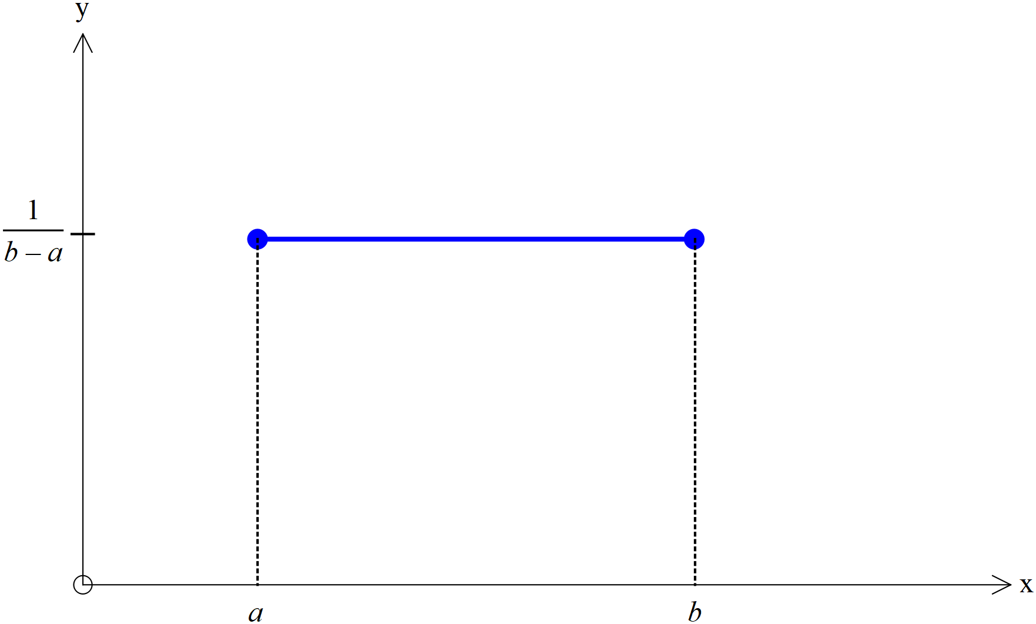

Uniform Distributions

A continuous random variable is uniformly distributed when the random variable is equally likely to take any value in the interval $\left[a, b\right]$

A uniform distribution is rectangular in shape

The probability density function is defined by:

$f\left(x\right)=\left\{\begin{aligned}\frac{1}{b-a}, &a≤x≤b \\ 0, & elsewhere\end{aligned}\right.$

The expected value for a uniform distribution is given by:

$E\left(X\right)=\frac{a+b}{2}$

Normal distributions

$X\sim N(μ,σ^{2})$ ( $X$ is normally distributed with a mean of $μ$ and a standard deviation of $σ$.)

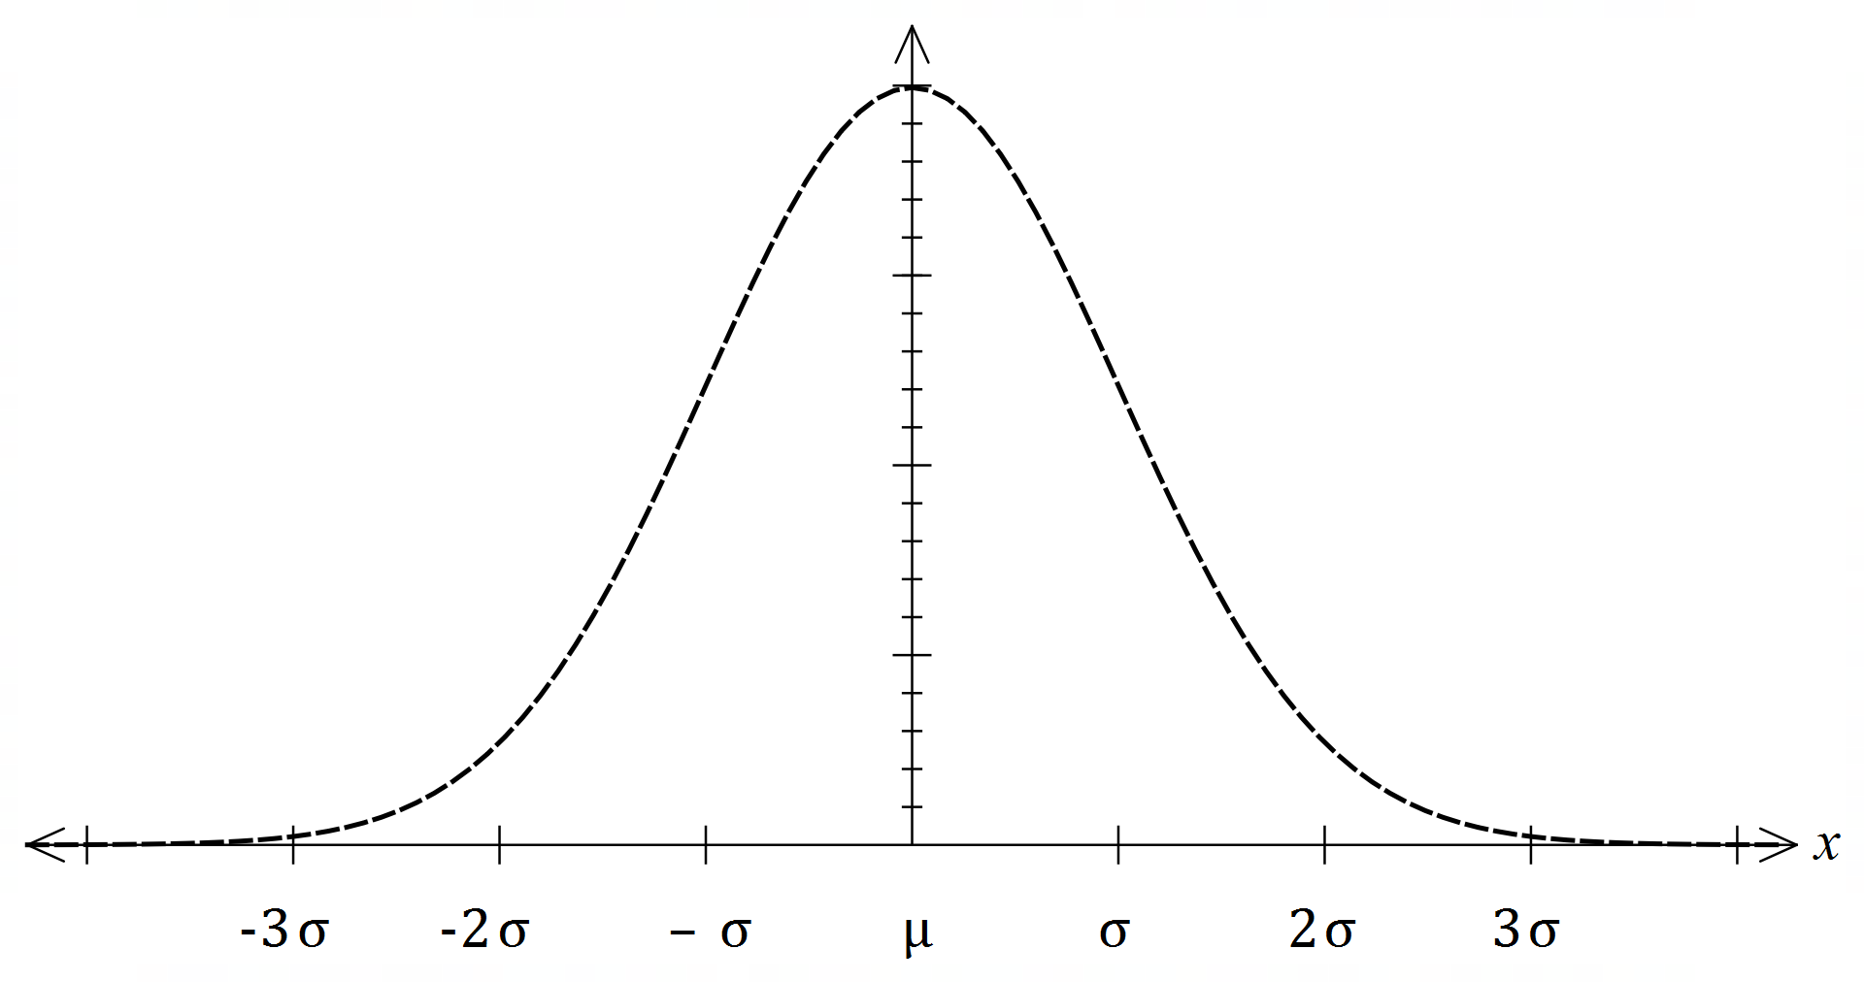The standard normal variable $Z$ has a mean of 0 and a standard deviation of 1.

The standard score is calculated by:

$z=\frac{x-μ}{σ}$

This standardised score indicates the number of standard deviations the value $x$ is away from the mean.

The graph of a normal distribution is a symmetrical bell-shaped curve.

The area under the curve $[-∞, ∞]$ is 1

Approximately:

* 68% of values lie within one standard deviation of the mean
* 95% of values lie within two standard deviations of the mean and
* 99.7% of values lie within three standard deviations of the mean.

Examples

**23.** An automated milk bottle machine fills bottles to between 247 ml and 255 ml such that the amount of milk follows a uniform distribution. The label on the bottle states that it holds 250 ml

**a)** Determine the probability that a bottle selected randomly from the conveyor belt of this machine contains less than the labelled amount.

|  |
| --- |
| $P\left(X<250\right)=\frac{3}{8}$ |

**b)** Calculate the mean and standard deviation of the amount of milk in the bottles.

|  |
| --- |
| Mean $=\frac{255+247}{2}$ $=251$  Standard deviation $=\sqrt{\int_{247}^{255}{\frac{1}{8}×{\left(x-251\right)}^{2}dx}}$ $=2.3094$ |

A worker selects bottles from the conveyor belt, one at a time.

**c)** Determine the probability that it takes the selection of 15 bottles before five bottles containing less than the labelled amount have been selected.

|  |
| --- |
| $X\sim B\left(14,\frac{3}{8}\right)$ $P\left(X=4\right)=0.1800359861$ $0.1800359861×\frac{3}{8}=0.0675$ |

**24.** A school has analysed the examination scores for all its Year 12 students taking Methods as a subject. Let $X=$ the examination percentage of the Methods Year 12 students at the school. The school found that the mean was 75 with a standard deviation of 22.

Determine the following:

**a) $E(X+5)$**

|  |
| --- |
| $E\left(X+5\right)$ $=E\left(X\right)+5$ $=80$ |

**b) $Var(25-2X)$**

|  |
| --- |
| $Var\left(25-2X\right)$ $=2^{2}Var\left(X\right)$ $=4×{22}^{2}$ $=1936$ |

The school has decided to scale the results using the transformation $Y=aX+b$ where $a$ and $b$ are constants and $Y=$ the scaled percentage scores. The aim is to change the mean to 60 and the standard deviation to 15.

**c)** Determine the values of $a$ and $b$.

|  |
| --- |
| $15$ $=22a$ $a$ $=\frac{15}{22}$ $=0.682$ $60$ $=75a+b$ $b$ $=\frac{195}{22}$ $=8.864$ |

**25.** The waiting times at a Perth Airport departure lounge have been found to be normally distributed. It is observed that passengers wait for less than 55 minutes, 5% of the time, while there is a 13% chance that the waiting times will be greater than 100 minutes.

**a)** Determine the mean and standard deviation for the waiting times at Perth Airport departure lounge.

|  |
| --- |
| $\left\{\begin{aligned}-1.64485=\frac{55-μ}{σ} \\ 1.12639=\frac{100-μ}{σ}\end{aligned}\right.$ $μ=81.71, σ=16.24$ |

**b)** Determine the probability that the waiting time will be 75 minutes and 90 minutes

|  |
| --- |
| $X\sim N\left({81.71,16.24}^{2}\right)$ $P\left(75≤X≤90\right)=0.3554$ |

Exam practice questions

**Question 36 Calculator free (5 marks)**

Anastasia is a university student. She records the time it takes for her to get from home to her campus each day. The histogram of relative frequencies below shows the journey times she recorded.



Use the above data to estimate the probability of her next journey from home to her university campus

**a)** taking her less than 36 minutes. (1 mark)

**b)** taking at least 35 minutes but no more than 39 minutes. (2 marks)

On three consecutive days, Anastasia needs to be on campus no later than 10 am.

**c)** If she leaves her home at 9.22 am each day, use the above data to estimate the probability that she makes it on or before time on all three days. (2 marks)

**Question 37 Calculator free (6 marks)**

Michelle is a soccer goalkeeper and has built a machine to help her practise. The machine will shoot a soccer ball randomly along the ground at or near a goal that is seven metres wide. The machine is equally likely to shoot the ball so that the centre of the ball crosses the goal line anywhere between point A three metres left of the goal, and point B five metres fight of the goal, as shown in the diagram below.



Michelle sets up a trial run without anyone in the goals. Assume the goal posts are of negligible width.

Let the random variable be the distance the centre of the ball crosses the goal line to the right of point A.

**a)** Complete the graphical representation of the probability density function for the random variable $X.$  
 (2 marks)

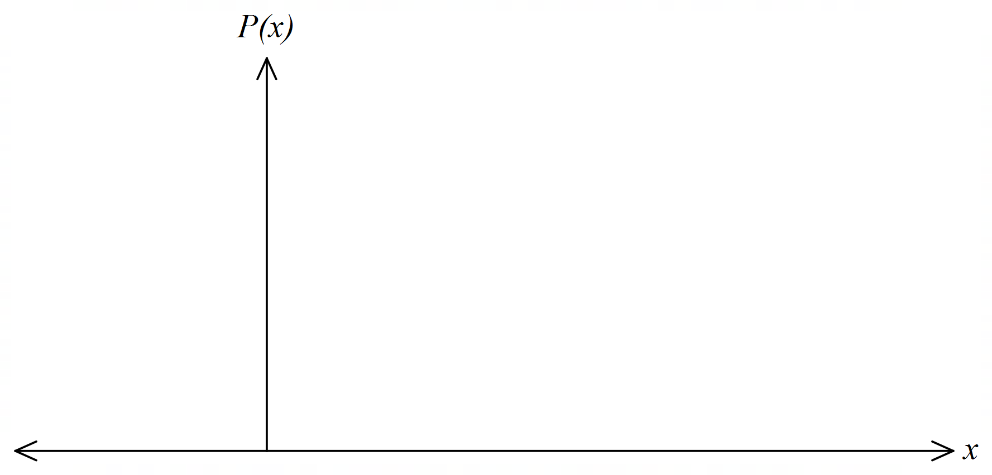

**b)** What is the probability that the machine shoots a ball so that its centre misses the goal to the left? (1 mark)

**c)** What is the probability that the machine shoots a ball so that its centre is inside a goal? (1 mark)

**d)** If the machine shoots a ball so that its centre misses the goal, what is the probability that the ball’s centre misses to the right? (2 marks)

**Question 38 Calculator assumed (9 marks)**

A pizza shop estimates that the time $X$ hours to deliver a pizza from when it is ordered is a continuous random variable with probability density function given by

$f\left(x\right)=\left\{\begin{aligned}\frac{4}{3}-\frac{2}{3}x , 0<x<1 \\ 0 , otherwise\end{aligned}\right.$

**a)** What is the probability of a pizza being delivered within half an hour of being ordered? (2 marks)

**b)** Calculate the mean delivery time to the nearest minute. (3 marks)

**c)** Calculate the standard deviation of the delivery time to the nearest minute. (4 marks)

**Question 39 Calculator assumed (12 marks)**

A global financial institution transfers a large aggregate data file every evening from offices around the world to its Hong Kong head office. Once the file is received it must be processed in the company’s data warehouse. The time required to process a file is normally distributed with a mean of 90 minutes and a standard deviation of 15 minutes.

**a)** An evening is selected at random. What is the probability that it takes more than two hours to process the file? (2 marks)

**b)** What is the probability that the process takes more than two hours on two out of five days in a week? (3 marks)

The company is considering outsourcing the processing of the files.

**c)** **(i)** A quotation for this job from an IT company is given in the table below.   
 Complete the table. (1 mark)

|  |  |  |  |
| --- | --- | --- | --- |
| Job duration (minutes) | $$T≤60$$ | $$60<T≤120$$ | $$T≥120$$ |
| Probability |  |  |  |
| Cost $Y$ $ | 200 | 600 | 1200 |

**(ii)** What is the mean cost? (2 marks)

**(iii)** Calculate the standard deviation of the cost. (2 marks)

**(iv)** In the following year, the cost (currently $\$Y$) will increase due to inflation and also the introduction of an additional fixed cost, so the new cost is given by:  
 .   
 In terms of $a$ and/or $b$, state the mean cost in the following year and the standard deviation of the cost in the following year. (2 marks)

**Question 40 Calculator free (6 marks)**

For a set of data values that are normally distributed, approximately 68% of the values will lie within one standard deviation of the mean, approximately 95% of the values will lie within two standard deviations of the mean and approximately 99.7% of the values will lie within three standard deviations of the mean.

If the heights of a large group of women are normally distributed with a mean cm and standard deviation cm, use the above information to answer the following questions.

**a)** A statistician says that almost all of the women have heights in the range 142 cm to 184 cm. Comment on her statement. (2 marks)

**b)** Approximately what percentage of women in the group has a height greater than 170 cm? (2 marks)

**b)** Approximately 2.5% of the women are shorter than what height? (2 marks)

**Question 41 Calculator assumed (17 marks)**

The manager of a the mail distribution centre in an organisation estimates that the weight (kg), of parcels that are posted is normally distributed, with mean 3 kg and standard deviation 1 kg.

**a)** What percentage of parcels weigh more than 3.7 kg? (2 marks)

**b)** Twenty parcels are received for posting. What is the probability that at least half of them weight more than 3.7 kg? (3 marks)

The cost of postage $\left(\$\right)y$, depends on the weight of a parcel as follows:

* A cost of $\$5$ for parcels 1 kg or less.
* An additional variable cost of for every kilogram or part thereof above 1 kg to a maximum of 4 kg.
* A cost of $\$12$ for parcels above 4 kg

**c)** Complete the probability distribution table for $Y$. (4 marks)

|  |  |  |  |  |  |
| --- | --- | --- | --- | --- | --- |
| $$x$$ | $$x≤1$$ | $$1<x≤2$$ | $$2<x≤3$$ | $$3<x≤4$$ | $$x≥4$$ |
| $$y$$ | $5 |  |  |  |  |
| $$P(Y=y)$$ |  |  |  |  |  |

**d)** Calculate the mean cost of postage per parcel. (2 marks)

**e)** Calculate the standard deviation of the cost of postage per parcel. (2 marks)

**f)** If the cost of postage is increased by 20% and a surcharge of $\$$ 1 is added for all parcels, what will be the mean and standard deviation of the new cost? (2 marks)

**g)** Give one reason why the given normal distribution is not a good model for the weight of the parcels. (2 marks)

**Question 42 Calculator assumed (10 marks)**

The error $X$ in digitising a communication signal has a uniform distribution with probability density function given by

$f\left(x\right)=\left\{\begin{aligned}1, &-0.5<x<0.5 \\ 0, & otherwise\end{aligned}\right.$

**a)** Sketch the graph of $f(x)$. (2 marks)

**b)** What is the probability that the error is at least 0.35? (2 marks)

**c)** If the error is negative, what is the probabilty that it is less than $-0.35$? (2 marks)

**d)** An engineer is more interested in the square of the error. What is the probability that the square of the error is less than 0.09? (2 marks)

**e)** Calcutate the variance of the error. (2 marks)

**Question 43 Calculator free (6 marks)**

Waiting times for patients at a hospital emergency department can be up to four hours. The associated probability density function is shown below.

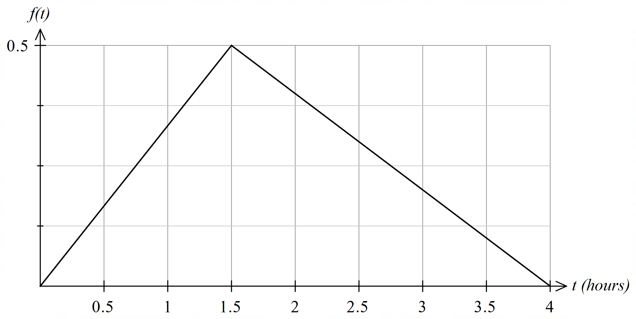

**a)** What is the probability a patient will wait less than one hour? (2 marks)

**b)** What is the probabilty a patient will wait between one hour and three hours? (4 marks)

**Question 44 Calculator assumed (8 marks)**

A pizza company runs a marketing campaign based on the delivery times of its pizzas. The company claims that it will deliver a pizza in a radius of 5 km within 30 minutes of ordering or it is free. The manager estimates that the actual time, , from order to delivery is normally distributed with mean 25 minutes and standard deviation 2 minutes.

**a)** What is the probabilty that a pizza is delivered free? (1 mark)

**b)** On a busy Saturday evening, a total of 50 pizzas are ordered. What is the probability that more than three are delivered free? (2 marks)

The company wants to reduce the percentage of pizzas that are delivered free to 0.1%.

**c)** The manager suggestes this can be achieved by increasing the advertised delivery time. What should the advertised delivery time be? (2 marks)

After some additional training, the company was able to maintain the advertised delivery time of 30 minutes but reduce the percentage of pizzas delivered free to 0.1%.

**d)** Assuming that the original mean of 25 minutes is maintained, what is the new standard deviation of delivery times? (3 marks)

Solutions

**Question 36 Calculator free (5 marks)**

Anastasia is a university student. She records the time it takes for her to get from home to her campus each day. The histogram of relative frequencies below shows the journey times she recorded.



Use the above data to estimate the probability of her next journey from home to her university campus

**a)** Taking her less than 36 minutes. (1 mark)

|  |  |  |
| --- | --- | --- |
| **Solution** | **Specific behaviours** | **Point** |
| $P(T≤36)$ $=0.02+0.04+0.04$ $=0.1$ | * Sums relative frequencies to determine probability | 4.2.1 |

**b)** Taking at least 35 minutes but no more than 39 minutes. (2 marks)

|  |  |  |
| --- | --- | --- |
| **Solution** | **Specific behaviours** | **Point** |
| $P(35≤T≤39)$ $=0.04+0.02+0.08+0.12$ $=0.26$ | * Recognises the probability involves frequencies above 35 and below 39 | 4.2.1 |

On three consecutive days, Anastasia needs to be on campus no later than 10 am.

**c)** If she leaves her home at 9.22 am each day, use the above data to estimate the probability that she makes it on or before time on all three days. (2 marks)

|  |  |  |
| --- | --- | --- |
| **Solution** | **Specific behaviours** | **Point** |
| $P\left(T≤38\right)$ $=0.02+0.04+0.04+0.02+0.08$ $=0.2$ 3 consecutive days $={0.2}^{3}$ $=0.008$ | * Sums relative frequencies to determine probability * Determines probability for 3 consecutive days | 4.2.1 |

**Question 37 Calculator free (6 marks)**

Michelle is a soccer goalkeeper and has built a machine to help her practise. The machine will shoot a soccer ball randomly along the ground at or near a goal that is seven metres wide. The machine is equally likely to shoot the ball so that the centre of the ball crosses the goal line anywhere between point A three metres left of the goal, and point B five metres fight of the goal, as shown in the diagram below.



Michelle sets up a trial run without anyone in the goals. Assume the goal posts are of negligible width.

Let the random variable be the distance the centre of the ball crosses the goal line to the right of point A.

**a)** Complete the graphical representation of the probability density function for the random variable $X.$  
 (2 marks)

|  |  |  |
| --- | --- | --- |
| **Solution** | **Specific behaviours** | **Point** |
|  | * Draws uniform distribution correctly * Includes $P(X)$ axes scale | 3.3.3  4.2.2 |

**b)** What is the probability that the machine shoots a ball so that its centre misses the goal to the left? (1 mark)

|  |  |  |
| --- | --- | --- |
| **Solution** | **Specific behaviours** | **Point** |
| $\frac{3}{15}$ | * States correct probability | 4.2.2 |

**c)** What is the probability that the machine shoots a ball so that its centre is inside the goal? (1 mark)

|  |  |  |
| --- | --- | --- |
| **Solution** | **Specific behaviours** | **Point** |
| $\frac{7}{15}$ | * States correct probability | 4.2.2 |

**d)** If the machine shoots a ball so that its centre misses the goal, what is the probability that the ball’s centre misses to the right? (2 marks)

|  |  |  |
| --- | --- | --- |
| **Solution** | **Specific behaviours** | **Point** |
| $\frac{\frac{5}{15}}{\frac{8}{15}}=\frac{5}{8}$ | * Correctly determines the numerator * Correctly determines the denominator | 4.2. |

**Question 38 Calculator assumed (9 marks)**

A pizza shop estimates that the time $X$ hours to deliver a pizza from when it is ordered is a continuous random variable with probability density function given by

$f\left(x\right)=\left\{\begin{aligned}\frac{4}{3}-\frac{2}{3}x , 0<x<1 \\ 0 , otherwise\end{aligned}\right.$

**a)** What is the probability of a pizza being delivered within half an hour of being ordered? (2 marks)

|  |  |  |
| --- | --- | --- |
| **Solution** | **Specific behaviours** | **Point** |
| $P\left(X<0.5\right)$ $=\int_{0}^{0.5}{\left(\frac{4}{3}-\frac{2}{3}x\right)dx}$ $={\left[\frac{4}{3}x-\frac{1}{3}x^{2}\right]}_{0}^{0.5}$ $=\frac{2}{3}-\frac{1}{12}$ $=\frac{7}{12}$ (or $0.5833$)  Or $P\left(X<0.5\right)$ $=$ Area of trapezium $=\frac{1}{4}\left(\frac{4}{3}+1\right)$ $=\frac{7}{12} (or 0.5833)$ | * Writes correct integral (or area) expression for probability * Calculates the correct probability | 4.2.2 |

**b)** Calculate the mean delivery time to the nearest minute. (3 marks)

|  |  |  |
| --- | --- | --- |
| **Solution** | **Specific behaviours** | **Point** |
| $E(X)$ $=\int_{0}^{1}{x\left(\frac{4}{3}-\frac{2}{3}x\right)dx}$ $={\left[\frac{2}{3}x^{2}-\frac{2}{9}x^{3}\right]}_{0}^{1}$ $=\frac{2}{3}-\frac{2}{9}$ $=\frac{4}{9}$ (or $0.4444$)  That is 27 minutes | * Writes correct integral for the mean * Calculates mean correctly * Converts to minutes | 4.2.3 |

**c)** Calculate the standard deviation of the delivery time to the nearest minute. (4 marks)

|  |  |  |
| --- | --- | --- |
| **Solution** | **Specific behaviours** | **Point** |
| $Var\left(X\right)$ = $\int_{0}^{1}{\left(\frac{4}{3}-\frac{2}{3}x\right)\left(x-\frac{4}{9}\right)dx}$ $=0.0802$  Or $E(X^{2})$ $=\int_{0}^{1}{x^{2}\left(\frac{4}{3}-\frac{2}{3}x\right)dx}$ $={\left[\frac{4}{9}x^{3}-\frac{1}{6}x^{4}\right]}_{0}^{1}$ $=\frac{4}{9}-\frac{1}{6}$ $=\frac{5}{18}$   (or $0.0802$) $σ$ $=\sqrt{ 0.0802}$ $≈0.2833$   That is 17 minutes | * Calculates $E(X^{2})$ correctly or states integral for variance * Calculates the variance correctly * Calculates the standard deviation correctly * Converts to minutes | 4.2.3 |

**Question 39 Calculator assumed (12 marks)**

A global financial institution transfers a large aggregate data file every evening from offices around the world to its Hong Kong head office. Once the file is received it must be processed in the company’s data warehouse. The time required to process a file is normally distributed with a mean of 90 minutes and a standard deviation of 15 minutes.

**a)** An evening is selected at random. What is the probability that it takes more than two hours to process the file? (2 marks)

|  |  |  |
| --- | --- | --- |
| **Solution** | **Specific behaviours** | **Point** |
| $T\sim N\left({90, 15}^{2}\right)$ $P(T>120)$ $=P\left(Z>\frac{120-90}{15}\right)$ $=P(Z>2)$ $=0.0228$ | * Writes correct probability statement * Calculates correct probability | 4.2.7 |

**b)** What is the probability that the process takes more than two hours on two out of five days in a week? (3 marks)

|  |  |  |
| --- | --- | --- |
| **Solution** | **Specific behaviours** | **Point** |
| Let the random variable $X$ denote the number of days out of 5 that the process takes more than 2 hours.  Then $X\sim Bin\left(5, 0.0228\right)$ $P\left(X=2\right)$ $=\left({5 \atop 2}\right){0.0228}^{2}{\left(1-0.0228\right)}^{3}$ $=0.00485$ | * Identifies binomial distribution * Uses correct parameters for binomial * Calculates correct probability | 3.3.14  3.3.16 |

The company is considering outsourcing the processing of the files.

**c)** **(i)** A quotation for this job from an IT company is given in the table below.   
 Complete the table. (1 mark)

|  |  |  |
| --- | --- | --- |
| **Solution** | **Specific behaviours** | **Point** |
| |  |  |  |  | | --- | --- | --- | --- | | Job duration (minutes) |  |  |  | | Probability | **0.0228** | **0.9545** | **0.0228** | | Cost $Y$ $ | 200 | 600 | 1200 | | * Calculates probability correctly | 4.2.1 |

**(ii)** What is the mean cost? (2 marks)

|  |  |  |
| --- | --- | --- |
| **Solution** | **Specific behaviours** | **Point** |
| Mean cost $=200×0.0228+600×0.9545$ $+1200×0.0228$ $=\$604.55$ | * Writes an expression for the mean cost per file * Calculates mean correctly | 4.2.3 |

**(iii)** Calculate the standard deviation of the cost. (2 marks)

|  |  |  |
| --- | --- | --- |
| **Solution** | **Specific behaviours** | **Point** |
| $E\left(Y^{2}\right)$ $={200}^{2}×0.0228+{600}^{2}×0.9545$ $+{1200}^{2}×0.0228$ $=377290$ $Var\left(Y\right)$ $=377290-{604.55}^{2}$ $=11809.36668$ $σ_{x}$ $=\$108.67$ | * Calculates $E\left(X^{2}\right)$ correctly * Calculates the standard deviation correctly | 4.2.3 |

**(iv)** In the following year, the cost (currently $\$Y$) will increase due to inflation and also the introduction of an additional fixed cost, so the new cost is given by:

. In terms of $a$ and/or $b$, state the mean cost in the following year and the standard deviation of the cost in the following year. (2 marks)

|  |  |  |
| --- | --- | --- |
| **Solution** | **Specific behaviours** | **Point** |
| New mean $=604.55a+b$ New SD $=108.67a$ | * States new mean correctly * States new SD correctly | 4.2. |

**Question 40 Calculator free (6 marks)**

For a set of data values that are normally distributed, approximately 68% of the values will lie within one standard deviation of the mean, approximately 95% of the values will lie within two standard deviations of the mean and approximately 99.7% of the values will lie within three standard deviations of the mean.

If the heights of a large group of women are normally distributed with a mean cm and standard deviation cm, use the above information to answer the following questions.

**a)** A statistician says that almost all of the women have heights in the range 142 cm to 184 cm. Comment on her statement. (2 marks)

|  |  |  |
| --- | --- | --- |
| **Solution** | **Specific behaviours** | **Point** |
| Her comment is appropriate as the range corresponds to 3 standard deviations above and below the mean, which equates to approximately 99.7% of the group. | * States that the comment is appropriate * Refers to the standard deviation and 99.7% | 4.2.6 |

**b)** Approximately what percentage of women in the group has a height greater than 170 cm? (2 marks)

|  |  |  |
| --- | --- | --- |
| **Solution** | **Specific behaviours** | **Point** |
| $170-163$ $7⇒$ 1 SD above  Percentage $=\frac{100-68}{2}$ $=16$ | * States one standard deviation above the mean. * Determines correct percentage | 4.2.6 |

**b)** Approximately 2.5% of the women are shorter than what height? (2 marks)

|  |  |  |
| --- | --- | --- |
| **Solution** | **Specific behaviours** | **Point** |
| Percentage $=100-2×2.5$ $=95\%$  2 SDs below $=163-14$ $=149$ cm | * Determines 95% * States height | 4.2.6 |

**Question 41 Calculator assumed (17 marks)**

The manager of a the mail distribution centre in an organisation estimates that the weight (kg), of parcels that are posted is normally distributed, with mean 3 kg and standard deviation 1 kg.

**a)** What percentage of parcels weigh more than 3.7 kg? (2 marks)

|  |  |  |
| --- | --- | --- |
| **Solution** | **Specific behaviours** | **Point** |
| $X\sim N(3, 1)$ $P(X>3.7)$ $=0.24196$ 24.2% are greater than 3.7 kg. | * States weight required greater than 3.7 kg * Obtains correct percentage | 4.2.7 |

**b)** Twenty parcels are received for posting. What is the probability that at least half of them weight more than 3.7 kg? (3 marks)

|  |  |  |
| --- | --- | --- |
| **Solution** | **Specific behaviours** | **Point** |
| Let the random variable $M$ denote the number of parcels that weigh more than 3.7 kg.  Then $M\sim Bin\left(20, 0.24196\right)$ $P\left(M≥10\right)=0.01095$ | * States the distribution is binomial * Determines correct parameters of the distribution * Obtains the correct probability | 3.3.14  3.3.16 |

The cost of postage $\left(\$\right)y$, depends on the weight of a parcel as follows:

* A cost of $\$5$ for parcels 1 kg or less.
* An additional variable cost of for every kilogram or part thereof above 1 kg to a maximum of 4 kg.
* A cost of $\$12$ for parcels above 4 kg

**c)** Complete the probability distribution table for $Y$. (4 marks)

|  |  |  |
| --- | --- | --- |
| **Solution** | **Specific behaviours** | **Point** |
| |  |  |  |  |  |  | | --- | --- | --- | --- | --- | --- | |  |  |  |  |  |  | |  | $5 | **$6.50** | **$8** | **$9.50** | **$12** | |  | **0.02275**  **(Accept 0.02140** | **0.13591** | **0.34134** | **0.34134** | **0.15866** | | * Obtains two correct values of $y$* Contains the other two correct values of $y$* Obtains two correct probabilities * Obtains the remaining correct probabilities | 4.2.2 |

**d)** Calculate the mean cost of postage per parcel. (2 marks)

|  |  |  |
| --- | --- | --- |
| **Solution** | **Specific behaviours** | **Point** |
| $E\left(Y\right)$ $=5×0.02275+6.5×0.13591+8×0.34134$ $$+9.5×0.34134+12×0.15866$$ $=8.874535$ That is, $8.87 is the mean cost of postage per parcel. | * Obtains correct expression for the mean * Obtains the correct value of the mean | 4.2.3 |

**e)** Calculate the standard deviation of the cost of postage per parcel. (2 marks)

|  |  |  |
| --- | --- | --- |
| **Solution** | **Specific behaviours** | **Point** |
| $Var\left(Y\right)$ $={\left(5-8.87\right)}^{2}×0.02275$ $+{\left(6.5-8.87\right)}^{2}×0.13591$ $+{\left(8-8.87\right)}^{2}×0.34134$ $+{\left(9.5-8.87\right)}^{2}×0.34134$ $+{\left(12-8.87\right)}^{2}×0.15866$ $=3.052311$ $σ$ $=1.7470864$ | * Substitutes into variance formula correctly * Calculates variance correctly * Calculates the standard deviation correctly | 4.2.3 |

**f)** If the cost of postage is increased by 20% and a surcharge of $\$$ 1 is added for all parcels, what will be the mean and standard deviation of the new cost? (2 marks)

|  |  |  |
| --- | --- | --- |
| **Solution** | **Specific behaviours** | **Point** |
| The mean will increase by 20% plus surcharge $1.2×8.874535+1=11.64944$   The standard deviation will increase by 20% $1.2×1.7470864=2.096504$ | * States new values will need to be multiplied by 1.2 * Correctly determines mean * Correctly determines standard deviation | 4.2.4 |

**g)** Give one reason why the given normal distribution is not a good model for the weight of the parcels. (2 marks)

|  |  |  |
| --- | --- | --- |
| **Solution** | **Specific behaviours** | **Point** |
| $P\left(Y<0\right)=0.001349898$ There is a non-zero (small) probability that the weight can be negative, which is not possible. | * Calculate the probability of a weight below 0 * Explains that negative weights are not possible here | 4.2.5 |

**Question 42 Calculator assumed (10 marks)**

The error $X$ in digitising a communication signal has a uniform distribution with probability density function given by

$f\left(x\right)=\left\{\begin{aligned}1, &-0.5<x<0.5 \\ 0, & otherwise\end{aligned}\right.$

**a)** Sketch the graph of $f\left(x\right).$ (2 marks)

|  |  |  |
| --- | --- | --- |
| **Solution** | **Specific behaviours** | **Point** |
|  | * Draws horizontal line at $y=1$* Indicates a domain of $0.5<x<0.5$ | 3.3.3  4.2.2 |

**b)** What is the probability that the error is at least 0.35? (2 marks)

|  |  |  |
| --- | --- | --- |
| **Solution** | **Specific behaviours** | **Point** |
| $P\left(X>0.35\right)=\left(0.5-0.35\right)×1=0.15$ | * Computes the correct probability | 4.2.2 |

**c)** If the error is negative, what is the probabilty that it is less than $-0.35$? (2 marks)

|  |  |  |
| --- | --- | --- |
| **Solution** | **Specific behaviours** | **Point** |
|  | * Writes the correct conditional probability statement * Computes the probability correctly | 4.2.2 |

**d)** An engineer is more interested in the square of the error. What is the probability that the square of the error is less than 0.09? (2 marks)

|  |  |  |
| --- | --- | --- |
| **Solution** | **Specific behaviours** | **Point** |
| $P\left(X^{2}<0.09\right)=P\left(-0.3<X<0.3\right)=0.6$ | * Correctly expresses that required probability in terms of $X$* Computes the probability correctly | 4.2.2 |

**e)** Calcutate the variance of the error. (2 marks)

|  |  |  |
| --- | --- | --- |
| **Solution** | **Specific behaviours** | **Point** |
| $E(X)$ $=\int_{-0.5}^{0.5}{x dx}$ $=0$ $Var\left(X\right)$ = $\int_{-0.5}^{0.5}{{\left(x-0\right)}^{2}(1) dx}$ $={\left[\frac{x^{3}}{3}\right]}_{-0.5}^{0.5}$ $=\frac{0.125+0.125}{3}=\frac{1}{12}$ | * Computes the mean correctly * States an integral for the variance * Evaluates the integral to determine variance correctly | 4.2.3 |

**Question 43 Calculator free (6 marks)**

Waiting times for patients at a hospital emergency department can be up to four hours. The associated probability density function is shown below.



**a)** What is the probability a patient will wait less than one hour? (2 marks)

|  |  |  |
| --- | --- | --- |
| **Solution** | **Specific behaviours** | **Point** |
| For: $0≤t≤1.5$ $f\left(t\right)$ $=\frac{0.5}{1.5}t$ $=\frac{t}{3}$ $P\left(T≤1\right)$ $=\int_{0}^{1}{\frac{t}{3}dt}$ $={\left[\frac{t^{2}}{6}\right]}_{0}^{1}$ $=\frac{1}{6}$    Or  Required probability is the area of the triangle that has base unit 1.  The height of the triangle is $\frac{2}{3}×\frac{1}{2}=\frac{1}{3}$ $P(T≤1)$ $\frac{1}{2}×1×\frac{1}{3}$ $=\frac{1}{6}$ | * Determines equation for $f\left(t\right)$* Writes a correct statement for probability involving calculus * Evaluates integral to determine probability   or   * Recognises that the probability is the area of the triangle with a base length 1 unit * Determines the height of the triangle * Correctly calculates the area | 4.2.2 |

**b)** What is the probabilty a patient will wait between one hour and three hours? (4 marks)

|  |  |  |
| --- | --- | --- |
| **Solution** | **Specific behaviours** | **Point** |
| $P\left(1≤T≤3\right)$ $=1-P\left(0≤T≤1\right)-P\left(3≤T≤4\right)$ $P\left(0≤T≤1\right)$ $=\frac{1}{6}$ For $1.5≤t≤4$ $f(t)$ $=-\frac{0.5}{2.5}t+c$ $=-\frac{t}{5}+c$ $f(4)$ $=0$ $0$ $=-\frac{4}{5}+c$ $c$ $=\frac{4}{5}$ $f\left(t\right)$ $=-\frac{t}{5}+\frac{4}{5}$ $P\left(3≤T≤4\right)$ $=\frac{1}{5}\int_{3}^{4}{\left(-t+4\right) dt}$ $=\frac{1}{5}{\left[-\frac{t^{2}}{2}+4t\right]}_{3}^{4}$ $=\frac{1}{5}\left[-8+16+\frac{9}{2}-12\right]$ $=\frac{1}{10}$ $P\left(1≤T≤3\right)$ $=1-\frac{1}{10}-\frac{1}{6}$ $=\frac{22}{30}$ $=\frac{11}{15}$ | * Determines the equation for $f(t)$ when $1.5≤t≤4$* Writes a correct statement for probability * Calculates $P(3≤T≤4)$ correctly * Calculates $P(1≤T≤3)$ correctly | 4.2.2 |

**Question 44 Calculator assumed (8 marks)**

A pizza company runs a marketing campaign based on the delivery times of its pizzas. The company claims that it will deliver a pizza in a radius of 5 km within 30 minutes of ordering or it is free. The manager estimates that the actual time, , from order to delivery is normally distributed with mean 25 minutes and standard deviation 2 minutes.

**a)** What is the probabilty that a pizza is delivered free? (1 mark)

|  |  |  |
| --- | --- | --- |
| **Solution** | **Specific behaviours** | **Point** |
| $P\left(T>30\right)$ $=P\left(Z>\frac{30-25}{2}\right)$ $=P\left(Z>2.5\right)$ $=1-0.9938$ $=0.0062$ | * Give the correct value of the probability | 4.2.7 |

**b)** On a busy Saturday evening, a total of 50 pizzas are ordered. What is the probability that more than three are delivered free? (2 marks)

|  |  |  |
| --- | --- | --- |
| **Solution** | **Specific behaviours** | **Point** |
| Let $X$ denote the number of pizzas out of 50 that are delivered free.  Then $X\sim Bin(50, 0.0062)$ $P(X>3)$ $=1-P(X≤3)$ $=1-0.9997$ $=0.0003$ | * State the distribution of the number of pizzas delivered free * Computes the probability correctly | 3.3.14  3.3.16 |

The company wants to reduce the percentage of pizzas that are delivered free to 0.1%.

**c)** The manager suggests this can be achieved by increasing the advertised delivery time. What should the advertised delivery time be? (2 marks)

|  |  |  |
| --- | --- | --- |
| **Solution** | **Specific behaviours** | **Point** |
| $P\left(Z>z\right)$ $=0.001$ $z$ $=3.0902$ $t$ $=25+3.0902×2$ $=31.2$ minutes | * Uses tail probability of 0.001 * Calculates correct value of the delivery time. | 4.2.7 |

After some additional training the company was able to maintain the advertised delivery time as 30 minutes but reduce the percentage of pizzas delivered free to 0.1%.

**d)** Assuming that the original mean of 25 minutes is maintained, what is the new standard deviation of delivery times? (3 marks)

|  |  |  |
| --- | --- | --- |
| **Solution** | **Specific behaviours** | **Point** |
| $z$ $=\frac{30-25}{σ}=3.0902$ $σ$ $=\frac{30-25}{3.0902}$ $=1.6$ minutes | * Uses the correct critical value of the normal distribution * Forms the correct equation for $σ$* Solves for | 4.2.3 |

6. Interval estimates for proportions

Topic 4.3: Interval estimates for proportions

**Random sampling**

4.3.1examine the concept of a random sample

4.3.2discuss sources of bias in samples, and procedures to ensure randomness

4.3.3use graphical displays of simulated data to investigate the variability of random samples from various types of distributions, including uniform, normal and Bernoulli

**Sample proportions**

4.3.4examine the concept of the sample proportion $\hat{p}$ as a random variable whose value varies between samples, and the formulas for the mean $p$ and standard deviation $\sqrt{\frac{p\left(1-p\right)}{n}}$ of the sample proportion $\hat{p}$

4.3.5 examine the approximate normality of the distribution of $\hat{p}$ for large samples

4.3.6simulate repeated random sampling, for a variety of values of $p$ and a range of sample sizes, to illustrate the distribution of $\hat{p}$ and the approximate standard normality of $\frac{\hat{p} –p}{\sqrt{\frac{\hat{p}\left(1-\hat{p}\right)}{n}}}$ where the closeness of the approximation depends on both $n$ and $p$

**Confidence intervals for proportions**

4.3.7examine the concept of an interval estimate for a parameter associated with a random variable

4.3.8use the approximate confidence interval $\left(\hat{p}-z\sqrt{\left(\frac{\hat{p}\left(1-\hat{p}\right)}{n}\right)}, \hat{p}+z\sqrt{\left(\frac{\hat{p}\left(1-\hat{p}\right)}{n}\right)}\right)$ as an interval estimate for $p$, where $z$ is the appropriate quantile for the standard normal distribution

4.3.9define the approximate margin of error $E=z\sqrt{\frac{\hat{p}\left(1-\hat{p}\right)}{n}}$ and understand the trade-off between margin of error and level of confidence

4.3.10use simulation to illustrate variations in confidence intervals between samples and to show that most, but not all, confidence intervals contain $p$

Random sampling

A population is the the entire group from which data can be collected.

If collecting data from the entire population it is called a census.

A sample is part of the population.

A fair sample is one that represents the population. The sample must be carefully chosen.

A random sample is where every item of a population has an equal chance of being selected.

Types of sampling may include:

* Random sampling where each item has an equal chance of being selected using a random number generator.
* Stratified sampling where a random choice of representatives are chosen from a strata in proportion to the size of each group.
* Cluster sampling, where the population is separated into clusters and then a cluster or clusters are randomly chosen.
* Systematic sampling where a choice of representaives from a group are chosen by selecting every $k$ th item.

A biased sample is not representative of the population. Bias can be:

* Selection bias from the way the sample is chosen and some members of the population are more or less likely to be chosen.
* Design bias from faults in the structure or questions in the survey or the way that they are asked.
* Self selection or non response bias where members of the sample do not complete the survey.

Sample proportions

The population proportion $p$ is the proportion of individuals in the entire population that possess a particular feature.

The sample proportion $\hat{p}$ is the proportion of individuals from a sample that possess a particular feature.

$\hat{p}=\frac{X}{n}$ where $X$ is the number of individuals that possess the feature from a sample size of $n$.

The central limit theorem states that as $n$ becomes large, the distribution of the sample proportions will approximate a normal dsitribution with mean $p$ and standard deviation $\sqrt{\frac{p(1-p)}{n}}$.

To approximate a normal distribution the following should hold true:

$np>5$ and $n\left(1-p\right)>5$ and $n>30$

As $n→∞$ and $p→0.5$ the distribtion of $\frac{\hat{p}-p}{\sqrt{\frac{p\left(1-p\right)}{n}}}$ appropaches a standard normal distribution.

Confidence intervals

A confidence interval is the proportion of values that lie within a given interval. It consists of two parts:

* An interval calculated by the margin of error and
* The confidence level (often, 90%, 95% or 99%)

The margin of error is calculated by:

$E=z\sqrt{\frac{\hat{p}(1-\hat{p})}{n}}$ where $z$ is the standard score for the confidence interval required.The confidence interval is calculated by adding and subtracting the margin of error from the sample proportion:

|  |  |  |  |
| --- | --- | --- | --- |
| Confidence interval | 90% | 95% | 99% |
| $z$ score | 1.645 | 1.960 | 2.576 |

So the confidence interval is calculated by:

$\hat{p}-E≤P≤\hat{p}+E$ or

$\hat{p}-z\sqrt{\left(\frac{\hat{p}\left(1-\hat{p}\right)}{n}\right)}, \hat{p}+z\sqrt{\left(\frac{\hat{p}\left(1-\hat{p}\right)}{n}\right)}$

To calculate the size of a distribution required

$n={\left(\frac{z}{E}\right)}^{2}\hat{p}(1-\hat{p})$

Always round $n$ up to the nearest whole number.

Examples

**20.** A survey in Western Australia was conducted on the popularity of a calculator known as Type A.   
 Out of 1450 Year 12 students, the survey found that 986 students used the Type A calculator.

Determine the following:

**a)** A 90% confidence interval, to three decimal places, for the proportion of Western Australian students who use the Type A calculator. What assumption was made in calculating this interval?

|  |
| --- |
| $\hat{p}$ $=\frac{986}{1450}$ $s_{p}$ $=\sqrt{\frac{0.68\left(1-0.68\right)}{1450}}$ $=0.68$ $=0.01225$ $z=1.645$ $0.68-1.645\left(0.01225\right)≤p≤0.68+1.645\left(0.01225\right)$ $0.6598≤\hat{p}≤0.7001$ Assumes that sample proportions form a normal distribution. |

**b)** The margin of error in this confidence interval.

|  |
| --- |
| Margin of error $=\frac{0.7001-0.6598}{2}$ $=0.02015$ |

Another three surveys of Year 12 students were conducted on the use of Type A calculators across Australia.

|  |  |  |
| --- | --- | --- |
| **Survey 2** | **Survey 3** | **Survey 4** |
| Type A usage  1772 out of 3221  Year 12 students | Type A usage  1021 out of 1566  Year 12 students | Type A usage  2203 out of 3221  Year 12 students |

**c)** Determine which of these surveys was more likely to have been taken outside of Western Australia. Justify your answer(s).

|  |
| --- |
| **Survey 2 Survey 3 Survey 4**    The interval for survey 2 doesn’t overlap with the interval from part **a)**. Hence it is more likely to be taken out of Perth. |

**d)** Using the sample proportion of the survey at the start of the question, determine a sample size that will halve the margin of error for the proportion of Western Australian Year 12 students who use the Type A calculator, with a confidence of 90%.

|  |
| --- |
| $1.645×\sqrt{\frac{0.68(1-0.68)}{n}}$ $=\frac{0.02015}{2}$ $n$ $=5800.969552$ $n=5801$ |

**21.** The simulation of a loaded (unfair) five-sided die rolled 60 times is recorded with the following results.



**a)** Calculate the proportion of prime numbers recorded in this simulation.

|  |
| --- |
| $\frac{15+15+5}{60}=0.5833$ |

**b)** Determine the mean and standard deviation of the distribution of sample proportions of prime numbers in 60 tosses, using the results above.

|  |
| --- |
| $\hat{p}$ $=0.5833$ $s_{x}$ $=\sqrt{\frac{0.5833(1-0.5833)}{60}}$ $=0.0637$ |

**c)** It has been decided to create a confidence interval for the proportion of prime numbers using the simulation results above. The level of confidence will be chosen from 90% or 95%. Explain which level of confidence will give the smallest margin of error. State this margin of error.

|  |
| --- |
| Smallest margin of error occurs for smallest confidence percentage 90%. There is a trade-off between level of confidence and margin of error.  Margin of error $=\frac{0.6880231-0.4786435}{2}$ $=0.1047$ |

This simulation of 60 rolls of the die is performed another 200 times, with the proportion of prime numbers recorded each time and graphed.

**d)** Comment briefly on the key features of this graph.

|  |
| --- |
| Graph takes shape of a binomial distribution  Approaches the shape of a normal distribution for large values of $n$.  Distribution is centred on 0.58 |

**22.** A chocolate factory produces chocolates of which 80% are pink. Each box of chocolates contains exactly 30 pieces.

**a)** Identify the probability distribution of $X=$ the number of pink chocolates in a single box and also give the mean and standard deviation.

|  |
| --- |
| $X$ ~ $Bin\left(30, 0.8\right)$ $μ$ $=30×0.8$ $=24$ $s$ $=\sqrt{30×0.8(1-0.8)}$ $=2.1909$ |

**b)** Determine the probability, to three decimal places, that there are at least 27 pink chocolates in a randomly selected box.

|  |
| --- |
| $X$ ~ $Bin\left(30, 0.8\right)$ $P\left(27≤X≤30\right)=0.1227$ |

Quality Control collects samples of 20 boxes and counts the number of pink chocolates in total.

**c)** Determine a 95% confidence interval for the proportion of pink chocolates in a sample of 20 boxes, using the assumption that 80% of chocolates in the sample are pink.

|  |
| --- |
| $n$ $=20×30$ $=600$ $p$ $=0.8$ 95% confidence interval $0.768≤p≤0.832$ |

**d)** Quality Control collects three samples and determines a 95% confidence interval each lie. Determine the probability that only one of these intervals will **not** contain the true value 0.8 of the proportion of pink chocolates.

|  |
| --- |
| $X$ ~ $Bin\left(3, 0.05\right)$ $P\left(X=1\right)=0.1354$ |

**e)** Using your 95% confidence interval in part (c), determine the range in which the expected number of pink chocolates in a sample of 20 boxes would lie.

|  |
| --- |
| $0.768×600$ $=460.8$ $0.8320×600$ $=499.2$ The range would lie between 460 and 499 pink chocolates |

Quality Control counted the number of pink chocolates in five samples as shown below.

|  |  |  |  |  |  |
| --- | --- | --- | --- | --- | --- |
| **Sample** | **1** | **2** | **3** | **4** | **5** |
| Number  of pink chocolates | 433 | 463 | 482 | 473 | 566 |

**f)** Decide which samples lie outside the 95% confidence intervals, if any. Justify.

|  |
| --- |
| Samples 1 and 5 lie outside the range in part **e)**, hence lie outside proportion level |

Exam practice questions

**Question 45 Calculator free (3 marks)**

Two independent samples of different sizes were taken from a population. The first sample had sample size and the second sample had sample size . The sample proportions of males in the samples were the same. When 99% confidence intervals were calculated for each sample, it was found that the corresponding margin of error in the second sample was half that of the first sample.

What is the ratio of the two samples sizes, $\frac{n_{2}}{n_{1}}$?

**Question 46 Calculator assumed (13 marks)**

The Slate Tablet Company produces a variety of electronic tablets. It wants to gather information on consumers’ interest in its tablets.

**a)** In each of the following cases, comment, giving reasons, whether or not the proposed sampling method introduces bias.

**(i)** A Slate Tablet Company representative stood outside an electronics store on a Saturday morning and asked people entering the store ‘If you were to purchase an electronic tablet would you choose a Slate Tablet or an inferior brand?’ (2 marks)

**(ii)** Fifteen hundred randomly selected mobile phone numbers were telephoned and people were asked ‘Which brand of electronic tablet do you prefer? (2 marks)

A common problem with a particular tablet is screen failure. The manufacturer of Slate Tablets has found that 1% of their screens will fail within three years. A sample of 200 tablets is taken. Let the random variable denote the number of tablets that have screen failure within three years in the sample of 200.

**b)** What is the distribution of $X$? (2 marks)

**c)** What is the probability that more than four tablets will have screen failure within three years?  
 (2 marks)

In a random sample of 200 Slate Tablets, four of them had screen failure within three years.

**d)** Calculate an approximate 95% confidence interval for the proportion of tablets that have screen failure within three years. Give your answer to four decimal places. (3 marks)

**e)** The company’s quality control department wants the proportion of tablets with faulty screens to be between 0.5% and 1%. Based on your confidence interval, decide whether the quality control department is meeting its target. Justify your decision. (2 marks)

**Question 47 Calculator assumed (11 marks)**

Alex is a beekeeper and has noticed that some of the bees are very sleepy. She takes a random sample of 320 bees and finds that 15 of them are indeed so called *lullabees* that fall asleep easily.

**a)** Calculate the sample proportion of lullabees. (1 mark)

**b)** Determine a 90% confidence interval for the population proportion of lullabees, rounded to four

decimal places. (3 marks)

**c)** What is the margin of error in the above estimate? (2 marks)

It turns out that the population proportion of lullabees is 0.02.

**d)** Now that Alex knows this, she decides to take a new sample.

**(i)** Suppose a new sample of 290 bees was taken. Given that the population proportion of lullabees is 0.02, what is the probability that the sample proportion in this new sample is at most 0.03?  
 (3 marks)

**(ii)** If Alex takes a larger sample, will the above probability increase or decrease?   
 Explain. (2 marks)

**Question 48 Calculator free (3 marks)**

A 95% confidence interval for a population proportion based on a sample size of 200 has width $w$. What sample size is required to obtain a 95% confidence interval of width $\frac{w}{3}$?

**Question 49 Calculator assumed (10 marks)**

The proportion of caravans on the road being towed by vehicles that have the incorrect towing capacity is .

**a)** Show, using calculus, that to maximise the margin of error a value of $\hat{p}=0.5$ should be used. Note: as $z$ and $n$ are constants, the standard error formula can be reduced to $E=\sqrt{\hat{p}(1-\hat{p})}$.  
 (3 marks)

**b)** A consulting firm wants to determine $p$ within 8% with 99% confidence. How many towing vehicles should be tested at a random check? (3 marks)

**c)** Six months later, the consulting firm carries out a random sampling of towing vehicles. A 99% confidence interval calculated for the proportion of vehicles with incorrect towing capacity is   
 (0.342, 0.558). Determine the number of vehicles in the sample that have an incorrect towing capacity. (4 marks)

**Question 50 Calculator assumed (14 marks)**

Tina believes that approximately 60% of the mangoes she produces on her farm are large. She takes a random sample of 500 mangoes from a day’s picking.

**a)** Assuming Tina is correct and 60% of the mangoes her farm produces are large, what is the approximate probability distribution of the sample proportion of large mangoes in her sample?   
 (3 marks)

**b)** What is the probability that the sample proportion of large mangoes is less than 0.58? (2 marks)

**c)** Tina decides to select the mangoes for her sample as they pass along the conveyor belt to be sorted. Describe briefly how Tina should select her sample. (2 marks)

A random sample of 500 contains 250 large mangoes.

**d)** On the basis of this date, estimate the proportion of large mangoes produced on the farm. (1 mark)

**e)** Calculate a 95% confidence interval for the proportion of large mangoes produced on the farm, rounded to four decimal places. (3 marks)

**f)** On the basis of your calculations, how would you respond to Tina’s belief that the proportion of large mangoes produced is at least 60%? Justify your response. (2 marks)

**g)** What can Tina do to further test her belief? (1 mark)

**Question 51 Calculator assumed (10 marks)**

The proportion of working adults who miss breakfast on week days is estimated to be 40%. A study takes a random sample of 400 adults.

**a)** For this sample

**(i)** What is the (approximate) distribution of the sample proportions of workers who miss breakfast? (2 marks)

**(ii)** What is the probability that the sample proportions of workers who miss breakfast is greater than 44%? (2 marks)

Tom takes a random sample of 400 adults. He obtained his sample by selecting the first 400 workers he met in a busy mall in Perth city during lunch time.

**b)** Discuss briefly **two** possible sources of bias in Tom’s sample. (2 marks)

Amir suggests that a better sampling scheme is to obtain a random sample of 400 voters and contact them by telephone.

**c)** **(i)** Outline **one** source of bias in Amir’s sampling scheme. (2 marks)

**(ii)** Which of Tom’s or Amir’s sampling schemee is better? Provide a reason for your choice.   
 (2 marks)

**Question 52 Calculator assumed (9 marks)**

Big foods is a large supermarket company. The manager of Big Foods wants to estimate the proportion of households that do the majority of their grocery shopping in their stores.

A junior staff member at Big Foods conducted a survey of 250 randomly selected households and found that just 56 did the majority of their grocery shopping at Big Foods

**a)** **(i)** Calculate the sample proportion of households who did the majority of their grocery shopping at Big Foods. (2 marks)

**(ii)** Determine the 95% confidence interval for the proportion of households who do the majority of their grocery shopping at Big Foods. Giver your answer to four decimal places. (3 marks)

**(iii)** What is the margin of error of the 95% confidence interval? Give your answer to four decimal places. (2 marks)

An independent survey company conducted a large-scale survey of household supermarket preferences and estimated that the true proportion of households that conduct most of their grocery shopping at Big Foods was 0.17 (assume that this is indeed the true proportion).

**b)** With reference to your answer from part **a) (ii)**, does the result suggest that the junior staff member at Big Foods made a mistake? (2 marks)

**Question 53 Calculator assumed (7 marks)**

**a)** What is the minimum sample size required to estimate a population proportion to within 0.01 with 95% confidence? (3 marks)

**b)** Identify **two** factors that affect the width of a confidence interval for a population proportion and describe the effect of each. (4 marks)

Solutions

**Question 45 Calculator free (3 marks)**

Two independent samples of different sizes were taken from a population. The first sample had sample size and the second sample had sample size . The sample proportions of males in the samples were the same. When 99% confidence intervals were calculated for each sample, it was found that the corresponding margin of error in the second sample was half that of the first sample.

What is the ratio of the two samples sizes, $\frac{n_{2}}{n_{1}}$?

|  |  |  |
| --- | --- | --- |
| **Solution** | **Specific behaviours** | **Point** |
| $z\sqrt{\frac{\hat{p}(1-\hat{p})}{n_{2}}}$ $=\frac{1}{2} z\sqrt{\frac{\hat{p}(1-\hat{p})}{n_{1}}}$ $\frac{\hat{p}(1-\hat{p})}{n_{2}}$ $=\frac{1}{4}×\frac{\hat{p}(1-\hat{p})}{n_{1}}$ $\frac{n_{2}}{n_{1}}$ $=4$ | * Uses formula for margin of error to relate the two sample sizes * Simplifies equation by squaring both sides and cancelling * Rearranges to find ratio | 4.3 |

**Question 46 Calculator assumed (13 marks)**

The Slate Tablet Company produces a variety of electronic tablets. It wants to gather information on consumers’ interest in its tablets.

**a)** In each of the following cases, comment, giving reasons, whether or not the proposed sampling method introduces bias.

**(i)** A Slate Tablet Company representative stood outside an electronics store on a Saturday morning and asked people entering the store ‘If you were to purchase an electronic tablet would you choose a Slate Tablet or an inferior brand?’ (2 marks)

|  |  |  |
| --- | --- | --- |
| **Solution** | **Specific behaviours** | **Point** |
| The methods is biased due to:   * The people being asked a leading question * The specific time and location used for the survey | * States methods biased with reason * States a correct reason | 4.3 |

**(ii)** Fifteen hundred randomly selected mobile phone numbers were telephoned and people were asked ‘Which brand of electronic tablet do you prefer? (2 marks)

|  |  |  |
| --- | --- | --- |
| **Solution** | **Specific behaviours** | **Point** |
| In this case the question is not biased, however, only mobile phone users were selected causing bias. Also many of these people may just hang up. | * States methods biased with reason * States a correct reason | 4.3 |

A common problem with a particular tablet is screen failure. The manufacturer of Slate Tablets has found that 1% of their screens will fail within three years. A sample of 200 tablets is taken. Let the random variable denote the number of tablets that have screen failure within three years in the sample of 200.

**b)** What is the distribution of $X$? (2 marks)

|  |  |  |
| --- | --- | --- |
| **Solution** | **Specific behaviours** | **Point** |
| $X\sim Bin(200, 0.01)$ | * Identifies the binomial distribution * Specifies correct parameters | 4.3 |

**c)** What is the probability that more than four tablets will have screen failure within three years?  
 (2 marks)

|  |  |  |
| --- | --- | --- |
| **Solution** | **Specific behaviours** | **Point** |
| $P(X>4)$ $=1-P(X≤4)$ $=1-0.9482$ $=0.0517$ | * Uses correct parameters for binomial * Calculates correct probability | 4.3 |

In a random sample of 200 Slate Tablets, four of them had screen failure within three years.

**d)** Calculate an approximate 95% confidence interval for the proportion of tablets that have screen failure within three years. Give your answer to four decimal places. (3 marks)

|  |  |  |
| --- | --- | --- |
| **Solution** | **Specific behaviours** | **Point** |
| $\hat{p}$ $=\frac{4}{200}$ $z$ $=1.96$ $=0.02$ $0.02-1.96\sqrt{\frac{0.02\left(1-0.02\right)}{200}}≤p≤0.02+1.96\sqrt{\frac{0.02(1-0.02)}{200}}$ $=[0.0006, 0.0394]$ | * Calculates correct sample proportion * Calculates standard error correctly * Calculates interval correctly | 4.3 |

**e)** The company’s quality control department wants the proportion of tablets with faulty screens to be between 0.5% and 1%. Based on your confidence interval, decide whether the quality control department is meeting its target. Justify your decision. (2 marks)

|  |  |  |
| --- | --- | --- |
| **Solution** | **Specific behaviours** | **Point** |
| The lower end of the confidence interval is below 0.005, so the lower target is met. However the higher end is above 0.01, so the upper target is not met. | * Refers to targets with reference to confidence intervals * States decision | 4.3 |

**Question 47 Calculator assumed (11 marks)**

Alex is a beekeeper and has noticed that some of the bees are very sleepy. She takes a random sample of 320 bees and finds that 15 of them are indeed so called *lullabees* that fall asleep easily.

**a)** Calculate the sample proportion of lullabees. (1 mark)

|  |  |  |
| --- | --- | --- |
| **Solution** | **Specific behaviours** | **Point** |
| $\frac{15}{320}=0.046875$ | * Calculates proportion | 4.3 |

**b)** Determine a 90% confidence interval for the true proportion of lullabees, rounded to four decimal places. (3 marks)

|  |  |  |
| --- | --- | --- |
| **Solution** | **Specific behaviours** | **Point** |
| $z=1.645$ $\frac{15}{320}-1.645\sqrt{\frac{\frac{15}{320}\left(1-\frac{15}{320}\right)}{320}}≤p≤\frac{15}{320}+1.645\sqrt{\frac{\frac{15}{320}\left(1-\frac{15}{320}\right)}{320}}$ $=[0.0274, 0.0663]$ | * Uses $z≈1.645$* Calculates confidence interval * Rounds to four decimal places | 4.3 |

**c)** What is the margin of error in the above estimate? (2 marks)

|  |  |  |
| --- | --- | --- |
| **Solution** | **Specific behaviours** | **Point** |
| $1.645\sqrt{\frac{\frac{15}{320}\left(1-\frac{15}{320}\right)}{320}}=0.0194$ | * Substitutes into formula * Calculates standard error | 4.3 |

It turns out that the true proportion of lullabees is 0.02.

**d)** Now that Alex knows this, she decides to take a new sample.

**(i)** Suppose a new sample of 290 bees was taken. Given that the true proportion of lullabees is 0.02, what is the probability that the sample proportion in this new sample is at most 0.03?   
 (3 marks)

|  |  |  |
| --- | --- | --- |
| **Solution** | **Specific behaviours** | **Point** |
| $μ=0.02$ $σ=\sqrt{\frac{0.02×(1-0.02)}{290}}$ $=0.008221$ $X\sim N(0.02, 0.008221)$ $P\left(X≤0.03\right)=0.8881$ | * Determines standard deviation * CDF up to 0.03 * Calculates probability | 4.3 |

**(ii)** If Alex takes a larger sample, will the above probability increase or decrease?   
 Explain. (2 marks)

|  |  |  |
| --- | --- | --- |
| **Solution** | **Specific behaviours** | **Point** |
| Increase. The larger sample size will result in smaller standard deviation. With a less dispersed distribution the required probability will increase. | * States increase and standard deviation decreased * States lower standard deviation will give less dispersion and therefore higher probability | 4.3 |

**Question 48 Calculator free (3 marks)**

A 95% confidence interval for a population proportion based on a sample size of 200 has width $w$. What sample size is required to obtain a 95% confidence interval of width $\frac{w}{3}$?

|  |  |  |
| --- | --- | --- |
| **Solution** | **Specific behaviours** | **Point** |
| The width of a confidence interval is inversely proportional to the square root of sample size. Therefore, to have one third the width of the confidence interval requires a sample size nine times larger, so a sample size of 1800 is needed.  Or $w=\frac{zσ}{\sqrt{n}}$ Equation (1)  Sample size $n_{1}:\frac{w}{3}=\frac{zσ}{{\sqrt{n}}_{1}}$ Equation (2)  Dividing Equation (1) by 3 $\frac{w}{3}=\frac{zσ}{3\sqrt{n}}$   Substituting into Equation (2) $\frac{zσ}{3\sqrt{n}}=\frac{zσ}{{\sqrt{n}}_{1}}$   Solving for $n:n_{2}$ $9n=1800$ | * Uses the new width as $\frac{w}{3}$* States that the sample size is nine times as large * Gives correct value of sample size   Or   * Obtains equations (1) and (2) * Solves equation * Obtains correct sample size | 4.3 |

**Question 49 Calculator assumed (10 marks)**

The proportion of caravans on the road being towed by vehicles that have the incorrect towing capacity is .

**a)** Show, using calculus, that to maximise the margin of error a value of $\hat{p}=0.5$ should be used. Note: as $z$ and $n$ are constants, the standard error formula can be reduced to $E=\sqrt{\hat{p}(1-\hat{p})}$.  
 (3 marks)

|  |  |  |
| --- | --- | --- |
| **Solution** | **Specific behaviours** | **Point** |
| ∴ maximum | * Differentiates $E$ with respect to $\hat{p}$* Equates derivative to zero and solves for $\hat{p}$* Uses second derivative or sign test to confirm maximum | 4.3 |

**b)** A consulting firm wants to determine $p$ within 8% with 99% confidence. How many towing vehicles should be tested at a random check? (3 marks)

|  |  |  |
| --- | --- | --- |
| **Solution** | **Specific behaviours** | **Point** |
| Use $\hat{p}=0.5$ $z=2.576$ $E$ $=z\sqrt{\frac{p\left(1-p\right)}{n}}$ $0.08$ $=2.576\sqrt{\frac{0.5\left(1-0.5\right)}{n}}$ $n$ $=259.21$  Hence 260 vehicles should be tested. | * Uses $\hat{p}=0.5$ and $z=2.576$* Equates standard error to 0.08 * Solves for $n$ and rounds up to 260 | 4.3 |

**c)** Six months later, the consulting firm carries out a random sampling of towing vehicles. A 99% confidence interval calculated for the proportion of vehicles with incorrect towing capacity is   
 (0.342, 0.558). Determine the number of vehicles in the sample that have an incorrect towing capacity. (4 marks)

|  |  |  |
| --- | --- | --- |
| **Solution** | **Specific behaviours** | **Point** |
| $p$ $=\frac{0.342+0.558}{2}$ $=0.45$ $E$ $=0.558-0.45$ $=0.45$ $E$ $=z\sqrt{\frac{p\left(1-p\right)}{n}}$ $0.108$ $=2.576\sqrt{\frac{0.45\left(1-0.45\right)}{n}}$ $n$ $=141$ Number of vehicles with incorrect towing capacity $=np$ $=141×0.45$ $≈63$ | * Finds correct $p$* Finds correct $E$* Finds number in sample * Finds number of vehicles with incorrect towing capacity | 4.3. |

**Question 50 Calculator assumed (14 marks)**

Tina believes that approximately 60% of the mangoes she produces on her farm are large. She takes a random sample of 500 mangoes from a day’s picking.

**a)** Assuming Tina is correct and 60% of the mangoes her farm produces are large, what is the approximate probability distribution of the sample proportion of large mangoes in her sample?  
 (3 marks)

|  |  |  |
| --- | --- | --- |
| **Solution** | **Specific behaviours** | **Point** |
| $\hat{p}\sim N\left(0.6,\frac{0.6×0.4}{500}\right)$ That is, $\hat{p}\sim N\left(0.6, {0.02191}^{2}\right)$ | * States the distribution as normal * Gives the correct value of the mean * Gives the correct value of the variance (or standard deviation) | 4.3 |

**b)** What is the probability that the sample proportion of large mangoes is less than 0.58? (2 marks)

|  |  |  |
| --- | --- | --- |
| **Solution** | **Specific behaviours** | **Point** |
| $P(\hat{p}<0.58)$ $=P\left(z<\frac{0.58-0.6}{\sqrt{\frac{0.6×\left(1-0.6\right)}{500}}}\right)$ $=P\left(z<-09129\right)$ $=0.18066$ | * Calculates the $z$ value correctly * Obtains the correct probability | 4.3 |

**c)** Tina decides to select the mangoes for her sample as they pass along the conveyor belt to be sorted. Describe briefly how Tina should select her sample. (2 marks)

|  |  |  |
| --- | --- | --- |
| **Solution** | **Specific behaviours** | **Point** |
| Tina should use a random number generator and pick the sample using the numbers she obtains. | * Indicates some random mechanism * Indicates that he mangoes are selected accordingly | 4.3 |

A random sample of 500 contains 250 large mangoes.

**d)** On the basis of this date, estimate the proportion of large mangoes produced on the farm. (1 mark)

|  |  |  |
| --- | --- | --- |
| **Solution** | **Specific behaviours** | **Point** |
| $\hat{p}$ $=\frac{250}{500}$ $=0.5$ | * Calculates the sample proportion | 4.3 |

**e)** Calculate a 95% confidence interval for the proportion of large mangoes produced on the farm, rounded to four decimal places. (3 marks)

|  |  |  |
| --- | --- | --- |
| **Solution** | **Specific behaviours** | **Point** |
| $z=1.96$ $0.5-1.96×\sqrt{\frac{0.5×0.5}{500}}≤p≤0.5+1.96×\sqrt{\frac{0.5×0.5}{500}}$ $=[0.4562, 0.5438]$ | * Uses the correct value for the standard error * Uses the correct $z-$ value interval * Calculates the confidence interval to 4 decimal places | 4.3. |

**f)** On the basis of your calculations, how would you respond to Tina’s belief that the proportion of large mangoes produced is at least 60%? Justify your response. (2 marks)

|  |  |  |
| --- | --- | --- |
| **Solution** | **Specific behaviours** | **Point** |
| Since 0.6 is not contained in the 95% confidence interval, it is unlikely that Tina is correct | * Refers to 0.6 not being in the interval * Concluding that it is unlikely that Tina is correct | 4.3 |

**g)** What can Tina do to further test her belief? (1 mark)

|  |  |  |
| --- | --- | --- |
| **Solution** | **Specific behaviours** | **Point** |
| Tina should take another random sample and obtain another 95% confidence interval. | * States answer | 4.3 |

**Question 51 Calculator assumed (10 marks)**

The proportion of working adults who miss breakfast on week days is estimated to be 40%. A study takes a random sample of 400 adults.

**a)** For this sample:

**(i)** What is the (approximate) distribution of the sample proportions of workers who miss breakfast? (2 marks)

|  |  |  |
| --- | --- | --- |
| **Solution** | **Specific behaviours** | **Point** |
| $\hat{p}\sim N\left(0.4,\frac{0.4×0.6}{400}\right)$ That is, $\hat{p}\sim N\left(0.4, 0.0006\right)$ | * States normal distribution with correct mean * Gives correct value of variance of standard deviation | 4.3 |

**(ii)** What is the probability that the sample proportions of workers who miss breakfast is greater than 44%? (2 marks)

|  |  |  |
| --- | --- | --- |
| **Solution** | **Specific behaviours** | **Point** |
| $P(\hat{p}>0.44)$ $=P\left(Z>\frac{0.44-0.4}{\sqrt{0.0006}}\right)$ $=P(Z>1.6330)$ $=1-0.9488$ $=0.0512$ | * Uses distribution from **(i)** * Determines correct probability | 4.3 |

Tom takes a random sample of 400 adults. He obtained his sample by selecting the first 400 workers he met in a busy mall in Perth city during lunch time.

**b)** Discuss briefly **two** possible sources of bias in Tom’s sample. (2 marks)

|  |  |  |
| --- | --- | --- |
| **Solution** | **Specific behaviours** | **Point** |
| 1. Location; only one is chosen, so only those present in that mall will be sampled from. 2. Time; only at lunch time so only those present at lunch time will be sampled from. 3. Selection scheme; the first 400 workers only are in the sample, so this is not a random sample from all workers | * States one source of bias with explanation * States a second source of bias with explanation | 4.3 |

Amir suggests that a better sampling scheme is to obtain a random sample of 400 voters and contact them by telephone.

**c)** **(i)** Outline **one** source of bias in Amir’s sampling scheme. (2 marks)

|  |  |  |
| --- | --- | --- |
| **Solution** | **Specific behaviours** | **Point** |
| * Only those with listed telephone numbers will be selected. * Not everyone will answer their phone when called. | * One source of bias is outlined | 4.3 |

**(ii)** Which of Tom’s or Amir’s sampling scheme is better? Provide a reason for your choice.   
 (2 marks)

|  |  |  |
| --- | --- | --- |
| **Solution** | **Specific behaviours** | **Point** |
| Amir’s scheme is better, as it samples randomly from the whole population of workers. | * States Amir’s is the better sample with reason | 4.3 |

**Question 52 Calculator assumed (9 marks)**

Big foods is a large supermarket company. The manager of Big Foods wants to estimate the proportion of households that do the majority of their grocery shopping in their stores.

A junior staff member at Big Foods conducted a survey of 250 randomly selected households and found that just 56 did the majority of their grocery shopping at Big Foods.

**a)** **(i)** Calculate the sample proportion of households who did the majority of their grocery shopping at Big Foods. (2 marks)

|  |  |  |
| --- | --- | --- |
| **Solution** | **Specific behaviours** | **Point** |
| $\hat{p}$ $=\frac{56}{250}$ $=0.224$ | * Calculates correct proportion | 4.3 |

**(ii)** Determine the 95% confidence interval for the proportion of households who do the majority of their grocery shopping at Big Foods. Giver your answer to four decimal places. (3 marks)

|  |  |  |
| --- | --- | --- |
| **Solution** | **Specific behaviours** | **Point** |
| $z=1.96$ $0.224-1.96\sqrt{\frac{0.224\left(1-0.224\right)}{250}}≤p≤0.224+1.96\sqrt{\frac{0.224\left(1-0.224\right)}{250}}$ $=[0.1723, 0.2757]$ | * Uses $z=1.96$\ * Calculates confidence interval * Rounds to four decimal places | 4.3 |

**(iii)** What is the margin of error of the 95% confidence interval? Give your answer to four decimal places. (2 marks)

|  |  |  |
| --- | --- | --- |
| **Solution** | **Specific behaviours** | **Point** |
| $E$ $=1.96\sqrt{\frac{0.224\left(1-0.224\right)}{250}}$ $=0.0517$ Or $E$ $=\frac{0.2757-0.1723}{2}$ $=0.0517$ | * Calculates margin of error | 4.3 |

An independent survey company conducted a large-scale survey of household supermarket preferences and estimated that the true proportion of households that conduct most of their grocery shopping at Big Foods was 0.17 (assume that this is indeed the true proportion)

**b)** With reference to your answer from part **a) (ii)**, does the result suggest that the junior staff member at Big Foods made a mistake? (2 marks)

|  |  |  |
| --- | --- | --- |
| **Solution** | **Specific behaviours** | **Point** |
| No. Only 95% of 95% confidence intervals are expected to contain the true proportion, it is possible that the survey and calculation by the junior staff member was performed appropriately, but happened to yield one of the 5% of confidence intervals that do not contain the true proportion. | * Answer ‘No’ with a reference to part **a)** * Justifies answer by saying that only 95% of intervals are expected to contain the true proportion | 4.3 |

**Question 53 Calculator assumed (7 marks)**

**a)** What is the minimum sample size required to estimate a population proportion to within 0.01 with 95% confidence? (3 marks)

|  |  |  |
| --- | --- | --- |
| **Solution** | **Specific behaviours** | **Point** |
| $z$ $=1.96$ $0.01$ $=1.96\sqrt{\frac{0.5(1-0.5)}{n}}$ $n$ $=\frac{{1.96}^{2}×0.5×0.5}{{0.01}^{2}}$ $=9603.6$ That is 9604 | * Uses correct $z$ value * Uses correct formula * Gives correct value to nearest integer rounded up | 4.3 |

**b)** Identify **two** factors that affect the width of a confidence interval for a population proportion and describe the effect of each. (4 marks)

|  |  |  |
| --- | --- | --- |
| **Solution** | **Specific behaviours** | **Point** |
| Any two of   1. Sample size; as sample size increases the width decreases 2. Sample proportion; as sample proportion moves away from 0.5 the width decreases 3. Confidence level; as confidence level increases the width increases | * States one correct answer * States the reason * States two correct reasons * States effect | 4.3 |